## Spark Data Sources and Sinks

We dedicate this section for Spark Data Sources and Sinks. In this first lecture, I am going to give you a brief introduction to the Spark Sources and Sinks. The rest of the section will help you learn them in more detail. So, let's start. I already introduced you to the Data Lake concept, and you learned that the Spark is used for processing large volumes of data.

|  |  |
| --- | --- |
|  | However, any processing engine, including Spark, must-read data from some data source. And that's what we mean by Spark Data Sources. These data sources can be further categorized into two groups. External Data Sources and Internal Data Sources. Now let's try to understand them from a Data Lake perspective. Your data might be stored in some source systems such as Oracle or SQL Server Databases. It might be stored at some application servers, such as your application logs. However, all these systems are external to your Data Lake. You don't see them in this Data Lake conceptual diagram. So, we categorize such data sources as external data sources. |

The list of possible external data sources is too long. However, here are some notable systems. JDBC Data Sources such as Oracle, SQL Server, MySQL, PostgreSQL etc. No SQL Data Systems such as Cassandra, MongoDB. Cloud Data Warehouses such as Snowflake, Redshift. Stream Integrators such as Kafka Now the question is this. How can we read data from external sources to Spark? You cannot process the data from these systems unless you read them and create a Spark DataFrame or a Dataset.

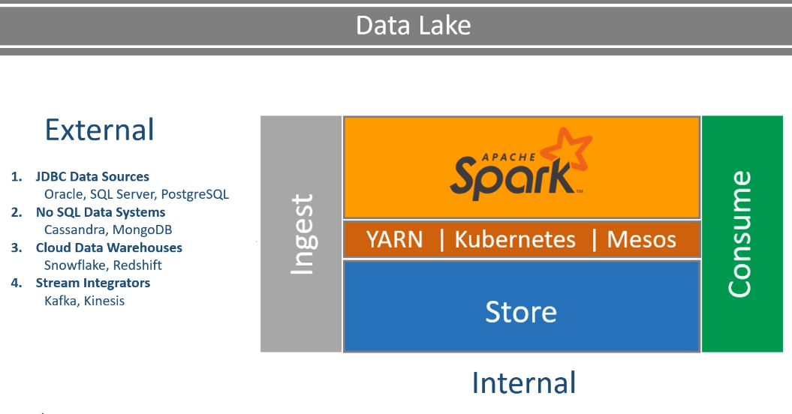

Make sense? There are two approaches. The first approach is to bring your data to the Data Lake and store them in your Lake's distributed storage. How you bring it to the lake is your choice. The most commonly used approach is to use a suitable data integration tool. The second approach is to use Spark Data Source API to directly connect with these external systems.

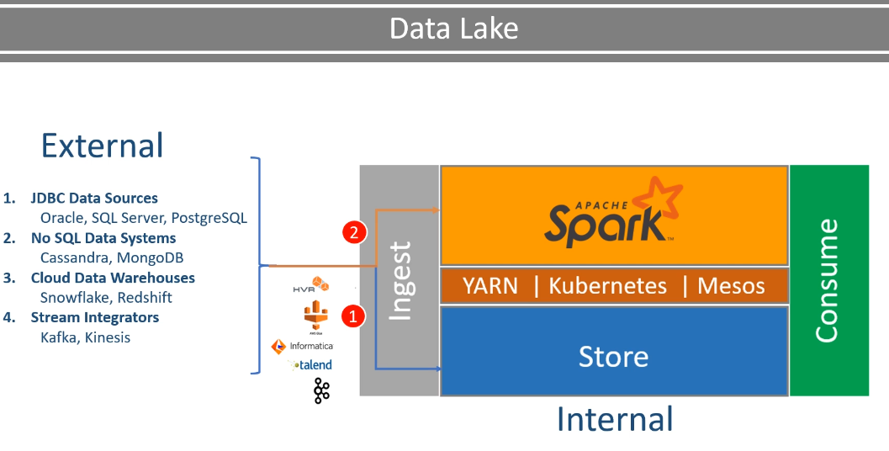

And Spark allows you to do it for a variety of source systems. For example, you can connect to all of these, which I have listed here. So now you have two choices. Which one do you prefer? I prefer the first one for all my batch processing requirements and the second one for all my stream processing requirements. **However, stream processing is not in the scope of this course, so I leave that discussion for another course.** Now let's assume that I have a batch processing requirement. So I am going to prefer the first approach Using a data integration tool to bring data to the distributed storage, and then we start processing it. Why do I prefer this two-step approach? Here are some reasons. Bringing data correctly and efficiently to your lake is a complex goal in itself. We want to decouple the ingestion from the processing to improve manageability. Your source system would have been designed for some specific purpose. And the capacity of your source system would have been planned accordingly.

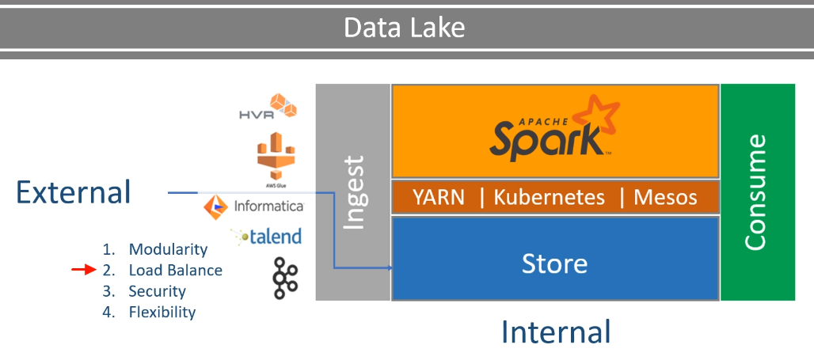

Now, if you want to connect your Spark workload to these systems, then you must have to replan your source system capacity and the security aspects of those systems.   We want to use the right tool for the right purpose. A spark is an excellent tool for data processing. However, It wasn't designed to handle the complexities of Data Ingestion. So, most of the well designed real-life projects are not going to directly connect to the external systems even though we can do it. Now let's come to the second category - Internal Data Sources So your internal data source is your distributed storage.

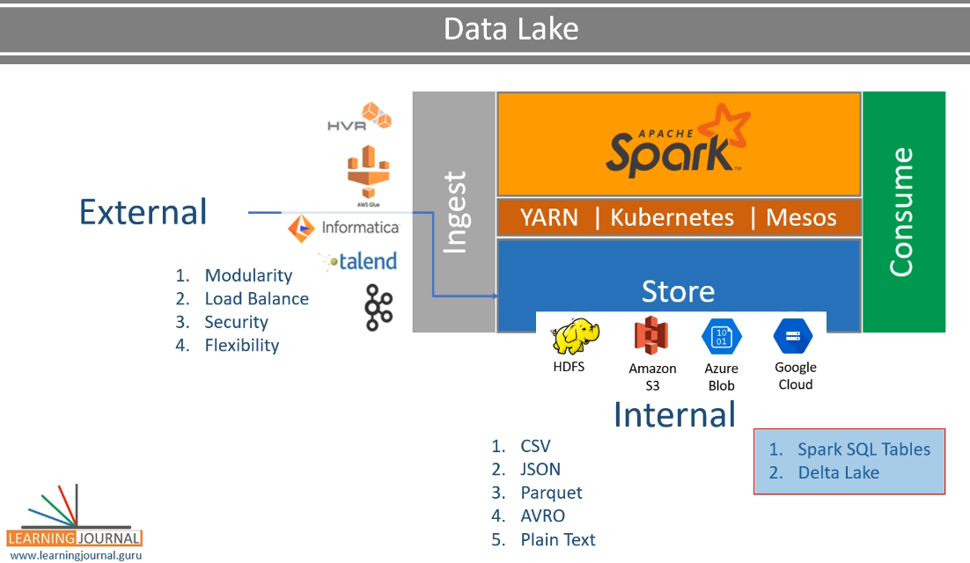

It could be HDFS or cloud-based storage. However, at the end of the day, your data is stored in these systems as a data file. The mechanics of reading data from HDFS or from cloud storage is the same. However, the difference lies in the data file format. Here are some commonly used file formats.

Other than these file formats, we also have two more options. Spark SQL Tables and Delta Lake These two are also backed by data files. However, they also include some additional metadata that is stored outside the data file. So we do not categorize them as file sources.

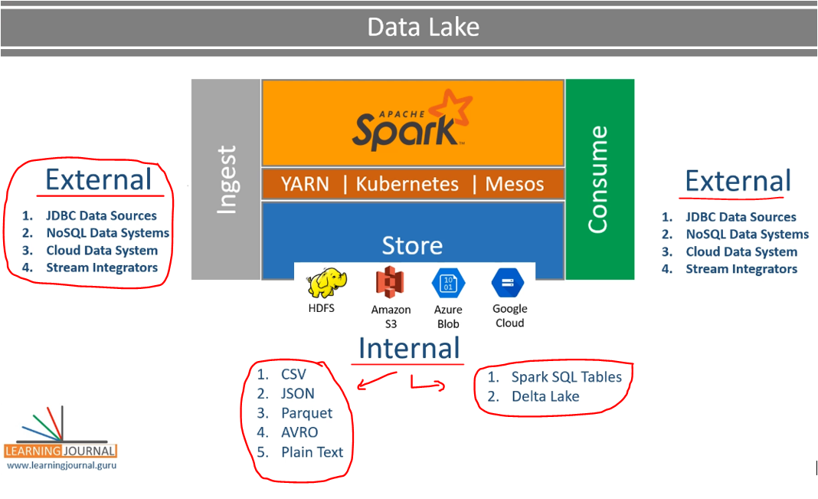

Great! So now you understand the Spark Data Sources part. What is the Data Sink? The data sinks are the final destination of the processed data. So you are going to load the data from an internal or an external source. Then you will be handling it using the Spark APIs. Once your processing is complete, you want to save the outcome to an internal or an external system. And these systems could be a data file in your data lake storage, or it could be an external system such as a JDBC database, or a NoSQL database. So the idea remains the same. Working with the data source is all about reading the data, and working with the sink is about writing the data. Same as sources, Spark allows you to write the data in a variety of file formats, SQL tables, and delta-lake. Spark also allows you to directly write the data to a bunch of external sources such as JDBC databases, Cassandra, and MongoDB.

However, we again do not recommend directly writing data to the external systems for the same reasons as we do not directly read from these external systems.

So now you understand the basics of Spark Data Sources and Sinks. In the rest of the section, I am going to create some examples and help you learn the mechanics of working with internal sources and sinks. External systems are beyond the scope of the course.

### Spark DataFrameReader API

Apache Spark offers a standardized API interface to work with Data Sources. These APIs have a well-defined format, and a recommend pattern for usage. In this video, I am going to help you understand the basics of using Spark Data Sources. So, let's start. Spark allows you to read data using the DataFrameReader API. You can access the DataFrameReader through the SparkSession via the read method. Here is the general structure of the DataFrameReader API. And here is an example. So, you can get the DataFrameReader using the spark.read method where spark is the SparkSession variable.

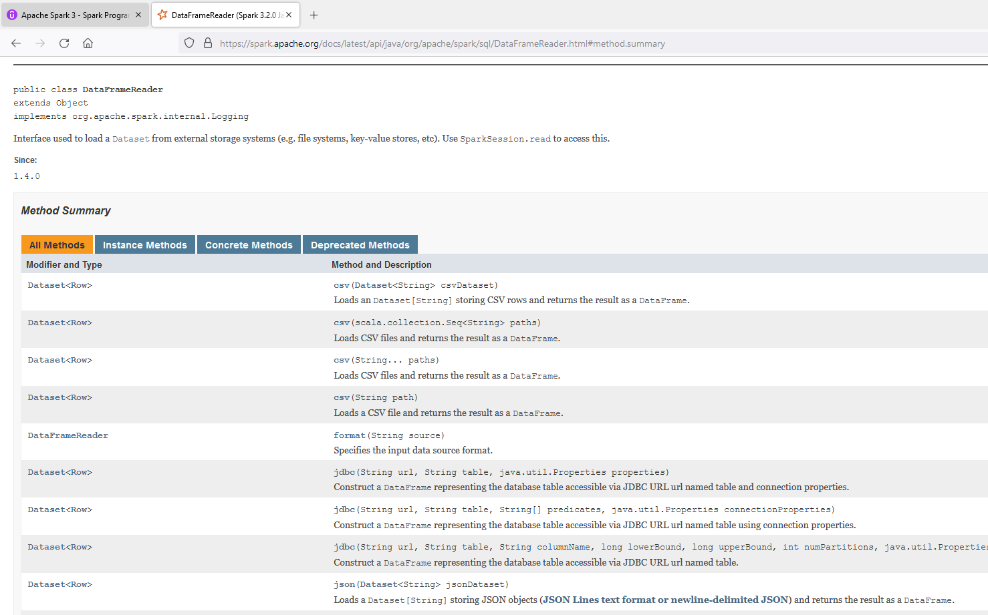

Once you have the DataFrameReader, you can specify four main things. Format of your data source I am using CSV format because my data files are CSV files. Spark DataFrameReader reader supports several built-in formats such as CSV, JSON, Parquet, ORC, and JDBC. The DataFrameReader API is extended by the community to support hundreds of external data sources. And they offer a separate format for different sources such as Cassandra, MongoDB, XML, HBase, Redshift, and many more.

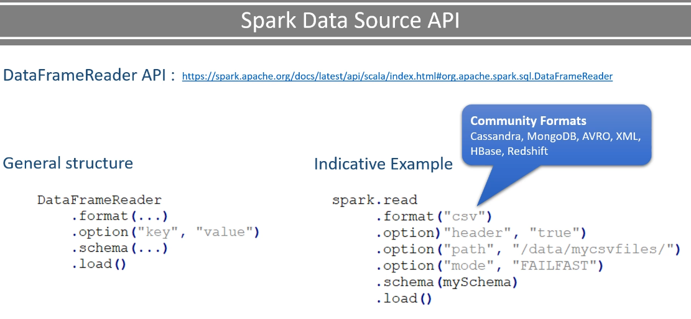

So the point is straight. You can use the Spark DataFrameReader API to read data from any data source, which is supported by Spark or by the community developers. And all of those are going to use the same set of API and the structure. I will show you some other examples to help you grab this standardized structure. The next thing is to specify the options. Every data source has a specific set of options to determine how the DataFrameReader is going to read the data. The header option in this example is specific to CSV format. For other formats, you must look into the documentation of the data source. I will show you some other formats. The third most important thing is the Read Mode. You can specify the Mode via the option method itself. But what is the Mode? Reading data from a source file, especially the semi-structured data sources such as CSV, JSON, and XML, may encounter a corrupt or malformed record. Read modes specify what will happen when Spark comes across a malformed record. Spark allows three read modes. permissive, dropMalformed and failFast

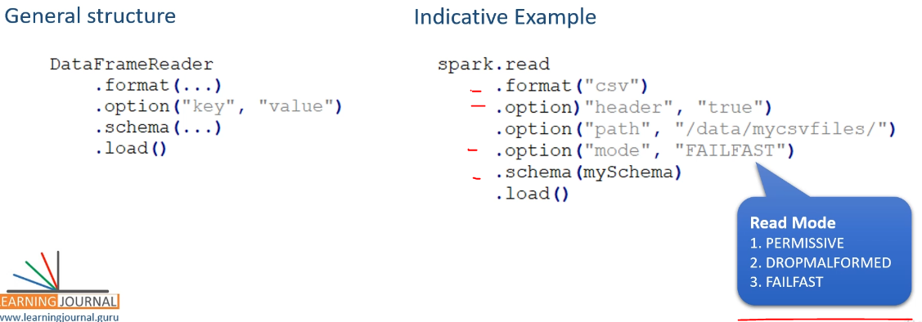

The permissive Mode is the default option. This Mode sets all the fields to null when it encounters a corrupted record and places the corrupted records in a string column called _corrupt_record. The dropMalformed is going to remove the malformed record. That means, you are ignoring the malformed records and only loading the well-formed records. Finally, the fail-fast raises an exception and terminates immediately upon encountering a malformed record. The last thing is the schema. The schema is optional for two reasons. DataFrameReader allows you to infer the schema in many cases. So, if you are inferring the schema, then you may not provide an explicit schema.

|  |  |
| --- | --- |
| **General Structure** | **Indicative Example** |
| DataFrameReader  .format(...)  .option("key", "value")  .schema(...)  .load() | spark.read  .format("csv")  .option("header", "true")  .option("path", "/data/mycsvfiles/")  .option("mode", "FAILFAST")  .schema(mySchema)  .load()   * **Schema can be Implict, Explicit or Inferred** |

Some data sources such as Parquet and AVRO comes with a well-defined schema inside the data source itself.

So, in those cases, you do not need to specify a schema. Once you are done setting the format, all necessary options, Mode, and schema, you can call the load() method to read the data and create a DataFrame. This is a standard structure.

|  |  |
| --- | --- |
| **General Structure** | **Indicative Example** |
| DataFrameReader  .format(...)  .option("key", "value")  .schema(...)  .load() | spark.read  .format("csv")  .option("header", "true")  .option("path", "/data/mycsvfiles/")  .option("mode", "FAILFAST")  .schema(mySchema)  .load() |

However, like any other tool, DataFrameReader also comes with some shortcuts and variations. We have already seen one such shortcut in the earlier examples. Do you remember? Instead of using the load method, we used the CSV() method.

|  |  |
| --- | --- |
| **General Structure** | **Indicative Example** |
| DataFrameReader  .format(...)  .option("key", "value")  .schema(...)  .load() | spark.read  .format("csv")  .option("header", "true")  ~~.option("path", "/data/mycsvfiles/")~~  .option("mode", "FAILFAST")  .schema(mySchema)  ~~.load()~~  .csv("/data/mycsvfiles/") |

That was a shortcut. However, I recommend avoiding shortcuts and follow the standard style. Following the standard is going to add to your code maintainability. Isn't it?

### Reading CSV, JSON and Parquet files

We have created this new example SparkSchemaDemo. Most of the things are copied from the earlier example. However, I have included three data files in this project. The first one is a CSV file with more than 400K records of flight timing data.

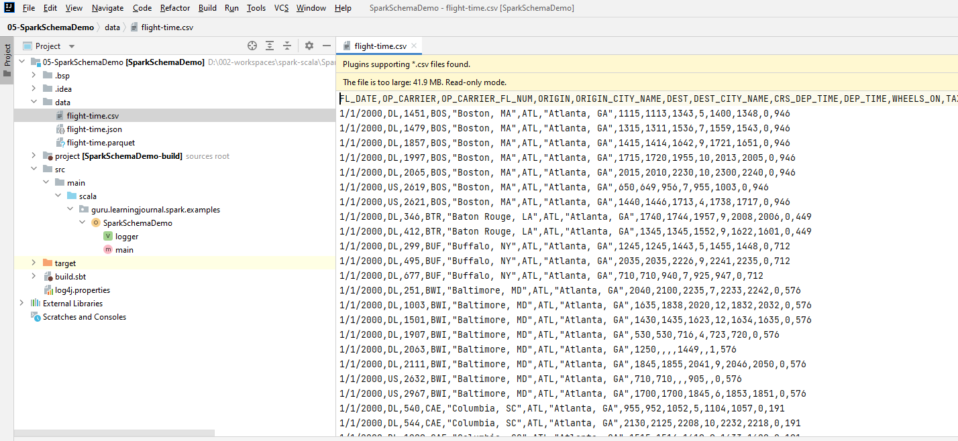

The second one is also the same data, but this one is a JSON file.

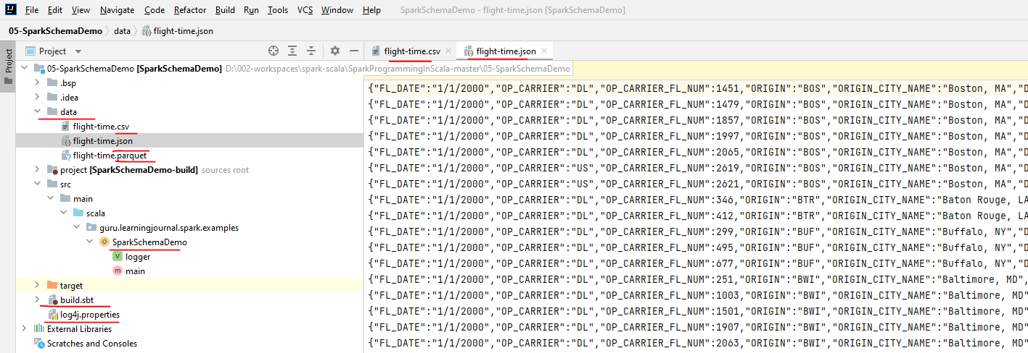

Similarly, I have another version of the same data, but this one is a parquet file. In this example, I want to show you the following. How to use DataFrameReader for CSV, JSON, and Parquet data sources And in the next lecture, I will extend the same example to help you learn the following.

Here we will see

1. How to use DataFrameReader for CSV, JSON and Parquet

In next chapter

1. Spark Data Types
2. How to explicitly define a schema for your data

Spark Data Types And How to explicitly define a schema for your data Let's start with the first thing. How to use DataFrameReader? Here is my Spark Project. I already have some basic setup, and I am not going to repeat it here because you already learned all those things.

**SparkSchemaDemo.scala**

package guru.learningjournal.spark.examples

import org.apache.log4j.Logger

import org.apache.spark.sql.SparkSession

import org.apache.spark.sql.types.{DateType, IntegerType, StringType, StructField, StructType}

object SparkSchemaDemo extends Serializable {

@transient lazy val *logger*: Logger = Logger.getLogger(getClass.getName)

def main(args: Array[String]): Unit = {

val spark = SparkSession.builder()

.appName("Spark Schema Demo")

.master("local[3]")

.getOrCreate()

}  
  
}

Let me use DataFrameReader to read the CSV file. As explained in the earlier video, we start with the spark session and use the read method. The next thing is to specify the data source format. In my case, this is a CSV source. Now I want to give you some necessary options. My CSV file comes with a header, so let me set the header to true. Then I specify the file path. The path could be a file name, or it could be a directory location.

val flightTimeCsvDF = spark.read

.format("csv")

.option("header", "true")

.option("mode", "FAILFAST")

.option("path", "data/flight*.csv")

.option("dateFormat", "M/d/y")

.option("inferSchema", "true")

.load()

Spark DataFramReder is going to read all the files in the given directory. You can even use some wild cards to target specific files. Let me try it. Good. So now we are ready to load the CSV file to a DataFrame. I am not giving any schema, and I am not even asking DataFrameReader to infer the schema. Let's see what do I get. Let me show five records of this DataFrame. I also want to know the default DataFrame Schema. So, I will again log the DataFrame schema converted to a simple string. Now let's run it and see what we get.

flightTimeJsonDF.show(5)

logger.info("JSON Schema:" + flightTimeJsonDF.schema.simpleString)

So, it looks like I am reading it correctly. The field name and the expected data in these columns are matching. I cross-checked it. So the DataFrame reader is correctly picking the column names from the header row. However, all of these fields are given a String Datatype. What if I inferred the schema? Let's try.

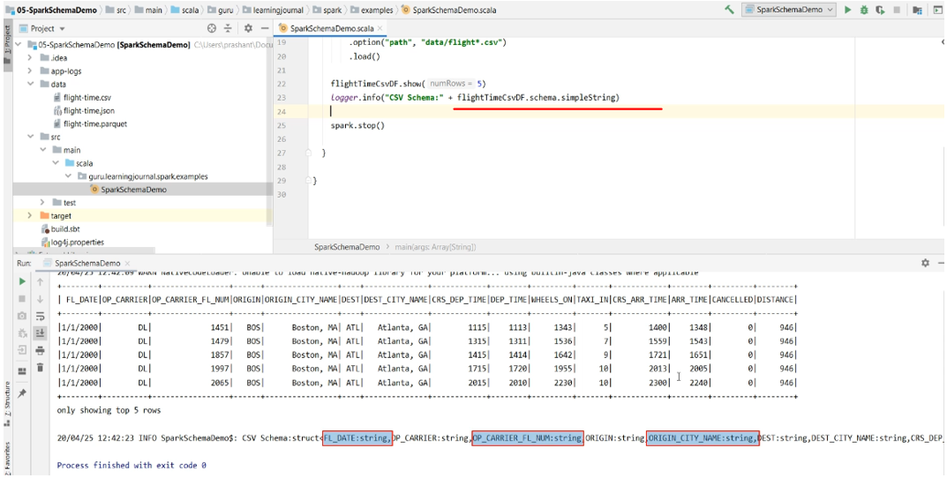

val flightTimeCsvDF = spark.read

.format("csv")

.option("header", "true")

.option("mode", "FAILFAST")

.option("path", "data/flight*.csv")

.option("dateFormat", "M/d/y")

.option("inferSchema", "true")

.load()

flightTimeCsvDF.show(5)

logger.info( "CSV Schema:" + flightTimeCsvDF.schema.simpleString )

So, I am setting the option to infer the schema. Let's re-run it. Now it is a little better. My numeric fields are now inferred to be an integer. That's what I wanted. However, my date filed is still a string.

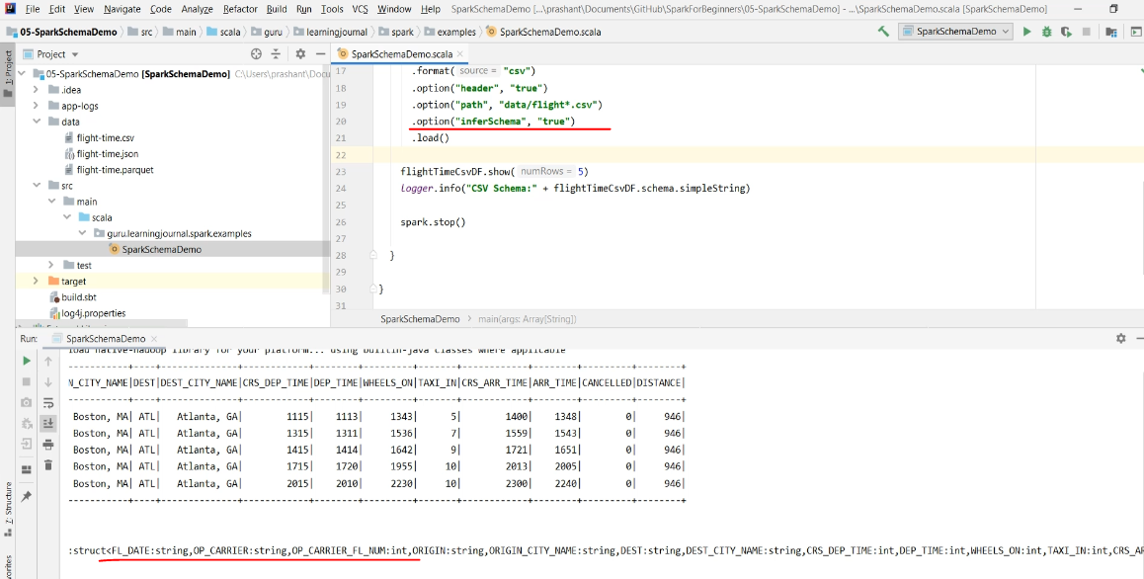

* So the point is straight. You cannot rely on the infer schema option. So you have got only two options. Explicitly specify a schema Or use a data file format which comes with the schema

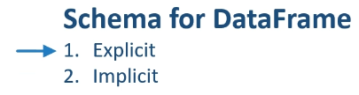

We learn both these options. However, let me create one more DataFrame reading my JSON file. I am going to copy the same code and modify it. Let me change the name of the DataFrame. Now the format is JSON. Header goes away because the JSON doesn't come with a header row. You may want to keep the inferSchema, but let me check the documentation before using it.  Search for the DataFrameReader. Look for the JSON method.

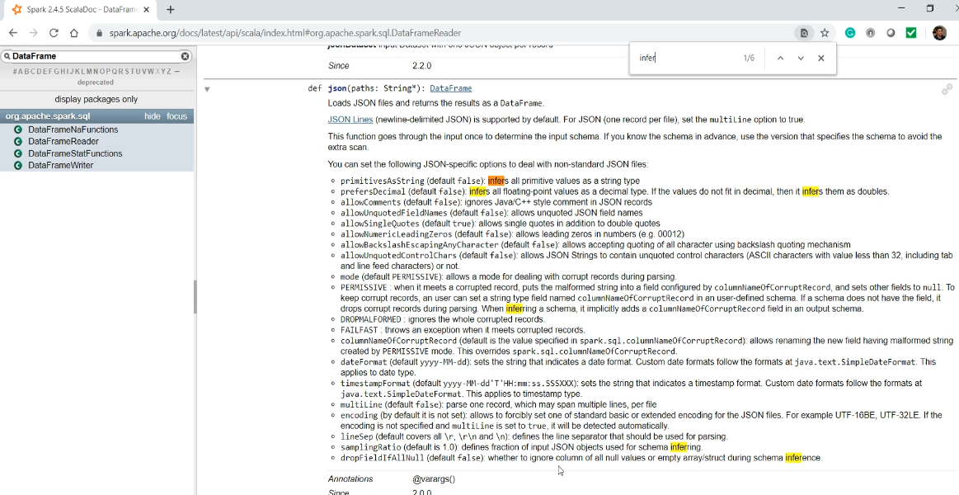

Here are the JSON options. Search for the infer. I don't see the infer schema option. However, we see that the API makes some inferences. So, it looks like the JSON format will always infer the schema, and you do not need to give this option. Let's come back and remove the infer schema option. Then I change the file name. I also want to print the schema.

val flightTimeJsonDF = spark.read

.format("json")

.option("path", "data/flight*.json")

.option("dateFormat", "M/d/y")

.schema(flightSchemaDDL)

.load()

flightTimeJsonDF.show(5)

*logger*.info( "JSON Schema:" + flightTimeJsonDF.schema.simpleString )

Let me run it, and then we will see what schema was inferred. Okay. The JSON format also sorted the column names in alphabetical order. And that's fine. However, I do see a similar behavior for inference. My integer columns are now BigInt, but my date column is still a string.

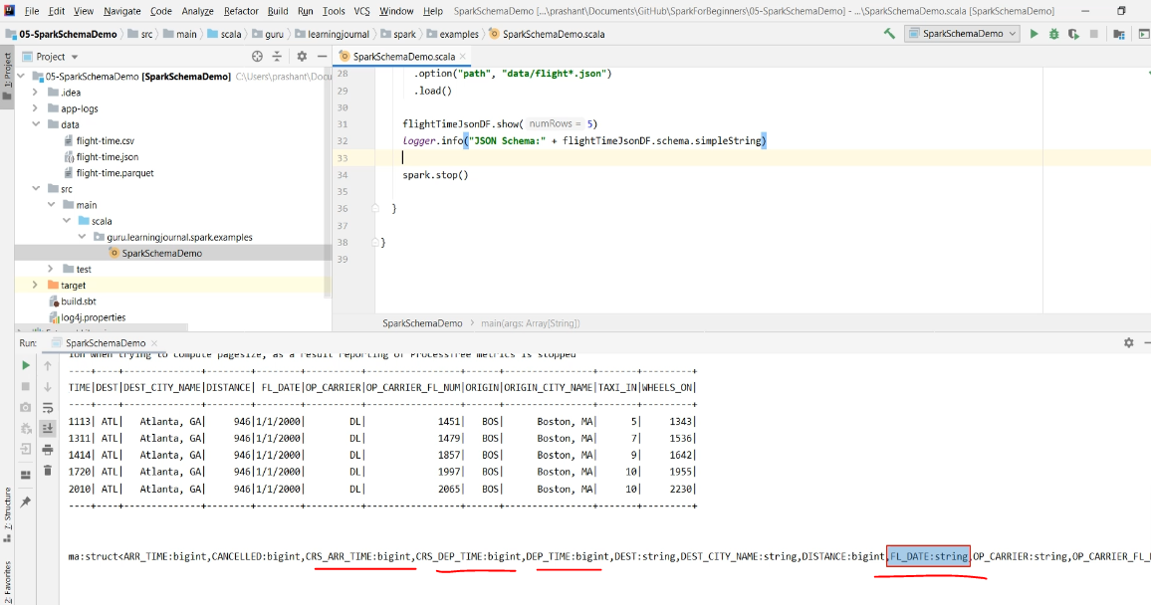

Now comes the second question. How do we fix it? And I already mentioned that you have two options

1. Explicitly specify a schema
2. Use a data file format which comes with the schema

We also have a parquet data file. The parquet is a binary file format and which comes with the schema information already included in the data file. So, you do not need to specify the schema explicitly.

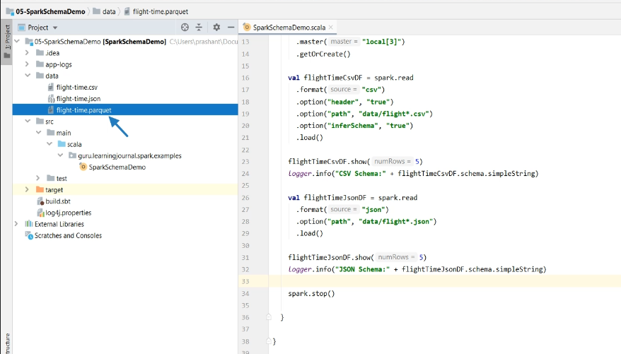

However, your data file should contain the correct schema. I created this parquet file purposefully with accurate schema information for all the fields. Let's load it and see if we get an appropriate schema. I will again copy this code. Change the name, Change the format, and also the file name.

val flightTimeParquetDF = spark.read

.format("parquet")

.option("path", "data/flight*.parquet")

.load()

flightTimeParquetDF.show(5)

logger.info( "Parquet Schema:" + flightTimeParquetDF.schema.simpleString )

We will again print the information. Let me run it, and we will look at the result. My parquet file contains the well defined correct schema along with the data. So, the DataFrame reader for the parquet source loaded it with the same schema. Now you can see the int as well as the date field. So the point is straight. You should prefer using the Parquet file format as long as it is possible.

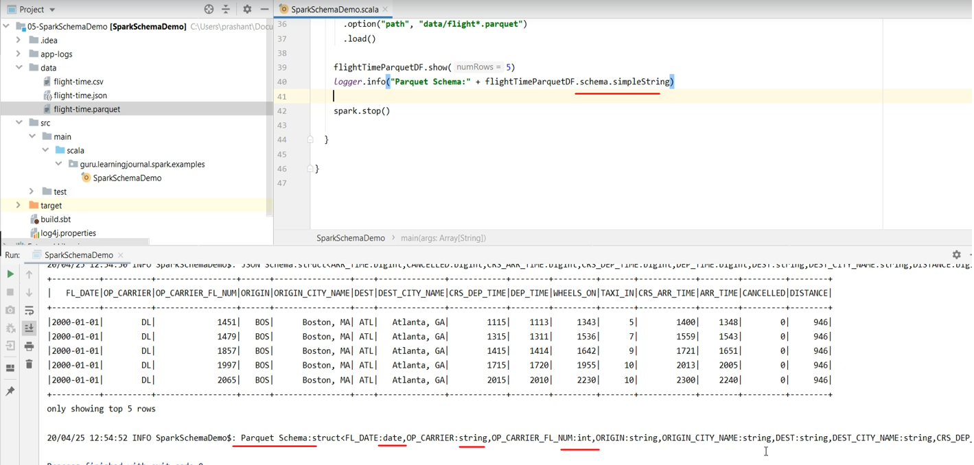

And the parquet file format is the recommended and the default file format for Apache Spark. Your data integration tools might bring the original data source in CSV or in JSON format. However, if you have a choice, then you must be trying to get your data in the Parquet file format. And most of the data integration tools are now supporting to create parquet files. So, I recommend you to stick to parquet files for your Spark data processing.

**Complete Code**

**SparkSchemaDemo.scala**

package guru.learningjournal.spark.examples

import org.apache.log4j.Logger

import org.apache.spark.sql.SparkSession

import org.apache.spark.sql.types.{DateType, IntegerType, StringType, StructField, StructType}

object SparkSchemaDemo extends Serializable {

@transient lazy val logger: Logger = Logger.getLogger(getClass.getName)

def main(args: Array[String]): Unit = {

val spark = SparkSession.builder()

.appName("Spark Schema Demo")

.master("local[3]")

.getOrCreate()

val flightTimeCsvDF = spark.read

.format("csv")

.option("header", "true")

//.option("inferSchema", "true")

.option("mode", "FAILFAST")

.option("path", "data/flight*.csv")

.option("dateFormat", "M/d/y")

.load()

flightTimeCsvDF.show(5)

logger.info("CSV Schema:" + flightTimeCsvDF.schema.simpleString)

val flightTimeJsonDF = spark.read

.format("json")

.option("path", "data/flight*.json")

.option("dateFormat", "M/d/y")

.schema(flightSchemaDDL)

.load()

flightTimeJsonDF.show(5)

logger.info("JSON Schema:" + flightTimeJsonDF.schema.simpleString)

val flightTimeParquetDF = spark.read

.format("parquet")

.option("path", "data/flight*.parquet")

.load()

flightTimeParquetDF.show(5)

logger.info("Parquet Schema:" + flightTimeParquetDF.schema.simpleString)

}

}

**build.sbt**

name := "SparkSchemaDemo"  
organization := "guru.learningjournal"  
version := "0.1"  
scalaVersion := "2.13.7"  
  
autoScalaLibrary := false  
val sparkVersion = "3.2.0"  
  
val sparkDependencies = Seq(  
 "org.apache.spark" %% "spark-core" % sparkVersion,  
 "org.apache.spark" %% "spark-sql" % sparkVersion  
)  
  
libraryDependencies ++= sparkDependencies

**log4j.properties**

# Set everything to be logged to the console

log4j.rootCategory=WARN, console

# define console appender

log4j.appender.console=org.apache.log4j.ConsoleAppender

log4j.appender.console.target=System.out

log4j.appender.console.layout=org.apache.log4j.PatternLayout

log4j.appender.console.layout.ConversionPattern=%d{yy/MM/dd HH:mm:ss} %p %c{1}: %m%n

#application log

log4j.logger.guru.learningjournal.spark.examples=INFO, console, file

log4j.additivity.guru.learningjournal.spark.examples=false

#define rolling file appender

log4j.appender.file=org.apache.log4j.RollingFileAppender

log4j.appender.file.File=${spark.yarn.app.container.log.dir}/${logfile.name}.log

#define following in Java System

# -Dlog4j.configuration=file:log4j.properties

# -Dlogfile.name=hello-spark

# -Dspark.yarn.app.container.log.dir=app-logs

log4j.appender.file.ImmediateFlush=true

log4j.appender.file.Append=false

log4j.appender.file.MaxFileSize=500MB

log4j.appender.file.MaxBackupIndex=2

log4j.appender.file.layout=org.apache.log4j.PatternLayout

log4j.appender.file.layout.conversionPattern=%d{yy/MM/dd HH:mm:ss} %p %c{1}: %m%n

# Recommendations from Spark template

log4j.logger.org.apache.spark.repl.Main=WARN

log4j.logger.org.spark_project.jetty=WARN

log4j.logger.org.spark_project.jetty.util.component.AbstractLifeCycle=ERROR

log4j.logger.org.apache.spark.repl.SparkIMain$exprTyper=INFO

log4j.logger.org.apache.spark.repl.SparkILoop$SparkILoopInterpreter=INFO

log4j.logger.org.apache.parquet=ERROR

log4j.logger.parquet=ERROR

log4j.logger.org.apache.hadoop.hive.metastore.RetryingHMSHandler=FATAL

log4j.logger.org.apache.hadoop.hive.ql.exec.FunctionRegistry=ERROR

**data/flight-time.csv**

FL_DATE,OP_CARRIER,OP_CARRIER_FL_NUM,ORIGIN,ORIGIN_CITY_NAME,DEST,DEST_CITY_NAME,CRS_DEP_TIME,DEP_TIME,WHEELS_ON,TAXI_IN,CRS_ARR_TIME,ARR_TIME,CANCELLED,DISTANCE

1/1/2000,DL,1451,BOS,"Boston, MA",ATL,"Atlanta, GA",1115,1113,1343,5,1400,1348,0,946

1/1/2000,DL,1479,BOS,"Boston, MA",ATL,"Atlanta, GA",1315,1311,1536,7,1559,1543,0,946

**data/flight-time.json**

{"FL_DATE":"1/1/2000","OP_CARRIER":"DL","OP_CARRIER_FL_NUM":1451,"ORIGIN":"BOS","ORIGIN_CITY_NAME":"Boston, MA","DEST":"ATL","DEST_CITY_NAME":"Atlanta, GA","CRS_DEP_TIME":1115,"DEP_TIME":1113,"WHEELS_ON":1343,"TAXI_IN":5,"CRS_ARR_TIME":1400,"ARR_TIME":1348,"CANCELLED":0,"DISTANCE":946}

{"FL_DATE":"1/1/2000","OP_CARRIER":"DL","OP_CARRIER_FL_NUM":1479,"ORIGIN":"BOS","ORIGIN_CITY_NAME":"Boston, MA","DEST":"ATL","DEST_CITY_NAME":"Atlanta, GA","CRS_DEP_TIME":1315,"DEP_TIME":1311,"WHEELS_ON":1536,"TAXI_IN":7,"CRS_ARR_TIME":1559,"ARR_TIME":1543,"CANCELLED":0,"DISTANCE":946}

{"FL_DATE":"1/1/2000","OP_CARRIER":"DL","OP_CARRIER_FL_NUM":1857,"ORIGIN":"BOS","ORIGIN_CITY_NAME":"Boston, MA","DEST":"ATL","DEST_CITY_NAME":"Atlanta, GA","CRS_DEP_TIME":1415,"DEP_TIME":1414,"WHEELS_ON":1642,"TAXI_IN":9,"CRS_ARR_TIME":1721,"ARR_TIME":1651,"CANCELLED":0,"DISTANCE":946}

**data/flight-time.parquet**

<parquet format data>

### Creating a Parquet File ???

### Creating Spark DataFrame Schema

In the earlier lecture, we learned to load data from a CSV, JSON as well as Parquet file. However, we also noticed that the schema inference doesn't work well for CSV and JSON.

In this lecture, I am going to talk about explicitly setting Schema for your DataFrames. So, let's start. DataFrame schema is all about setting the column name and appropriate data types. However, you should also know the Spark supported data types. So, let's try to understand the Spark Types before we talk about the Schema.

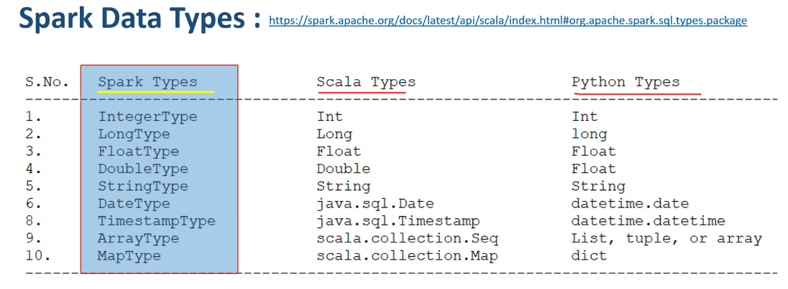

Apache Spark comes with its own data types. Here are the ten most commonly used types. However, you can find the full list in the org.apache.spark.sql.types package. If you are using Scala, they simply correspond to their equivalent Scala Types. In Python, they correspond to equivalent Python types. However, we define Spark DataFrame schema using the Spark Types. You might be wondering why Spark maintains its own types. Why don't we simply use the language-specific types? Well, there is a valid reason for this. Spark is like a compiler. It complies with the high-level API code into low-level RDD operations. And during this compilation process, it generated different execution plans and also performed a bunch of optimizations. This all is not at all possible for the Spark engine without maintaining its own type of information. And this approach is not new. Every SQL database would have a set of SQL data types. Similarly, Spark also works on Spark data types.

Now that you learned about the Spark types. Let's move on to the Schema. Spark allows you to define Schema in two ways. Programmatically and Using DDL String

**Spark Schema**

1. Programmatically
2. Using DDL String

The second method is is much simpler and easier. However, let's learn both techniques. I reopened the SparkSchemaDemo example, which we created in the previous lecture. In this example, we are reading the same data using three different sources. Now I want to define the Schema for this data set. I am going to use the Programmatic method. A Spark DataFrame Schema is a StructType which is made up of a list of StructField. The StructField takes two mandatory arguments. The first one is a column name, and the second one is the data type. You must be using one of the Spark Data Types. Let me complete the schema definition.

def main(args: Array[String]): Unit = {

val spark = SparkSession.builder()

.appName("Spark Schema Demo")

.master("local[3]")

.getOrCreate()

val **flightSchemaStruct** = StructType(List(

StructField("FL_DATE", DateType),

StructField("OP_CARRIER", StringType),

StructField("OP_CARRIER_FL_NUM", IntegerType),

StructField("ORIGIN", StringType),

StructField("ORIGIN_CITY_NAME", StringType),

StructField("DEST", StringType),

StructField("DEST_CITY_NAME", StringType),

StructField("CRS_DEP_TIME", IntegerType),

StructField("DEP_TIME", IntegerType),

StructField("WHEELS_ON", IntegerType),

StructField("TAXI_IN", IntegerType),

StructField("CRS_ARR_TIME", IntegerType),

StructField("ARR_TIME", IntegerType),

StructField("CANCELLED", IntegerType),

StructField("DISTANCE", IntegerType)

))

So, The StructType represents a DataFrame row structure, and the StructField is a column definition. Now you can use this Schema to load your CSV file to a DataFrame and comment out the inferSchema option. However, we still keep the header option because we want to skip the first row in the CSV file. If you look at the schema structure, I am using three Spark Types. DateType, StringType, and IntegerType If the types in the data do not match the Schema at runtime, Spark should throw an error. However, you must set the mode for getting the error. So, let me fix it. Good. I defined the Schema correctly, and I am not expecting any error.

val flightTimeCsvDF = spark.read

.format("csv")

.option("header", "true")

*//.option("inferSchema", "true")*

.option("mode", "FAILFAST")

.option("path", "data/flight*.csv")

.schema(**flightSchemaStruct**)

.load()

However, let's run it once and check it. Oops. I got an exception. What is the error? DateTimeParseException So, Spark DataFrameReader is not able to parse the FL_DATE field as DateType. How do I fix it?

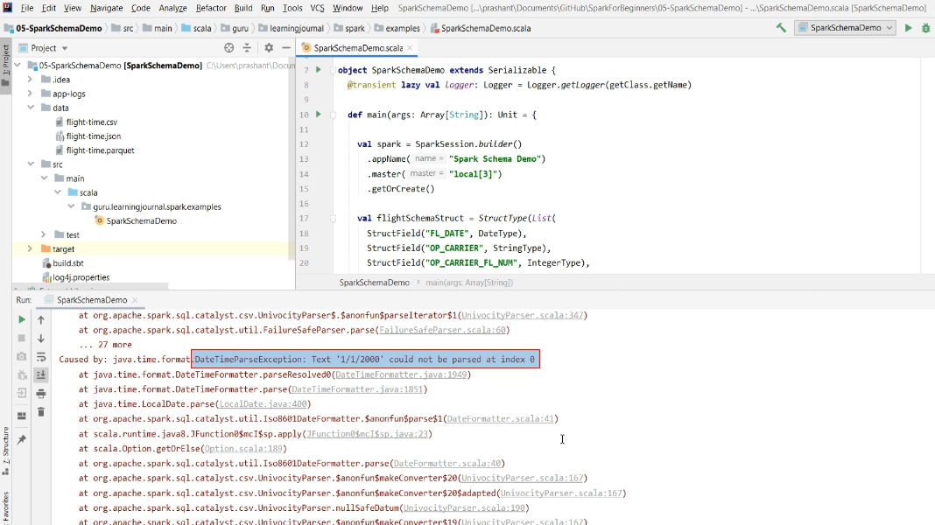

Well, the CSV source requires you to define the data format pattern. And it takes a java.text.SimpleDateFormat pattern. So, My date string can be defined using the "M/d/y". Let's try it again.

val flightTimeCsvDF = spark.read

.format("csv")

.option("header", "true")

*//.option("*inferSchema*", "true")*

.option("mode", "FAILFAST")

.option("path", "data/flight*.csv")

.option("dateFormat", "M/d/y")

.schema(flightSchemaStruct)

.load()

flightTimeCsvDF.show(5)

logger.info("CSV Schema:" + flightTimeCsvDF.schema.simpleString)

Amazing. My data looks good. And the Schema is also perfect. The date field is now a Date.

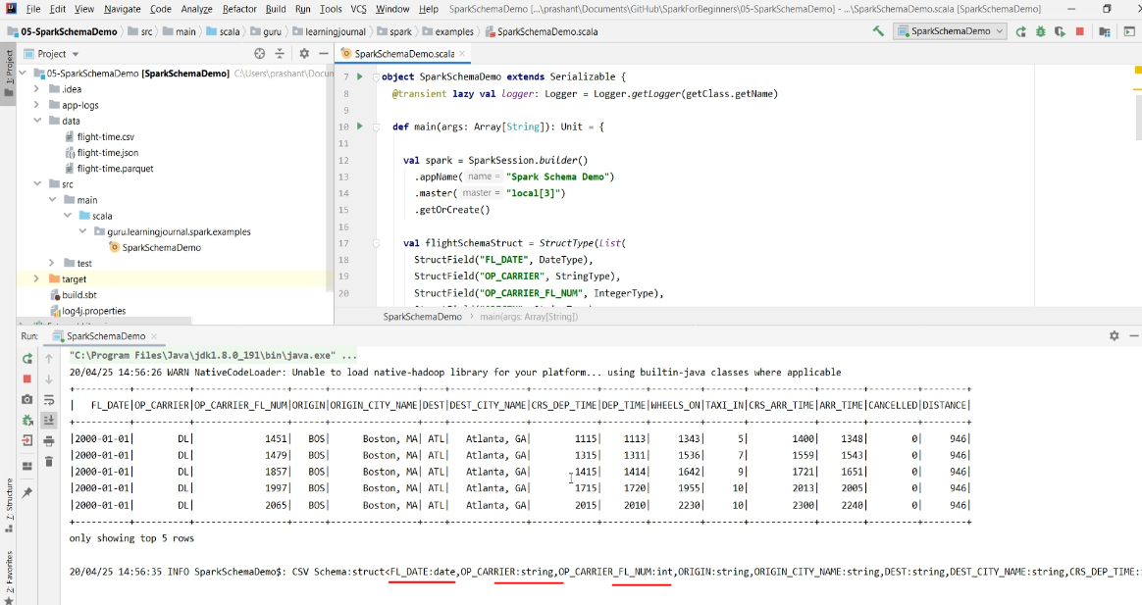

So you learned to define and use the Schema. Now let's try the DDL string to define the Schema. Here it is. The Schema DDL is straightforward. All you need is the column name and data type separated by a comma. And you can use this Schema in the same way as a Programmatically defined schema.

val flightSchemaDDL = "FL_DATE DATE, OP_CARRIER STRING, OP_CARRIER_FL_NUM INT, "

+ " ORIGIN STRING, ORIGIN_CITY_NAME STRING, DEST STRING, "

+ "DEST_CITY_NAME STRING, CRS_DEP_TIME INT, DEP_TIME INT, "

+ "WHEELS_ON INT, TAXI_IN INT, CRS_ARR_TIME INT, "

+ "ARR_TIME INT, CANCELLED INT, DISTANCE INT"

val flightTimeJsonDF = spark.read

.format("json")

.option("path", "data/flight*.json")

.option("dateFormat", "M/d/y")

.schema(flightSchemaDDL)

.load()

flightTimeJsonDF.show(5)

*logger*.info("JSON Schema:" + flightTimeJsonDF.schema.simpleString)

Let me use it for the JSON source. You also need the dataFormat. Let me run it. It works.

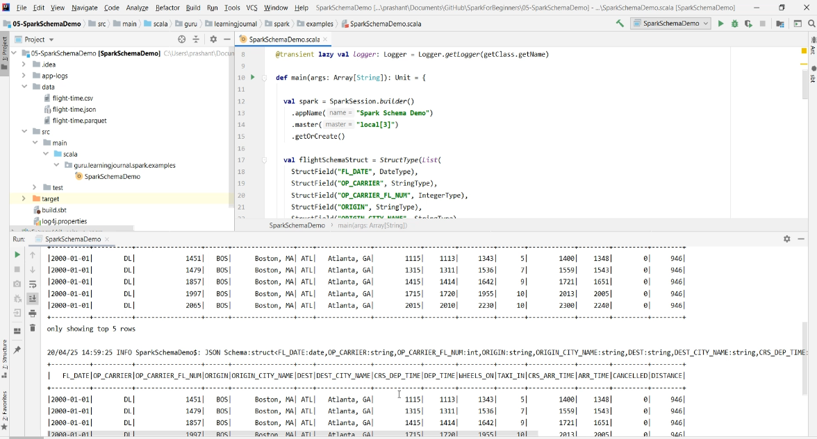

**Complete Code**

**SparkSchemaDemo.scala**

package guru.learningjournal.spark.examples

import org.apache.log4j.Logger

import org.apache.spark.sql.SparkSession

import org.apache.spark.sql.types.{DateType, IntegerType, StringType, StructField, StructType}

object SparkSchemaDemo extends Serializable {

@transient lazy val logger: Logger = Logger.getLogger(getClass.getName)

def main(args: Array[String]): Unit = {

val spark = SparkSession.builder()

.appName("Spark Schema Demo")

.master("local[3]")

.getOrCreate()

val flightSchemaStruct = StructType(List(

StructField("FL_DATE", DateType),

StructField("OP_CARRIER", StringType),

StructField("OP_CARRIER_FL_NUM", IntegerType),

StructField("ORIGIN", StringType),

StructField("ORIGIN_CITY_NAME", StringType),

StructField("DEST", StringType),

StructField("DEST_CITY_NAME", StringType),

StructField("CRS_DEP_TIME", IntegerType),

StructField("DEP_TIME", IntegerType),

StructField("WHEELS_ON", IntegerType),

StructField("TAXI_IN", IntegerType),

StructField("CRS_ARR_TIME", IntegerType),

StructField("ARR_TIME", IntegerType),

StructField("CANCELLED", IntegerType),

StructField("DISTANCE", IntegerType)

))

val flightSchemaDDL = "FL_DATE DATE, OP_CARRIER STRING, OP_CARRIER_FL_NUM INT, " +

"ORIGIN STRING, ORIGIN_CITY_NAME STRING, DEST STRING, DEST_CITY_NAME STRING, " +

"CRS_DEP_TIME INT, DEP_TIME INT, WHEELS_ON INT, TAXI_IN INT, CRS_ARR_TIME INT, " +

"ARR_TIME INT, CANCELLED INT, DISTANCE INT"

val flightTimeCsvDF = spark.read

.format("csv")

.option("header", "true")

//.option("inferSchema", "true")

.option("mode", "FAILFAST")

.option("path", "data/flight*.csv")

.option("dateFormat", "M/d/y")

.schema(flightSchemaStruct)

.load()

flightTimeCsvDF.show(5)

logger.info("CSV Schema:" + flightTimeCsvDF.schema.simpleString)

val flightTimeJsonDF = spark.read

.format("json")

.option("path", "data/flight*.json")

.option("dateFormat", "M/d/y")

.schema(flightSchemaDDL)

.load()

flightTimeJsonDF.show(5)

logger.info("JSON Schema:" + flightTimeJsonDF.schema.simpleString)

val flightTimeParquetDF = spark.read

.format("parquet")

.option("path", "data/flight*.parquet")

.load()

flightTimeParquetDF.show(5)

logger.info("Parquet Schema:" + flightTimeParquetDF.schema.simpleString)

}

}

**build.sbt**

name := "SparkSchemaDemo"

organization := "guru.learningjournal"

version := "0.1"

scalaVersion := "2.12.10"

autoScalaLibrary := false

val sparkVersion = "3.0.0-preview2"

val sparkDependencies = Seq(

"org.apache.spark" %% "spark-core" % sparkVersion,

"org.apache.spark" %% "spark-sql" % sparkVersion

)

libraryDependencies ++= sparkDependencies

**log4j.properties**

# Set everything to be logged to the console

log4j.rootCategory=WARN, console

# define console appender

log4j.appender.console=org.apache.log4j.ConsoleAppender

log4j.appender.console.target=System.out

log4j.appender.console.layout=org.apache.log4j.PatternLayout

log4j.appender.console.layout.ConversionPattern=%d{yy/MM/dd HH:mm:ss} %p %c{1}: %m%n

#application log

log4j.logger.guru.learningjournal.spark.examples=INFO, console, file

log4j.additivity.guru.learningjournal.spark.examples=false

#define rolling file appender

log4j.appender.file=org.apache.log4j.RollingFileAppender

log4j.appender.file.File=${spark.yarn.app.container.log.dir}/${logfile.name}.log

#define following in Java System

# -Dlog4j.configuration=file:log4j.properties

# -Dlogfile.name=hello-spark

# -Dspark.yarn.app.container.log.dir=app-logs

log4j.appender.file.ImmediateFlush=true

log4j.appender.file.Append=false

log4j.appender.file.MaxFileSize=500MB

log4j.appender.file.MaxBackupIndex=2

log4j.appender.file.layout=org.apache.log4j.PatternLayout

log4j.appender.file.layout.conversionPattern=%d{yy/MM/dd HH:mm:ss} %p %c{1}: %m%n

# Recommendations from Spark template

log4j.logger.org.apache.spark.repl.Main=WARN

log4j.logger.org.spark_project.jetty=WARN

log4j.logger.org.spark_project.jetty.util.component.AbstractLifeCycle=ERROR

log4j.logger.org.apache.spark.repl.SparkIMain$exprTyper=INFO

log4j.logger.org.apache.spark.repl.SparkILoop$SparkILoopInterpreter=INFO

log4j.logger.org.apache.parquet=ERROR

log4j.logger.parquet=ERROR

log4j.logger.org.apache.hadoop.hive.metastore.RetryingHMSHandler=FATAL

log4j.logger.org.apache.hadoop.hive.ql.exec.FunctionRegistry=ERROR

**data/flight-time.csv**

FL_DATE,OP_CARRIER,OP_CARRIER_FL_NUM,ORIGIN,ORIGIN_CITY_NAME,DEST,DEST_CITY_NAME,CRS_DEP_TIME,DEP_TIME,WHEELS_ON,TAXI_IN,CRS_ARR_TIME,ARR_TIME,CANCELLED,DISTANCE

1/1/2000,DL,1451,BOS,"Boston, MA",ATL,"Atlanta, GA",1115,1113,1343,5,1400,1348,0,946

1/1/2000,DL,1479,BOS,"Boston, MA",ATL,"Atlanta, GA",1315,1311,1536,7,1559,1543,0,946

**data/flight-time.json**

{"FL_DATE":"1/1/2000","OP_CARRIER":"DL","OP_CARRIER_FL_NUM":1451,"ORIGIN":"BOS","ORIGIN_CITY_NAME":"Boston, MA","DEST":"ATL","DEST_CITY_NAME":"Atlanta, GA","CRS_DEP_TIME":1115,"DEP_TIME":1113,"WHEELS_ON":1343,"TAXI_IN":5,"CRS_ARR_TIME":1400,"ARR_TIME":1348,"CANCELLED":0,"DISTANCE":946}

{"FL_DATE":"1/1/2000","OP_CARRIER":"DL","OP_CARRIER_FL_NUM":1479,"ORIGIN":"BOS","ORIGIN_CITY_NAME":"Boston, MA","DEST":"ATL","DEST_CITY_NAME":"Atlanta, GA","CRS_DEP_TIME":1315,"DEP_TIME":1311,"WHEELS_ON":1536,"TAXI_IN":7,"CRS_ARR_TIME":1559,"ARR_TIME":1543,"CANCELLED":0,"DISTANCE":946}

**data/flight-time.parquet**

. . .

### Spark DataFrameWriter API

We already learned to work with a variety of Spark data sources. In this lecture, I am going to give you an overview of Spark data sinks API. So, let's start. Spark allows you to write data using DataFrameWriter API. The DataFrameWriter is a standardized API to work with a variety of internal and external data sources. Here is the general structure of the DataFrameWriter API. And here is an example.

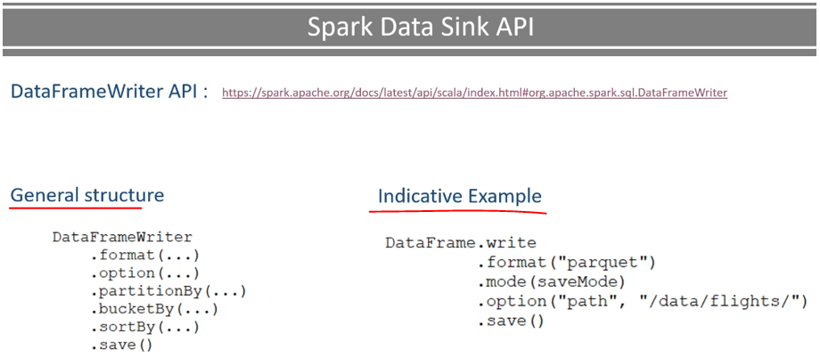

So, you can get the DataFrameWriter using the write method on any of your DataFrame. Once you have the DataFrameWriter, you can specify four main things. The first and the most important thing is the output format. Spark supports a bunch of internal file formats such as CSV, JSON, Parquet, AVRO, ORC, etc. However, Parquet is the default file format.

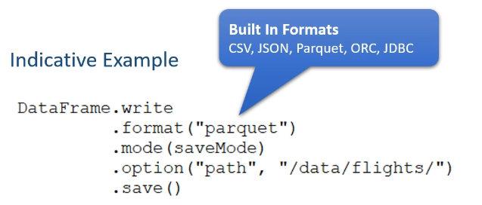 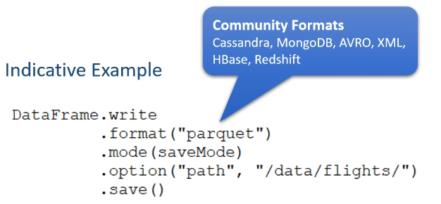

So, DataFrameWriter assumes Parquet when you do not specify the format. These are the internal Spark file-formats bundled with your Spark. However, you also have a bunch of formats offered by the community developers and third-party vendors. Some of the popular ones are JDBC, Cassandra, MongoDB, Kafka, and Delta Lake. The next thing is to specify the options. Every data sink has a specific set of options to determine how the DataFrameWriter is going to write the data. However, at a minimum, you must specify the target of your DataFrame. For a file-based data sink, such as Parquet, it should be a directory location. The next one is the save mode.

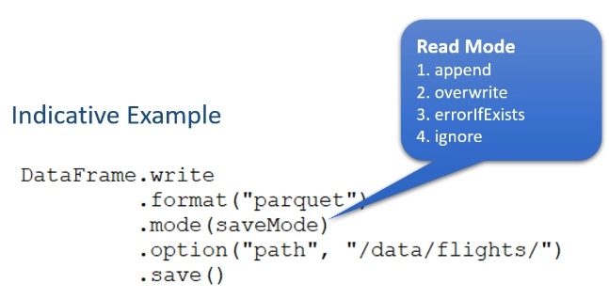

Save modes specifies what will happen when Spark existing finds data at the specified location. We have four valid modes. The append mode will create new files without touching the existing data at the given location The overwrite will remove the existing data files and create new files errorIfExists, will throw an error when you already have some data at the specified location The ignore will write the data if and only if the target directory is empty and do nothing if some files already exist at the location. Finally, the most important thing is to control the layout of your output data.

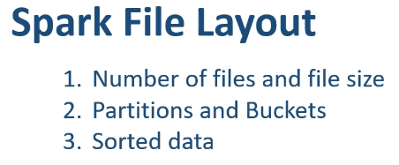

What does it mean? It means to control the following items. Number of files and file size Organizing your output in partitions and buckets Storing sorted data Let me explain. DataFrames are partitioned.

So, when you write your DataFrame to the file system, you are going to get one output file per partition. That's the default behavior, and it is perfectly fine because each partition is written by an executor core in parallel.

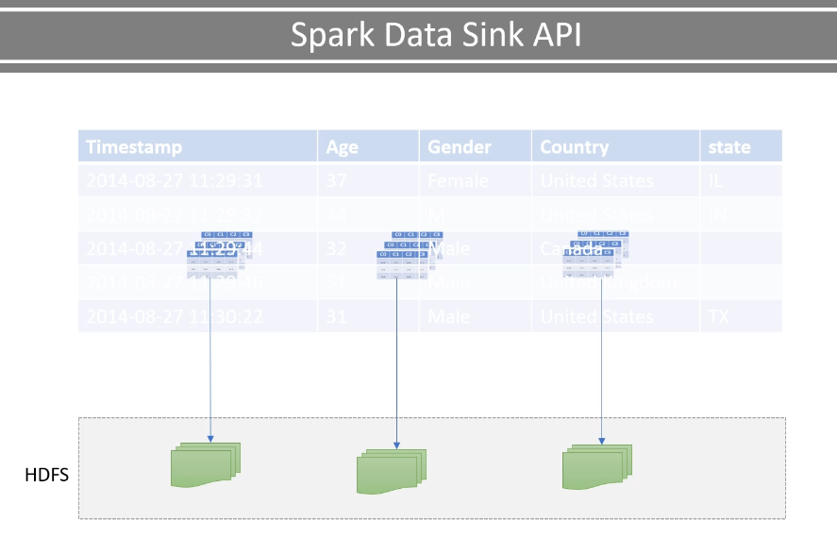

However, the default behavior may not be suitable for your requirements. So, you can tweak it. How? We have a bunch of ways. The simplest option is to repartition your DataFrame before you write it. Correct? Now the next question? How do we repartition? So we have three different ways to repartition your data to write it to the sink. The first option is to do the Simple Repartitioning and you already learned it. You can use the DataFrame.repartition() transformation. This transformation will repartition your data, and you can control the number of output files. However, this could be a blind repartitioning. This blind repartitioning is not going to help you in most of the situations.

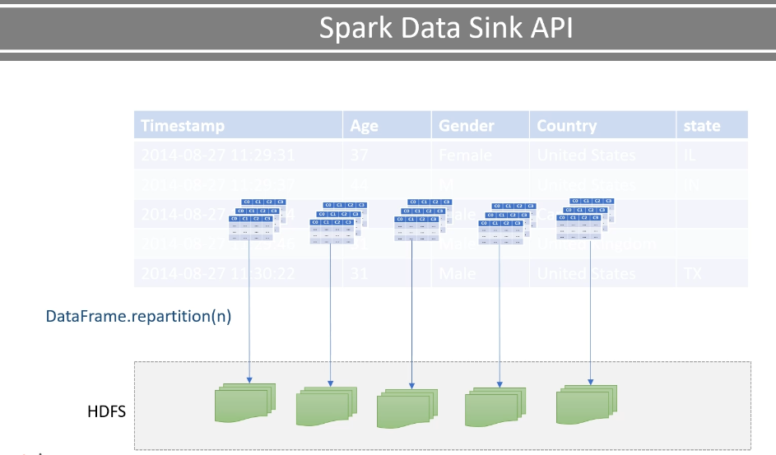

The second option is to use a partitionBy() method. The partitionBy() method will repartition your data based on a key column. You can use a single column key such as country code, or you can use a composite column key such as country code plus state code. Key-based partitioning is a powerful method to break your data logically. It also helps to improve your Spark SQL performance using the partition pruning technique.

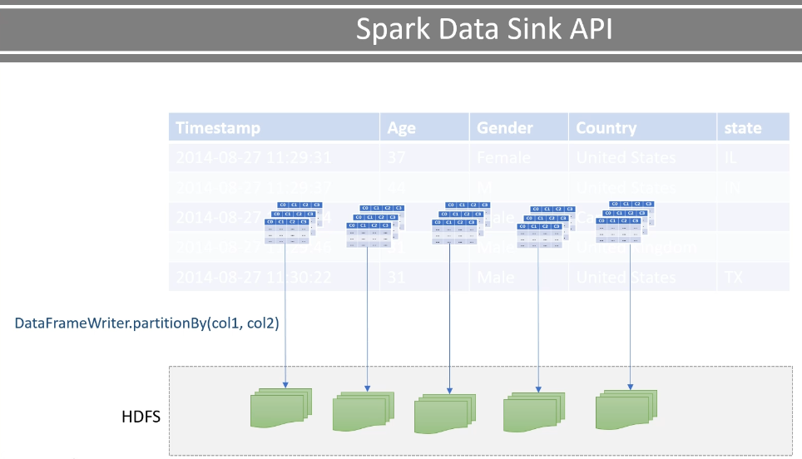

The third option is to partition your data into a fixed number of predefined buckets. And this is known as bucketing. You can use the bucketBy() method. However, the bucketBy() is only available on Spark managed tables.

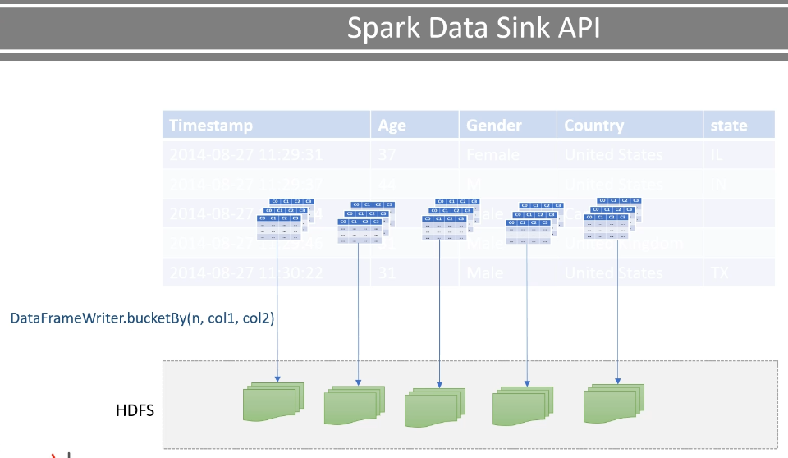

You will learn managed tables and more on bucketBy() in a separate lecture.   I will also cover partitionBy() with appropriate examples. However, as of now, you know that we have two logical partitioning options. partitionBy() and BucketBy().

We have two more suitable options to learn here. sortBy() and maxRecordsPerFile

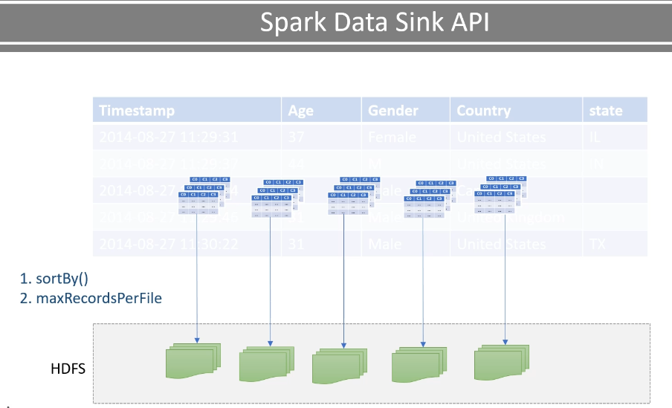

The sortBy() method is commonly used with the bucketBy(). This option allows you to create sorted buckets. I will cover it with the bucketBy() example. MaxRecordsPerFile is an option. This option allows you to limit the number of records per file. You can use this option with or without partitionBy(). Basically, the maxRecordsPerFile helps you to control the file size based on the number of records and protect you from creating huge and inefficient files. That's all for the DataFrameWriter overview. I am going to elaborate on all these things using appropriate examples in further lectures.

### Writing Your Data and Managing Layout

|  |  |
| --- | --- |
|  | In the previous lecture, we learned some basics of DataFrameWriter. In this lecture, I am going to create one example and help you understand the mechanics of using DataFrameWriter.  So, let's start. I created this new example project named DataSinkDemo. Most of the things are again copied from the earlier project.  I have this log4j.properties and the build.sbt. I have included a new dependency in this build file. We are going to create Avro output in this example, so I included it here. |

**build.sbt**

name := "DataSinkDemo"

organization := "guru.learningjournal"

version := "0.1"

scalaVersion := "2.12.10"

autoScalaLibrary := false

val sparkVersion = "3.0.0-preview2"

val sparkDependencies = Seq(

"org.apache.spark" %% "spark-core" % sparkVersion,

"org.apache.spark" %% "spark-sql" % sparkVersion,

"org.apache.spark" %% "spark-avro" % sparkVersion

)

libraryDependencies ++= sparkDependencies

Spark AVRO doesn't come bundled with Apache Spark, so I needed to include this dependency. Rest all are the same, and I have this parquet data file, which I am going to use as a data source. I have also created this DataSinkDemo object.

**DataSinkDemo.scala**

package guru.learningjournal.spark.examples

import org.apache.log4j.Logger

import org.apache.spark.sql.{SaveMode, SparkSession}

object DataSinkDemo extends Serializable {

@transient lazy val logger: Logger = Logger.getLogger(getClass.getName)

def main(args: Array[String]): Unit = {

val spark = SparkSession.builder()

.appName("Spark Schema Demo")

.master("local[3]")

.getOrCreate()

val flightTimeParquetDF = spark.read

.format("parquet")

.option("path", "dataSource/")

.load()

logger.info("Finished Partitioning.")

spark.stop()

}

}

I have the main() method, which creates a SparkSession and reads the data source. You already learned all this. Now, what do I want to do? I am not going to do any kind of data processing in this example. We will simply write this DataFrame using the DataFrameWriter API and learn the mechanics. However, in a real scenario, you will be processing your source data, and then you are going to write the output to a sink. So let's write this DataFrame as an Avro output.

partitionedDF.write

.format("avro")

.mode(SaveMode.Overwrite)

.option("path", "dataSink/avro/")

.save()

We start with the DataFrame and use the write() method to get the DataFrameWriter. Then we set the format. And then the save mode. I am going to use the overwrite mode. The next most important thing is to set the output directory path. Finally, we call the save() method. Good. We are done. What do you expect when I execute it? This code is going to create one or more Avro files in the given directory. However, before writing to the directory location, this API call is also going to clean up the target directory because we are working in overwrite mode.

The save() method in an overwrite mode is a two-step process. Clean the directory and write the new files. So, be careful while using the overwrite mode.

I have one more question. How many Avro files do you expect? One, two, or ten? Well, you already learned. It depends upon the number of DataFrame partitions. So, if this DataFrame has got five partitions, you can expect five output files, and each of those files will be written in parallel by five executers. If you have three executors and five partitions, then they are going to share the five partitions among three executors. So it could be 2+2+1. But how many partitions do I have? Let me check the number of partitions. We convert the DataFrame to an RDD and get the number.

**DataSinkDemo.scala**

package guru.learningjournal.spark.examples

import org.apache.log4j.Logger

import org.apache.spark.sql.{SaveMode, SparkSession}

object DataSinkDemo extends Serializable {

@transient lazy val logger: Logger = Logger.getLogger(getClass.getName)

def main(args: Array[String]): Unit = {

val spark = SparkSession.builder()

.appName("Spark Schema Demo")

.master("local[3]")

.getOrCreate()

val flightTimeParquetDF = spark.read

.format("parquet")

.option("path", "dataSource/")

.load()

// Number of files?

logger.info("Num Partitions before: " + flightTimeParquetDF.rdd.getNumPartitions)

logger.info("Finished Partitioning.")

spark.stop()

}

}

Let me run it. So. Here is my output directory.

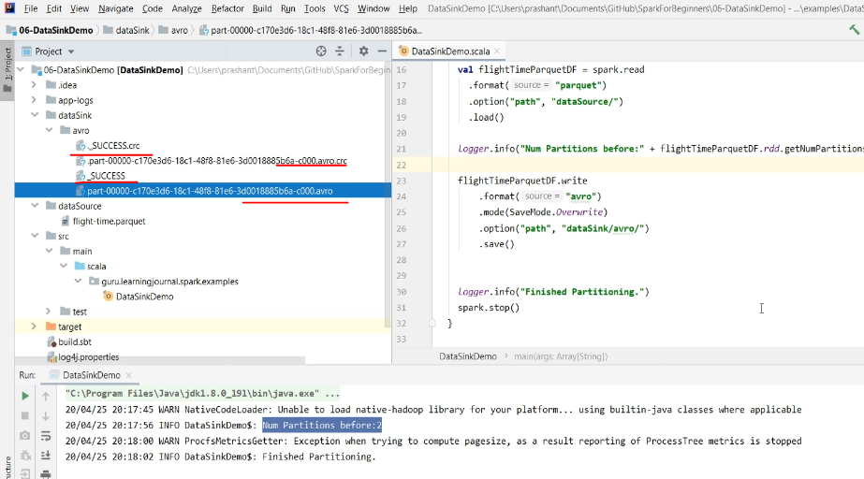

You can see three types of files here. The AVRO file is the data file. You also have this CRC file, which holds the data file checksum. And the SUCCESS file indicates that the write operation was successful. I got two partitions. However, I have only one AVRO file. So what went wrong? I was expecting two Avro files because I have two partitions here.

We have a small gotcha. We counted the number of partitions, but we do not know how many records do we have in each partition. Let me count the number of rows for the partitions. Here is the code. I am grouping the DataFrame on the partition-id and then taking a count. Simple. However, I am using a built-in function to get the partition id. So, I need to import the function.

// Number of files?

logger.info( "Num Partitions before: " + flightTimeParquetDF.rdd.getNumPartitions )

import org.apache.spark.sql.functions.spark_partition_id

flightTimeParquetDF.groupBy( spark_partition_id() ).count().show()

Let me execute it once again. So, the partition-id zero has got all the records, and we do not see any other partition-id here.

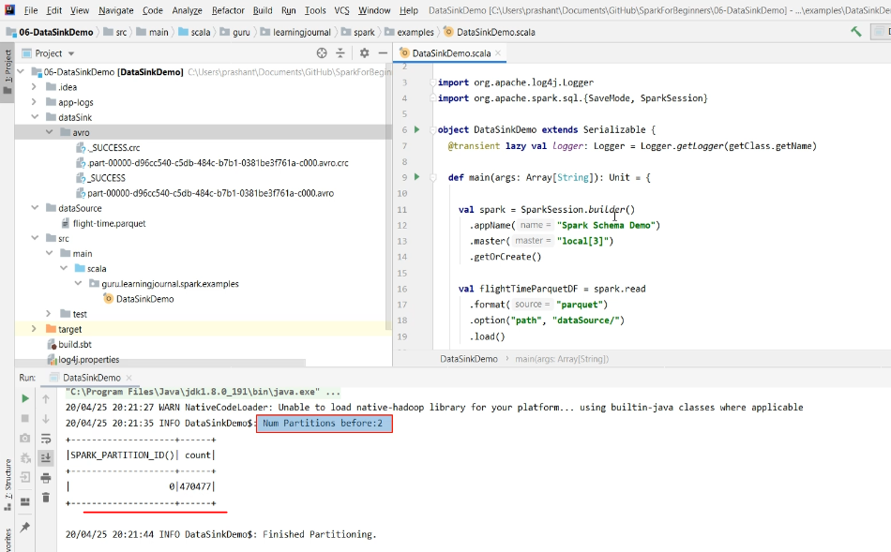

We do have two partitions, but it doesn't show up because the second partition has got nothing. And that is why I got only one output file.

package guru.learningjournal.spark.examples

import org.apache.log4j.Logger

import org.apache.spark.sql.{SaveMode, SparkSession}

object DataSinkDemo extends Serializable {

@transient lazy val *logger*: Logger = Logger.getLogger(getClass.getName)

def main(args: Array[String]): Unit = {

val spark = SparkSession.builder()

.appName("Spark Schema Demo")

.master("local[3]")

.getOrCreate()

val flightTimeParquetDF = spark.read

.format("parquet")

.option("path", "dataSource/")

.load()

//Number of files?

logger.info("Num Partitions before: " + flightTimeParquetDF.rdd.getNumPartitions)

import org.apache.spark.sql.functions.spark_partition_id

flightTimeParquetDF.groupBy(spark_partition_id()).count().show()

val partitionedDF = flightTimeParquetDF.repartition(5)

logger.info("Num Partitions after: " + partitionedDF.rdd.getNumPartitions)

partitionedDF.groupBy(spark_partition_id()).count().show()

}

Now let's repartition it and see if we get multiple files. Let me force it to make five partitions. We will again take a count. And this time, I am going to write the partitioned DataFrame. Let me Execute.

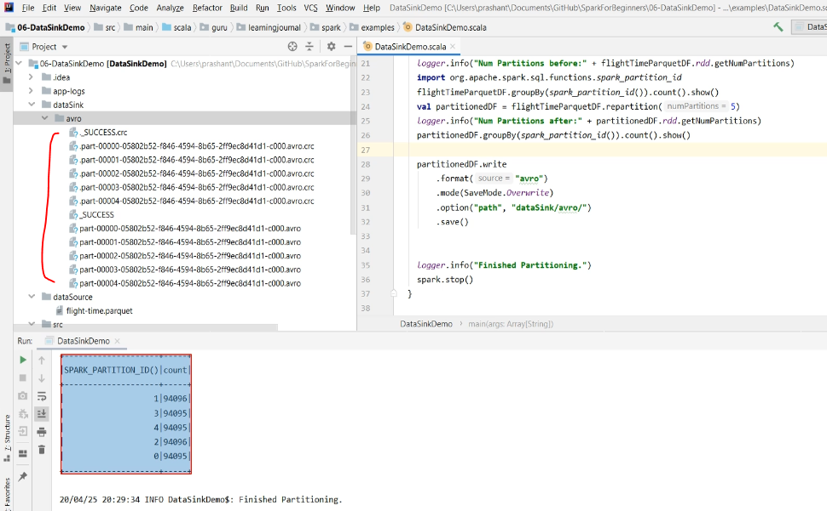

So now you can see that the repartition worked and I got five equal partitions. And I also got five output files. Simple! Isn't it. However, partitioning your data to equal chunks may not make a good sense in most of the cases. We do want to partition our data because we will be working with massive volumes. And partitioning our data might get us two types of direct benefits. Parallel Processing and Partition Elimination for certain read operations.

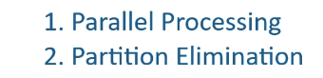

The random but equal partitions will give you parallel processing benefits. However, they do not help in partition elimination. So, you might want to partition your data for specific columns. And that is where you can use the partitionBy() method. Let's do it. I am commenting on this part of the code and going to create a new DataFrameWriter expression. This time I want to use the JSON format. We still use the overwrite mode. Specify the directory location. And finally, I want to partition the output on two columns. The first column is the flight carrier, and the second column is the flight origin.

//Partition By?

flightTimeParquetDF.write

.format("json")

.mode(SaveMode.Overwrite)

.option("path", "dataSink/json/")

.partitionBy( "OP_CARRIER", "ORIGIN")

.save()

logger.info("Finished Partitioning.")

spark.stop()

So what do you expect now? The DataFrameWriter will partition this DataFrame using these two columns. What does it mean? Let me execute it, and then I will explain. Well, repartitioning on a given column requires shuffling all the records. So, it is going to take some time. Done. Let's look at the output directory.

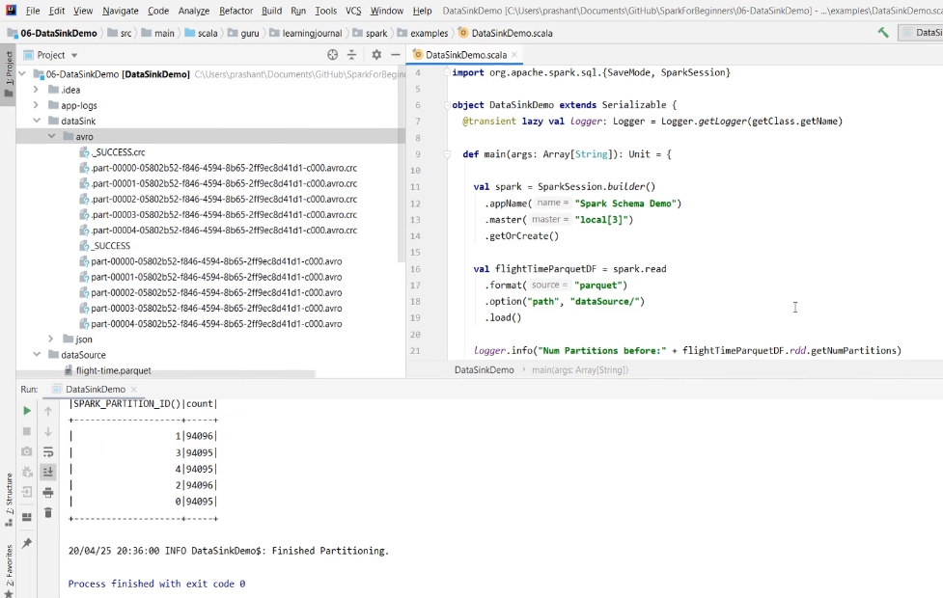

So, my dataset had ten different flight carriers. And I got one directory for each carrier.

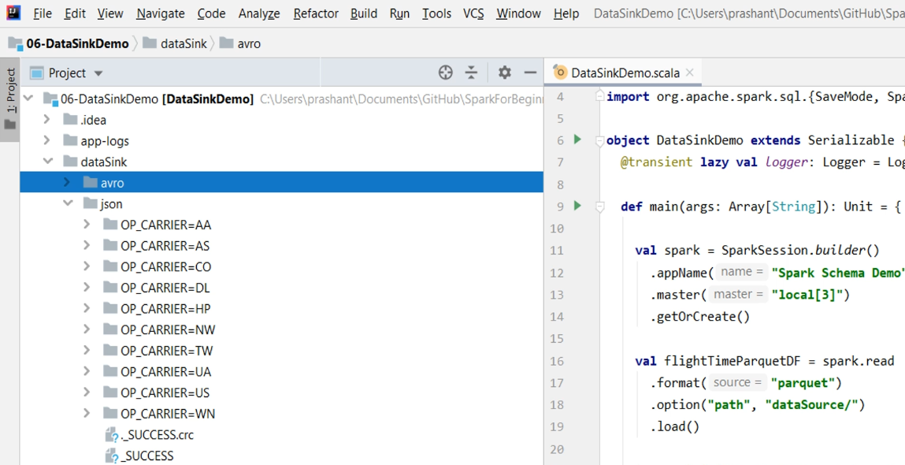

Now, if you are reading this dataset and want to filter it only for one carrier such as HP. Then your Spark SQL engine can optimize this read and filter operation, ignoring other directories and only reading the HP directory. Now let's go inside one of these directories. So we have a second level of directories. And this is caused by the second column in the partitionBy() method. So, The carrier AA has got these many origins.

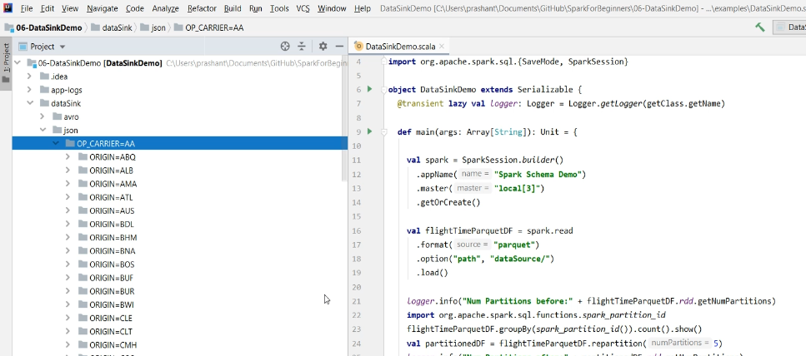

And each origin becomes a subdirectory. If you go inside these directories, then you will see the data file.

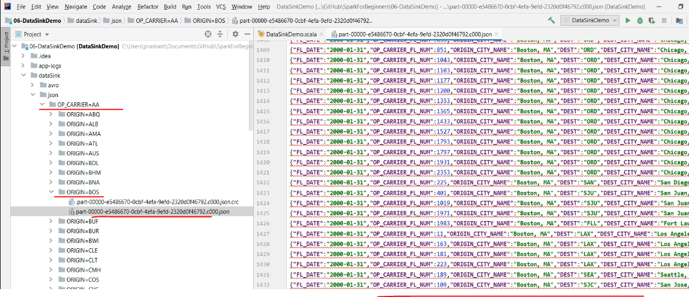

So the point is straight. Your data is partitioned by the unique combination of your partition columns. And these partitions are written down in a separate directory. Each data file in these directories will hold data only for the given combination. For example, this data file contains 1400 plus records, and all these records are for carrier=AA and origin=BOS. In fact, those two columns are not even recorded in the data file. Because that would be redundant information. If you look at the directory name, these are named as carrier=AA, and origin=BOS and these two columns are removed from the data file.

We played with a small data source of nearly 400K records. After partitioning them on these two columns, I got files that could be of reasonable size, and I am not expecting a too large file here. Let me show you. So my largest data file is roughly 4 MB. And this one is created for OP_CAREER=DL and ORIGIN=ATL. In fact, a 4MB file is too small for Spark. In real scenarios, you should have a much larger file. I prefer managing file sizes between 500 MB to a couple of GBs.

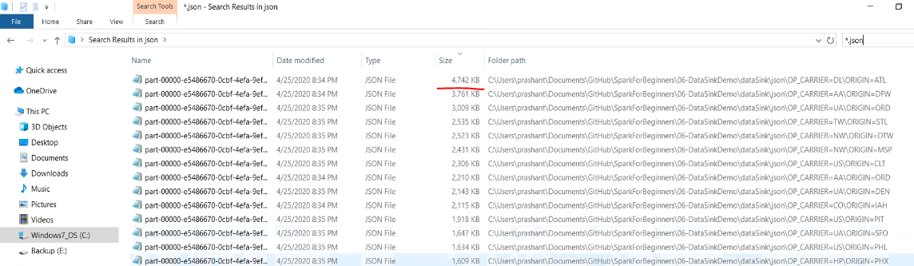

Not too big and not too small. But how can you control the file size here? You learned it already. maxRecordsPerFile. Let me apply that option. I am going to limit the file for 10K records only. But before we rerun, let's look at the largest file once. So, I am going to OP_CAREER=DL and ORIGIN=ATL. We have this one data file here, and it contains approximately 19K records.

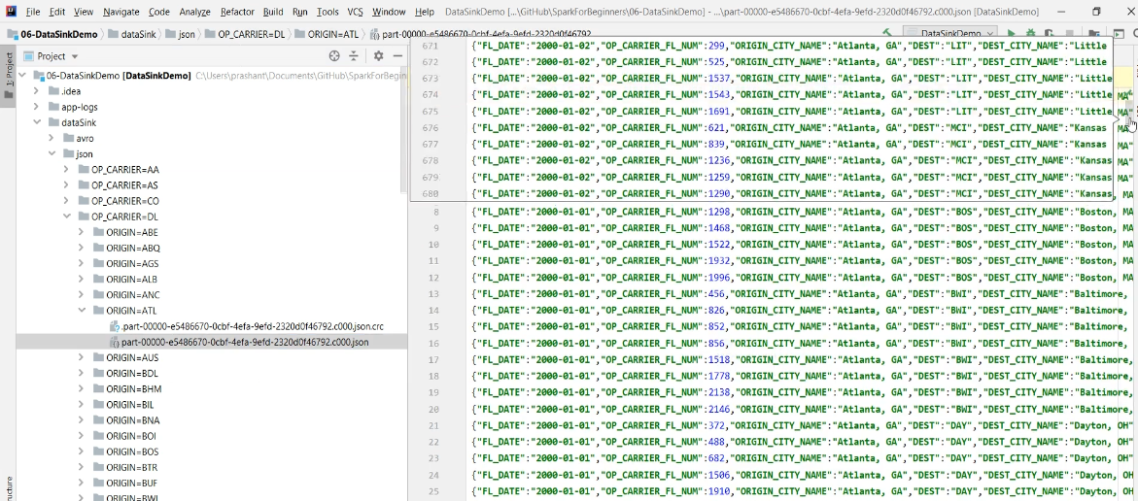

With this new maxRecordsPerFile option, I am expecting this file to split.

//Partition By?

flightTimeParquetDF.write

.format("json")

.mode(SaveMode.Overwrite)

.option("path", "dataSink/json/")

.partitionBy( "OP_CARRIER", "ORIGIN")

.option("maxRecordsPerFile", 10000)

.save()

Let's run it. Done. Let me check.

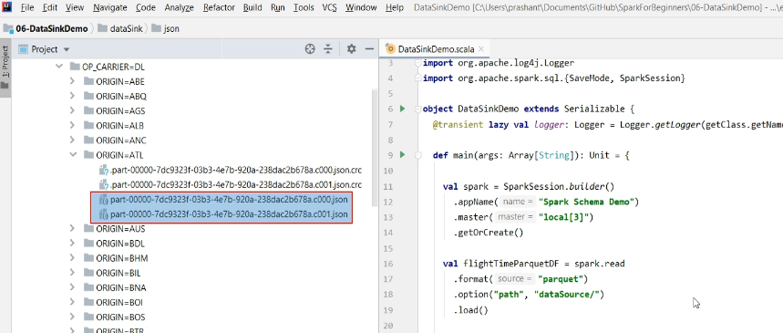

So you can see two data files. So we learned the following things in this video. How to write your data frame. And you can choose whatever format you prefer. However, the parquet is the recommendation.

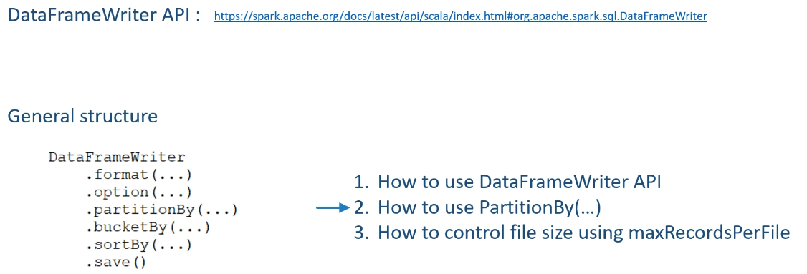

We also learned to partition the data and organize your output files the way it makes more sense for your use cases. We also learned to control the file size from growing too big.

### Spark Databases and Tables

In the earlier lectures, you learned about working with file-based data sources and sinks. In this lecture, we are going to learn about the Spark Database and Tables. So, let's start. Apache Spark is not only a set of APIs and a processing engine. It is a database in itself. So you can create a database in Spark. Once you have a database, you can create database tables and views. These tables and views reside inside your database. What does it mean?

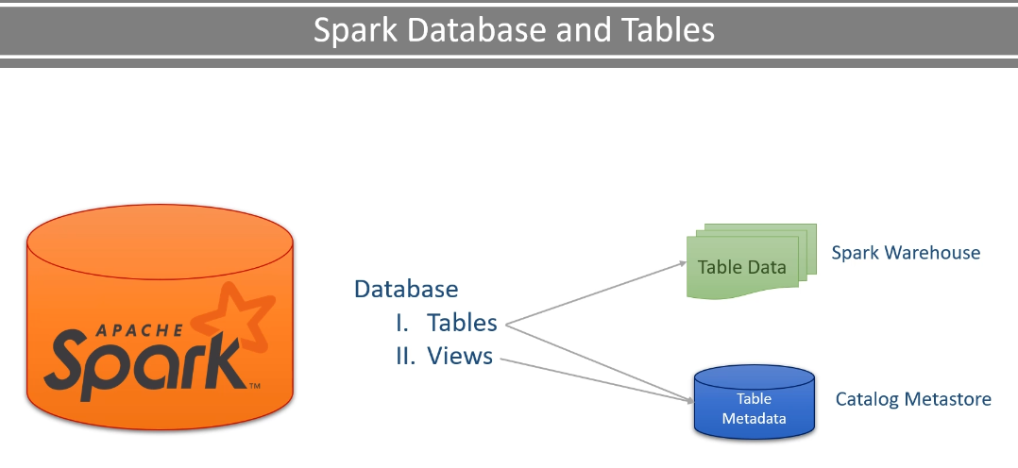

Well, the table has got two parts. Table Data and Table Metadata The table data still resides as data files in your distributed storage. However, you can control the file type. However, you can control the file type. The metadata is stored in a meta-store called **catalog**. The meta-store holds the information about the table and its data, such as schema, table name, database name, column names, partitions, the physical location where the actual data resides. All of this is stored in a central meta-store called catalog. By default, Spark comes with an in-memory catalog which is maintained per spark session. However, this information goes away when the session ends. So, we needed a persistent and durable meta-store. Spark decided to reuse the Apache Hive meta-store. We will see all this in an example. Now let's come back to the Spark Tables. Spark allows you to create two types of tables **Managed Tables** and **Unmanaged Tables (External Tables)**

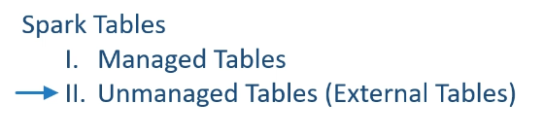

For managed tables, Spark manages both: the metadata and the data. What does it mean? Well, that's simple. If you create a managed table, then the Spark is going to do two things. Create and store metadata about the table in the meta-store. Then Spark is going to write the data inside a predefined directory location.

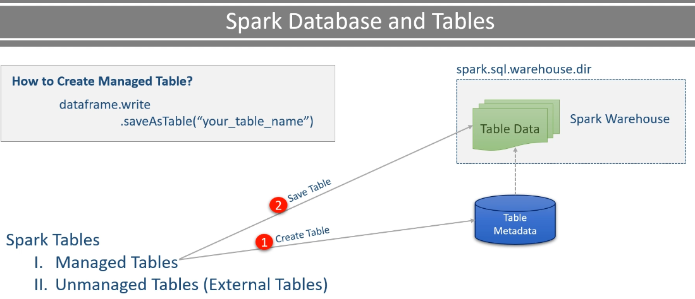

This directory is known as the spark.sql.warehouse.dir. So the spark.sql.warehouse.dir is the base location where all your managed tables are stored. And your cluster admin is going to set this base directory location for you. You cannot and should not change it at runtime. I will show you this as well in the example. Now let's come to the unmanaged tables. They are also the same with respect to the metadata. However, they are different in terms of data storage location. Let me explain. When you create an unmanaged table, the Spark is going to do only one thing. It will create metadata for your table and store it in the meta-store. That's all. However, when you create an unmanaged table, then you must specify the data directory location for your table.

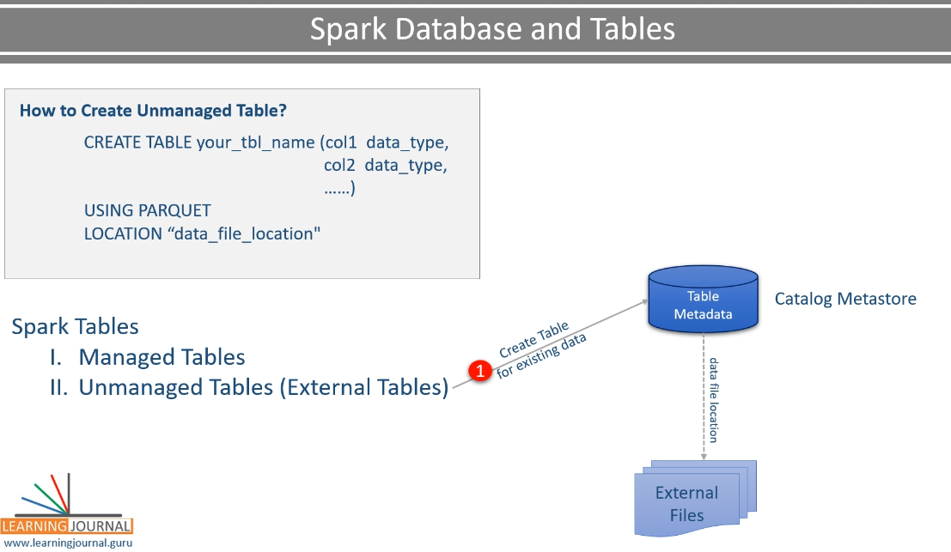

You do not have this facility with the managed table. Why? Because the managed table must be stored inside the warehouse directory. However, unmanaged tables are to give you the flexibility to store your data at your preferred location.

Think of it like this. You already have some data. It is stored at some directory location. And you want to use Spark SQL statements on this dataset, such as select count(*) from ...whatever.

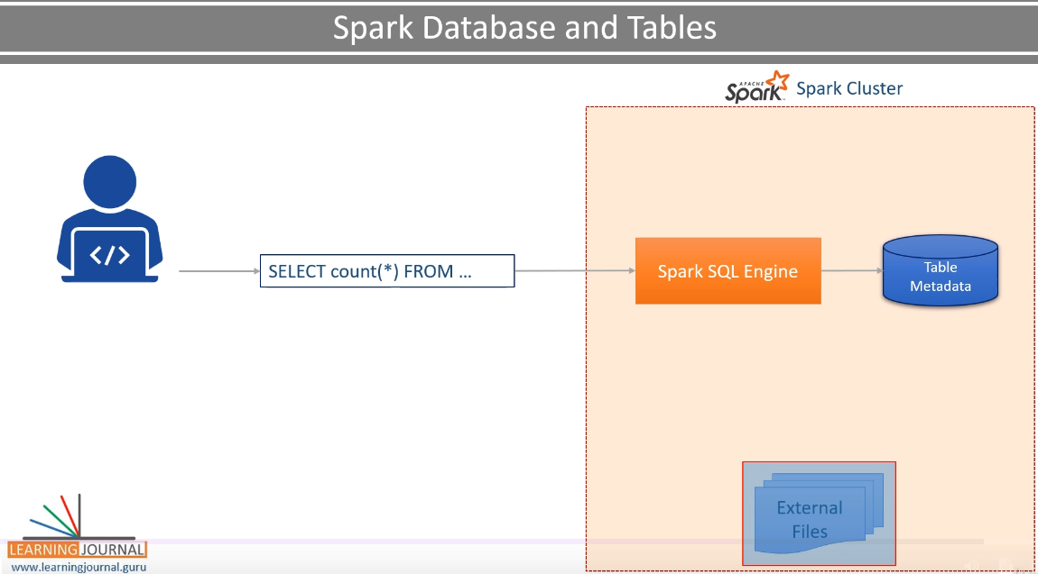

* However, Spark SQL Engine doesn't know anything about this data. So, you can create an unmanaged table and map the same data to a Spark Table.

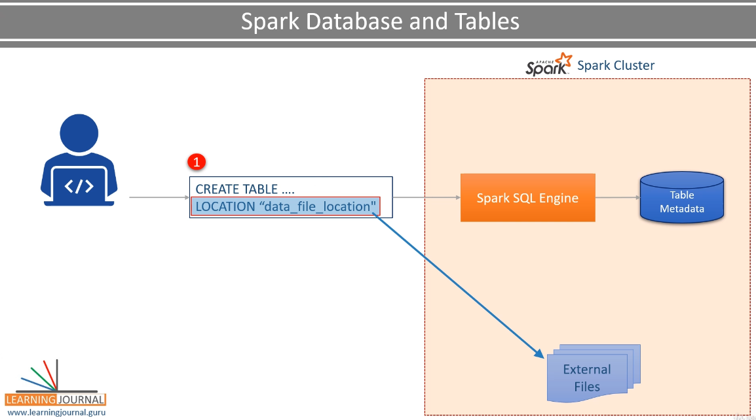

* Now, Spark will create metadata and store it. This will allow you to run your Spark SQL statements on this data.

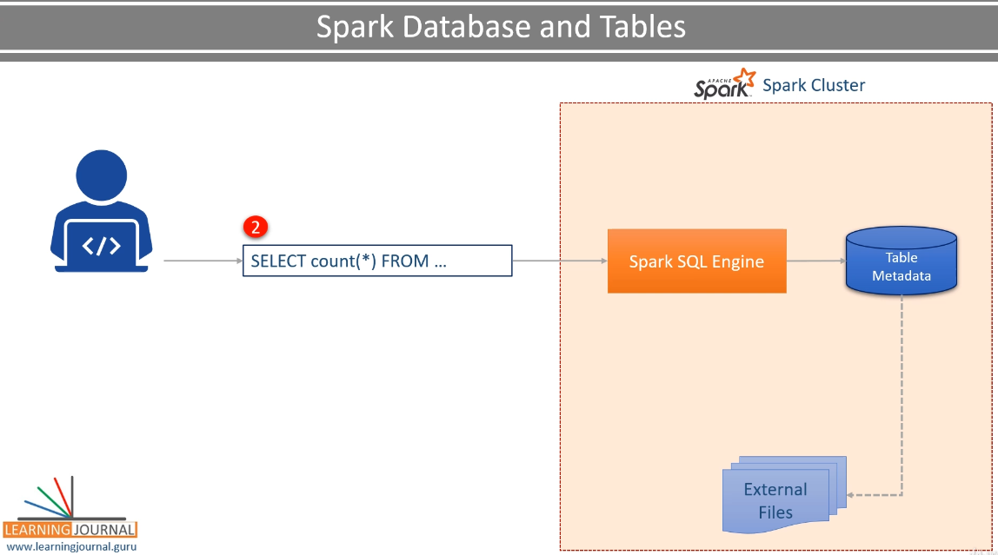

* As a side effect, if you drop your managed table, Spark is going to delete the metadata and the data as well.

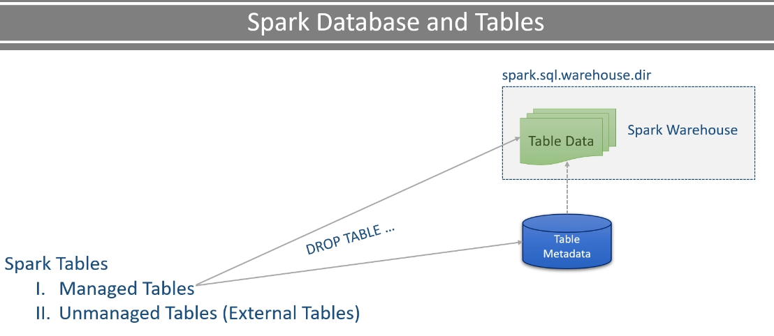

* If you drop an unmanaged table, then Spark is going to remove the metadata and do not touch the data files.

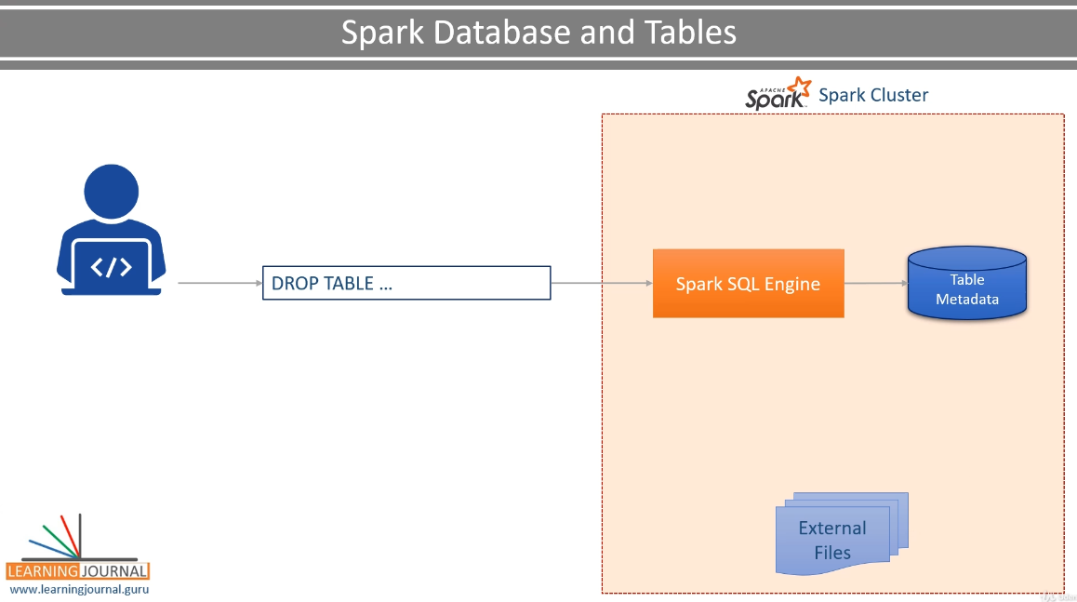

And that makes sense as well. Because the unmanaged tables are designed for temporarily mapping your existing data and using it in Spark SQL. Once you are done using it, drop them, and only metadata goes off, leaving your data files untouched. We prefer using managed tables because they offer some additional features such as bucketing and sorting.

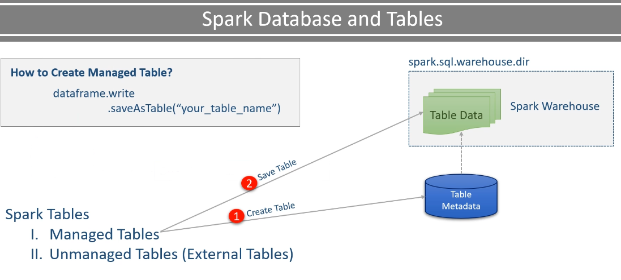

All the future improvements in Spark SQL will also target managed tables. Unmanaged tables are external tables, and Spark does not have enough control over them. They are designed for reusing the existing data in Spark SQL, and it should be used in those scenarios only. That's all for this video. In the next video, we will programmatically create a managed table, access the catalog, and also learn to implement bucketing.

### Working with Spark SQL Tables

In this video, we are going to learn to create a managed table and access the catalog. So let's start. I have created this SparkSQLTableDemo example. Most of the things are the same as the earlier example.

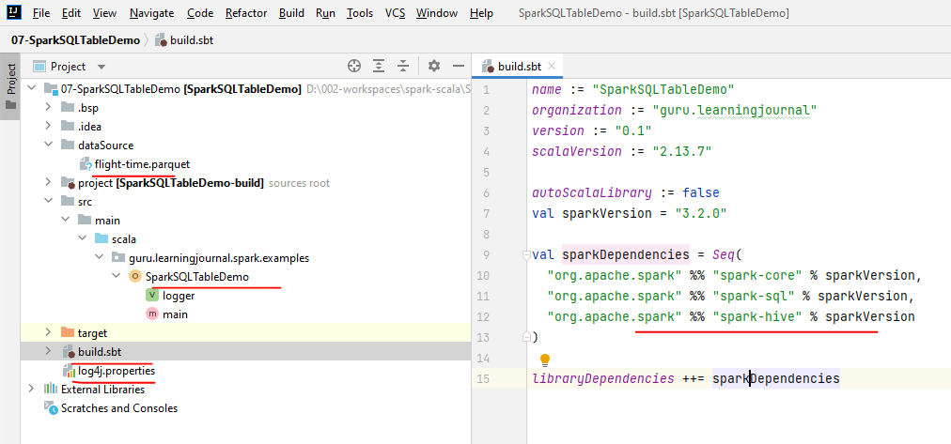

However, I have added spark-hive as an additional dependency. We are going to create a managed table in the apache spark. Creating managed tables is going to need persistent Metastore. We already learned that the Spark depends on HIve Metastore. So, we need spark-hive for this example. I also created this SparkSQLTableDemo object and the main() method. I am creating SparkSession and loading this DataFrame.

package guru.learningjournal.spark.examples

import org.apache.log4j.Logger

import org.apache.spark.sql.{SaveMode, SparkSession}

object SparkSQLTableDemo extends Serializable {

@transient lazy val *logger*: Logger = Logger.*getLogger*(getClass.getName)

def main(args: Array[String]): Unit = {

val spark = SparkSession.builder()

.appName("Spark SQL Table Demo")

.master("local[3]")

.enableHiveSupport()

.getOrCreate()

val flightTimeParquetDF = spark.read

.format("parquet")

.option("path", "dataSource/")

.load()

logger.info("Finished.")

spark.stop()

}

You already learned all this. We want to use the Hive Metastore, so I am going to enable hive support. This is needed to allow the connectivity to a persistent Hive Metastore.

So we are now ready to start working on this example. What do I want to do? I want to do one simple thing here. Create a managed table and save my DataFrame to the Spark Table. Well, In a real scenario, you will process your data and save the output DataFrame. However, for simplicity, I am not doing any processing here. I just want to learn the mechanics of saving a DataFrame to a Spark Managed table. However, one question still stands? Why do I want to save my DataFrame as a Managed Table?

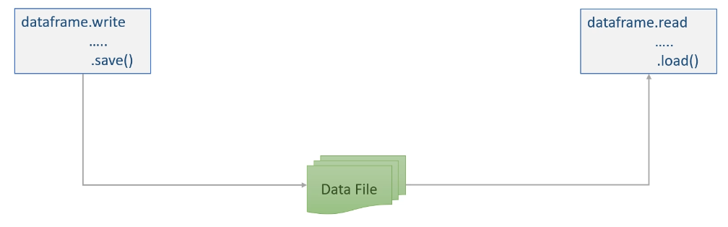

Why not as a parquet file. What is the difference? Let me explain. You can save your processed data to a data file such as Parquet or Avro. However, if you want to reaccess it, then you must use the DataFrame Reader API and read it as a DataFrame. However, Spark is a database also.

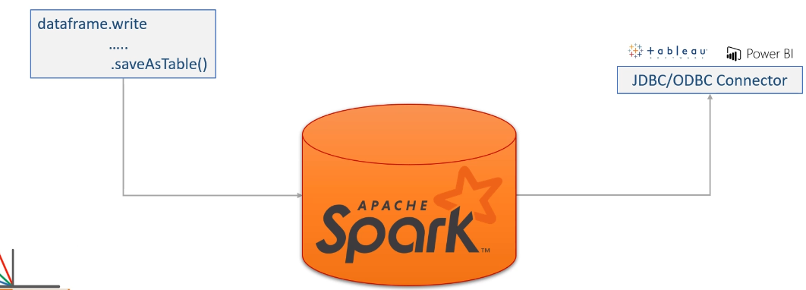

So if you create a managed table in a Spark database, then your data is available to a whole lot of other SQL compliant tools. Spark database tables can be accessed using SQL expressions over JDBC/ODBC connectors. So, you can use other third-party tools such as Tableau, Talend, PowerBI, and a whole bunch of other tools. However, plain data files such as Parquet, Avro, JSON, CSV, etc. are not accessible through JDBC/ODBC interface. So, let's do it.

Writing a DataFrame is as simple as using the DataFrame.write() method. Set the save mode. And finally, saveAsTable(). The saveAsTable() method takes the table name, and it creates a managed table in the current spark database. But what is the current Spark Database? Apache Spark comes with one default database. The database name itself is the default. So, the SaveAsTable() is going to create my flight_data_tbl in the default database. However, I wanted to create this table in the AIRLINE_DB. How to do it? You have two options. Prefix the database name with your table name. Simple. Isn't it? The second option is to access the catalog and set the current database for this session. So I can safely remove the database name from here. We are all set. I am assuming that the AIRLINE_DB already exists. But to be on the safer side, let me create it here.

import spark.sql

spark.sql("CREATE DATABASE IF NOT EXISTS AIRLINE_DB")

spark.catalog.setCurrentDatabase("AIRLINE_DB")

flightTimeParquetDF.write

.mode(SaveMode.Overwrite)

.saveAsTable("~~AIRLINE_DB.~~flight_data")

I want to do one thing. The catalog gives you access to the whole bunch of metadata information.

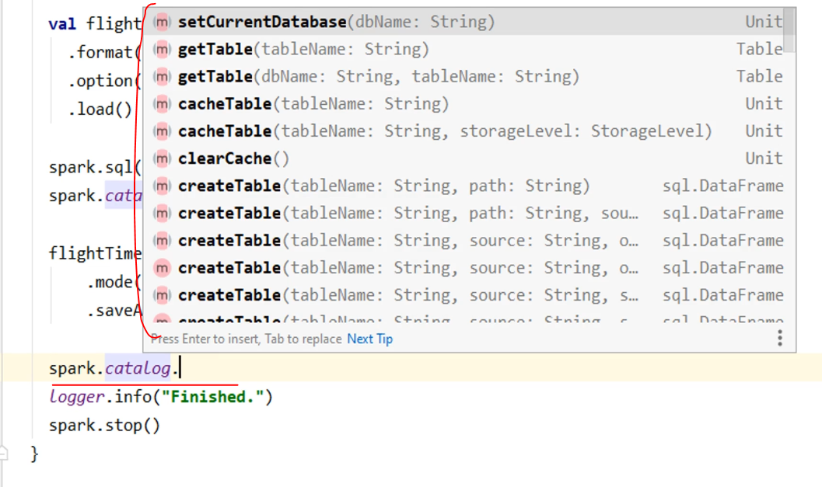

Let me use it to get a list of all the tables in my AIRLINE_DB. Good. Let me run it and show you some essential things. You can see the catalog information here.

spark.catalog.listTables( "AIRLINE_DB" ).show()

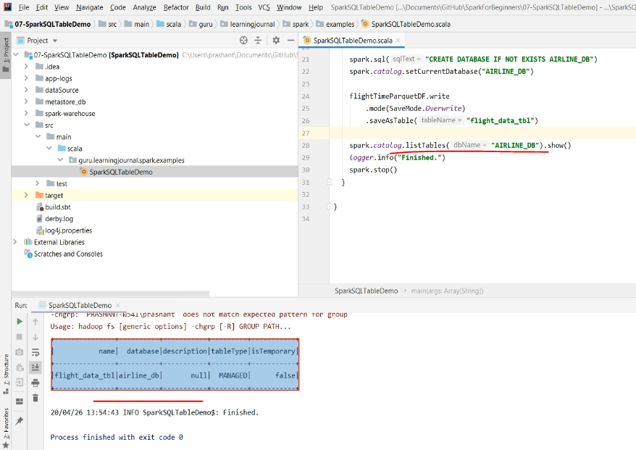

It shows you the table name, database name, and the table type as well. Do you notice these two directories? This one the spark.sql.warehouse.dir. If you look inside, you will see a base directory for your database. Then you will see another subdirectory for the table. And inside your table, you have your data file.

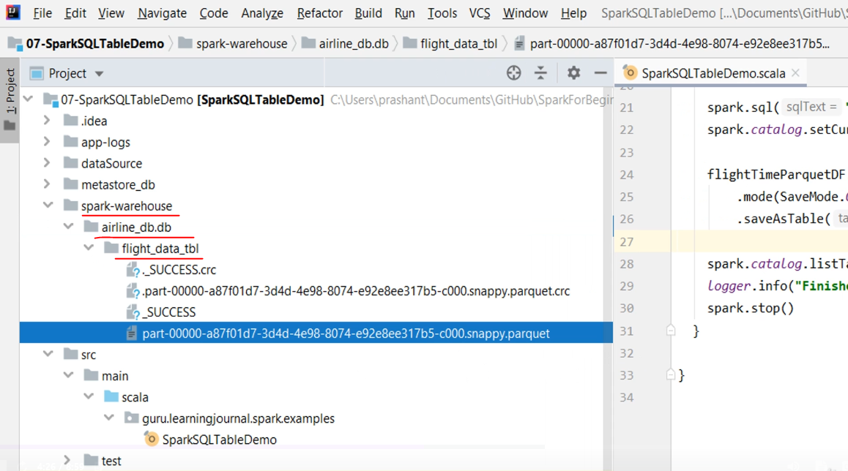

The next one is your persistent metadata store. When you are running in a local machine, these things are created in your current directory. However, in your cluster environment, both of these are configured by your cluster admin. And it would be a common location across all the Spark applications.

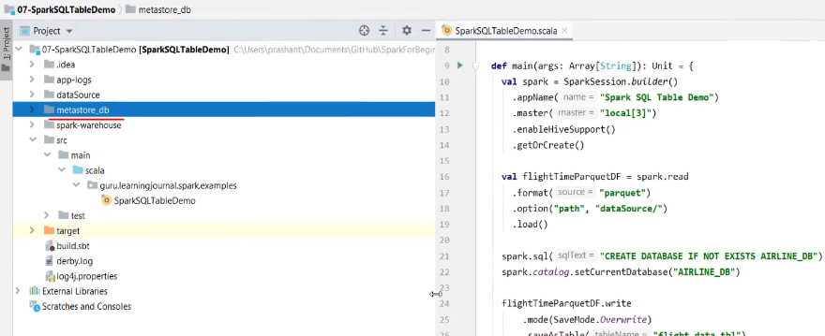

So I created a Spark SQL table. However, I wanted to create a partitioned table. So let me add a partitionBy() method. You already learned it earlier.

val spark = SparkSession.*builder*()

.appName("Spark SQL Table Demo")

.master("local[3]")

.partitionBy("ORIGIN", "OP_CARRIER")

.enableHiveSupport()

.getOrCreate()

I am using two columns to partition my table. Let me re-run it. So I have overwritten this plain table with a partitioned table. However, I got these 200+ partitions. And this happens because I have 200+ different origins.

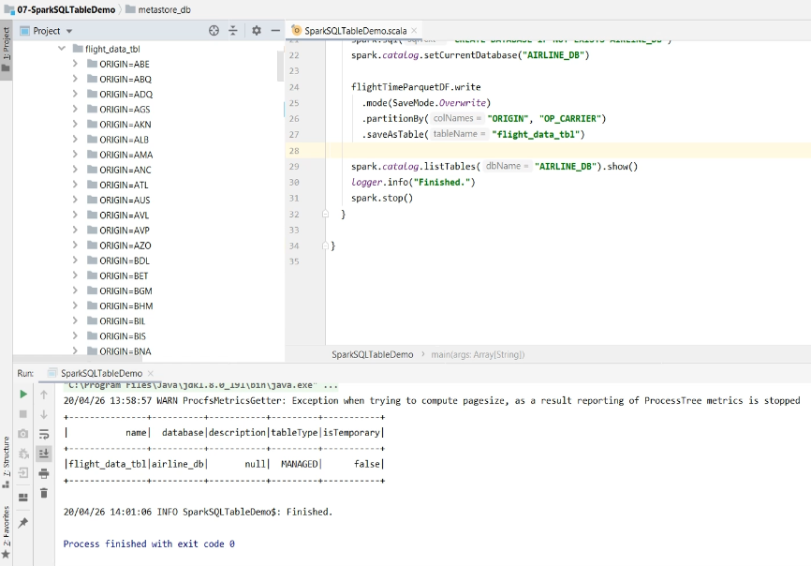

For a large dataset, these 200+ partitions are still fine. However, what if I had 100K unique values for my partition column. Do you want to create 100K partitions? Absolutely not. So, you should not be partitioning your data for a column that has got too many unique values. Instead, you can use the bucketBy(). Let me do it.

flightTimeParquetDF.write

.mode(SaveMode.Overwrite)

.format("csv")

//.partitionBy("ORIGIN", "OP_CARRIER")

.bucketBy(5, "ORIGIN", "OP_CARRIER")

.saveAsTable("MY_DB.flight_data")

spark.catalog.listTables("MY_DB").show()

logger.info("Finished.")

spark.stop()

The bucketBy() allows you to restrict the number of partitions. I am limiting it to 5. So, these five partitions are now called **buckets**. And I still want to partition my data using the same two columns. I am changing the format to CSV. Parquet is a binary format, and it is the recommended format. However, I want to manually investigate the data, so I am changing it to CSV. Let me run it and see what happens.

So now, I got five data files. These are my five partitions or buckets, whatever you call it. The bucketing does not require a lengthy directory structure. It is as simple as data files. But how it happened?

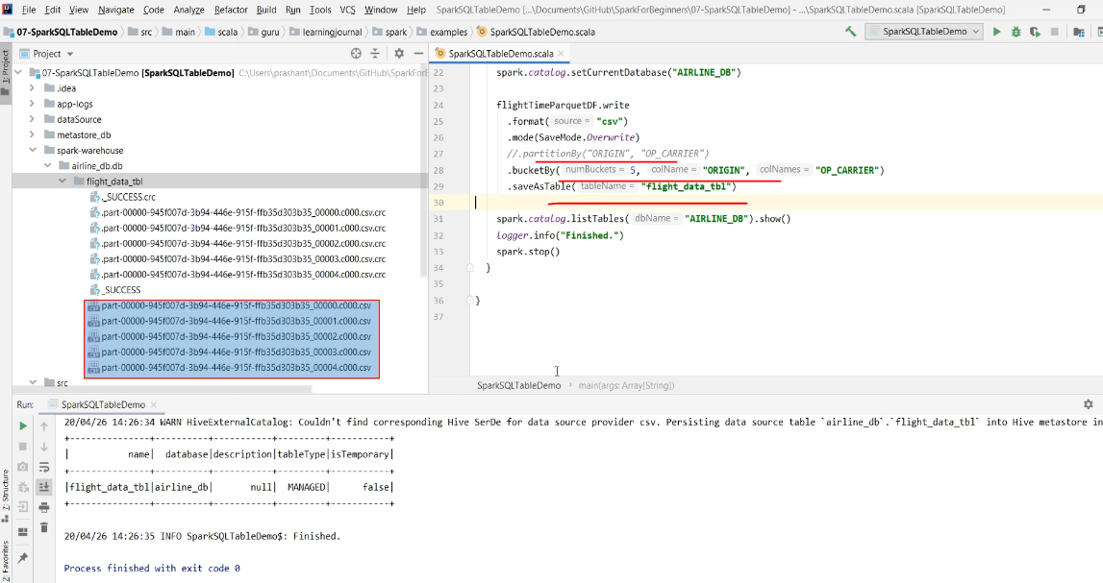

Let me explain. I asked to create five buckets. So Spark created five files. Each file is one bucket. Now Spark will read one record, look at the key column values. In my case, it is the OP_CARRIER+ORIGIN. Now compute the hash value. Let's say you got some hash number. Divide it by five and take the remainder. You are going to get something between 0 to 4. If the remainder is 0, place the record in the first file. If you got 1, put it in the second file and so on.

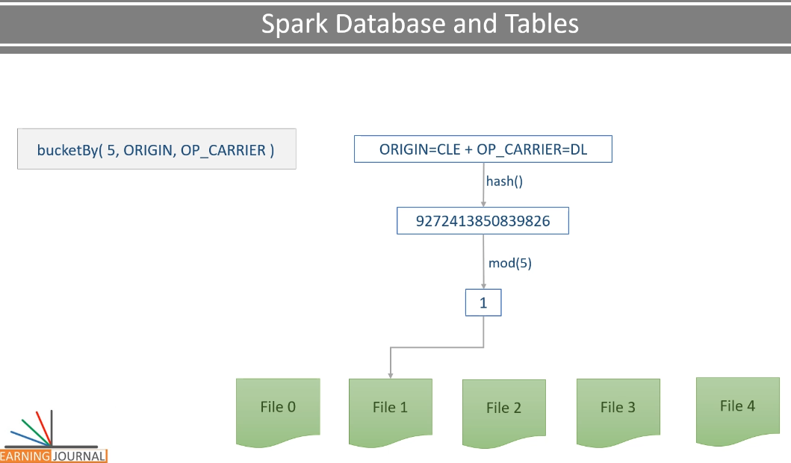

Well, this is the simplest form of the hashing. There are other variations for hashing, but the basic principle is the same. So you now understand the bucketing. As an end result, each unique key combination is going to produce the same hash value, and hence it is going to land in the same file. Let me show you. So, all the records for the OP_CARRIER=DL and ORIGIN=CLE will land in the first file only.

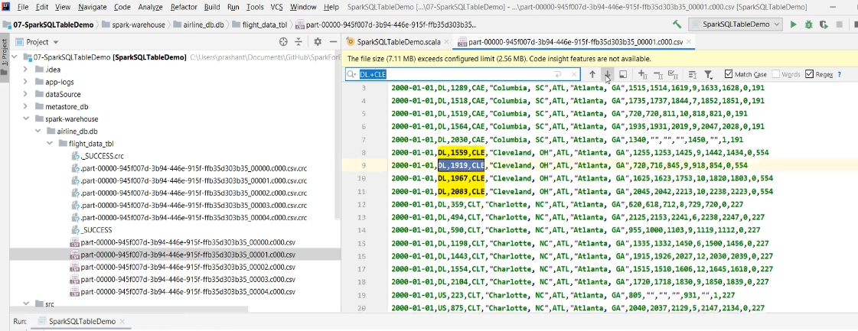

You will not find this combination in any other bucket. Sometimes, these buckets can improve your join operations significantly. However, if these records are sorted, they could be much more ready to use for certain operations. So the bucketBy() can also have a sortBy() companion.

package guru.learningjournal.spark.examples

import org.apache.log4j.Logger

import org.apache.spark.sql.{SaveMode, SparkSession}

object SparkSQLTableDemo extends Serializable {

@transient lazy val logger: Logger = Logger.getLogger(getClass.getName)

def main(args: Array[String]): Unit = {

val spark = SparkSession.builder()

.appName("Spark SQL Table Demo")

.master("local[3]")

.enableHiveSupport()

.getOrCreate()

val flightTimeParquetDF = spark.read

.format("parquet")

.option("path", "dataSource/")

.load()

import spark.sql

sql("CREATE DATABASE IF NOT EXISTS MY_DB")

sql("USE MY_DB")

flightTimeParquetDF.write

.mode(SaveMode.Overwrite)

.format("csv")

//.partitionBy("ORIGIN", "OP_CARRIER")

.bucketBy(5, "ORIGIN", "OP_CARRIER")

.sortBy("ORIGIN", "OP_CARRIER")

.saveAsTable("MY_DB.flight_data")

spark.catalog.listTables("MY_DB").show()

logger.info("Finished.")

spark.stop()

}

}

Let me rerun it once again. Good! Now, if you look at these files, they are sorted by the same columns.

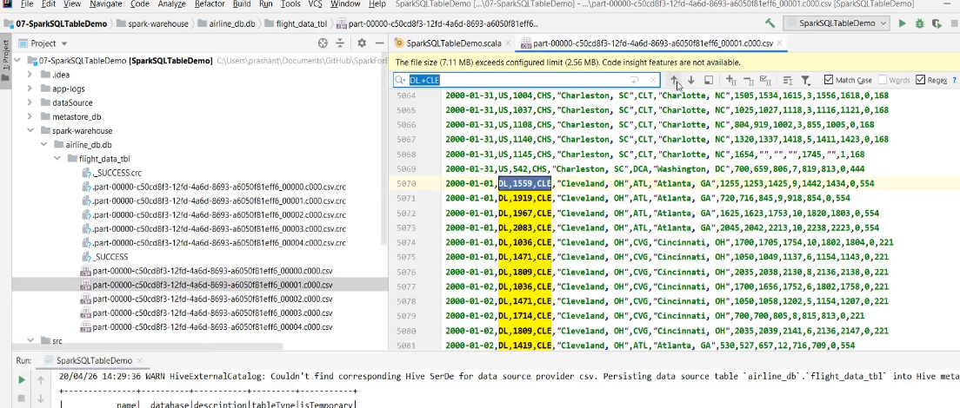

So you learned to create bucketed, sorted, and spark managed tables.

## Spark Dataframe and DataSet Transformations

### Data Transformation

So far, in this course, we covered a lot of things about Apache Spark. However, the whole point of Data Engineering in Apache Spark is to be able to read the data, apply a series of transformations, and write it back for consumption.

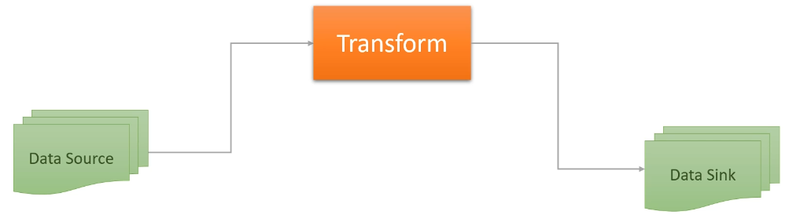

We already learned about reading and writing. And we dedicate this section to talk about the transformations. So, let's start with the most basic question. What do we mean by transformations? I am not going to define this term. We will try to get a general sense of it. So, In Spark, we read the data and create one of the two things.

|  |  |
| --- | --- |
|  | DataFrames and Database Tables Both of these are the same but two different interfaces. The DataFrame is the programmatic interface for your data, and the database table is the SQL interface of your data. Now when we talk about the transformations, we again have two approaches. A programmatic approach that we apply on DataFrames. |

SQL expressions that we can use on the Database Tables. SQL is straightforward. And I am assuming you already know it. However, we need to learn the programmatic approach for doing similar things, which you can easily do using the SQL expressions And then we can take it to the next level where you have more flexibility in your hand to go beyond the straightforward SQL expressions. So we again come back to the initial question. What do we mean by transformations? Here is the list to answer this question.

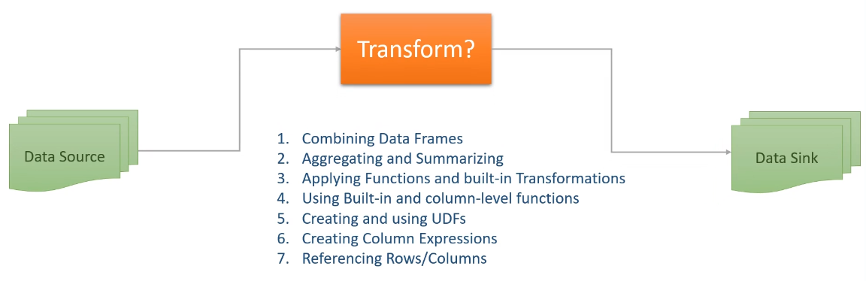

1. Combining one or more DataFrames using operations such as Join and Union
2. Aggregating and summarizing your DataFrames using operations such as grouping, windowing, and rollups
3. Applying functions and built-in transformations on your DataFrame such as filtering, sorting, splitting, sampling, and finding unique.
4. Using and implementing built-in functions, column-level functions, and user-defined functions
5. Creating and using UDFs
6. Creating Column Expressions
7. Referencing Rows/Columns and creating custom expressions

With these capabilities in your hand, you should be able to cover most of your transformation requirements. And that's what we are going to cover in this section. I have listed these things in the top-down order. However, we will be learning them in the bottom-up order.

### Working with DataFrame Rows

Data transformation is all about playing with your DataFrame rows and columns. However, working with a row and column is not that straightforward. In this video, I am going to take you a little deeper into the rows, and we will talk about the columns in the upcoming lecture. So, let's start. Spark DataFrame is a Dataset[Row]. And each row in a DataFrame is a single record represented by an object of type Row. Most of the time, you do not directly work with the entire row.

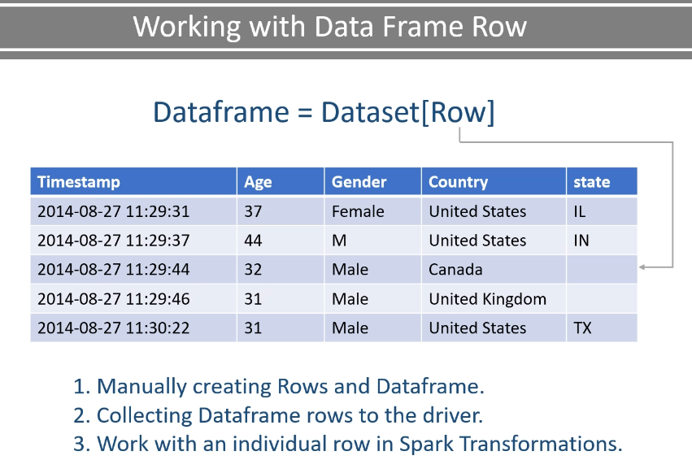

However, we have three specific scenarios when you might have to work with the Row object. Here are them. Manually creating Rows and DataFrame. Collecting DataFrame rows to the driver. Work with an individual row in Spark Transformations. The first two scenarios are mostly used in unit testing or during development. Let me explain with a simple example. However, I want to use the DataBricks cloud for doing this.

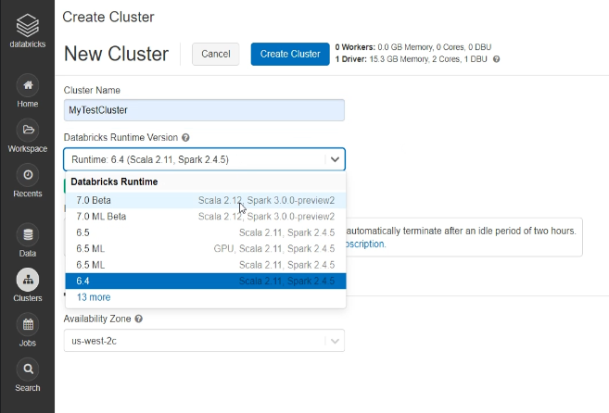

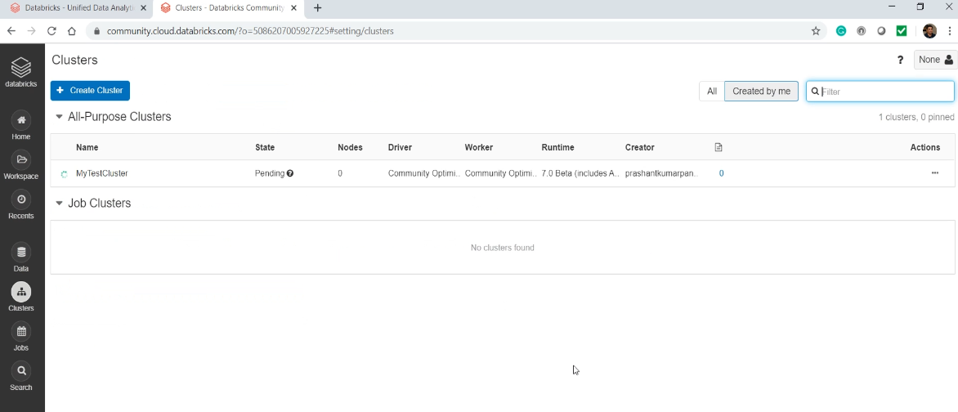

Why DataBricks Cloud? Well, I want you to be a little more familiar with the DataBricks Cloud environment. No other specific reason. We already learned to create a DataBricks Community Cloud account. Login to your DataBricks Cloud account and create a new cluster. Give a name to your cluster, select your Spark Version, and create it. Good. Now you need a notebook. Let me create a new notebook. Give a name to your notebook. Select your preferred language and create it.

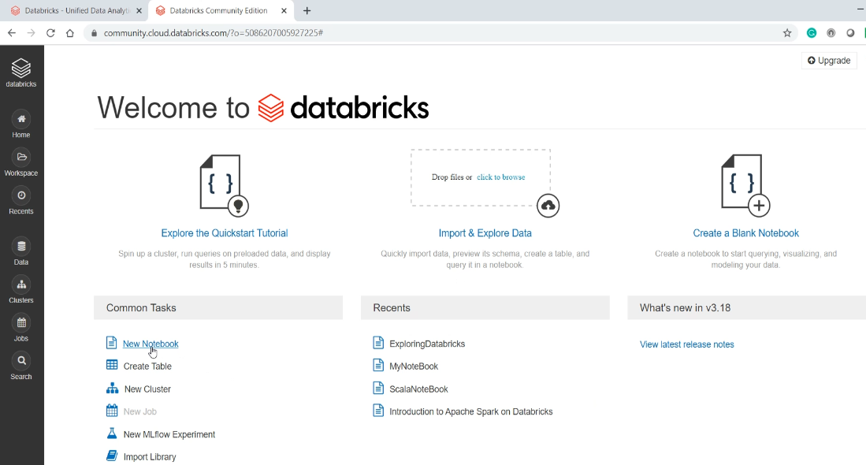

Now I am ready to write some code and run it from here. Let's assume I am a spark developer, and I created a function. Here it is.

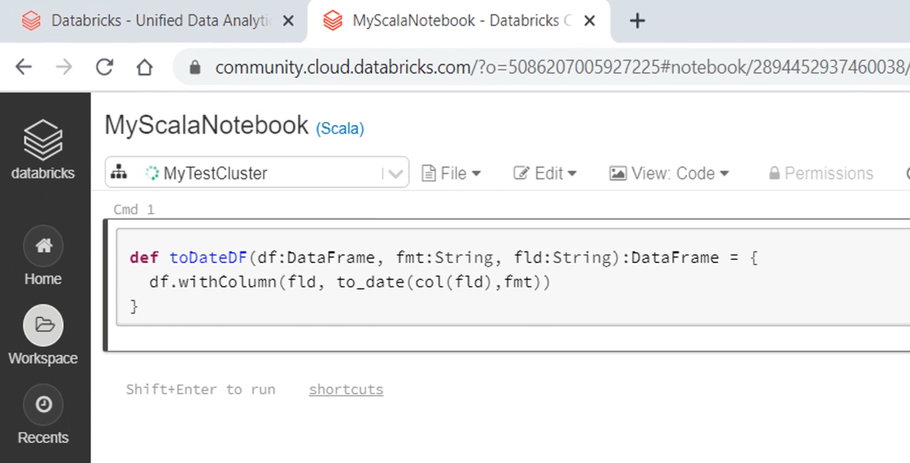

This function takes a DataFrame, date format string, and a field name. Then it simply returns a new DataFrame converting the type of the field using a given date format. So, let's assume that the input DataFrame is something like this. And the output DataFrame is expected to be like this.

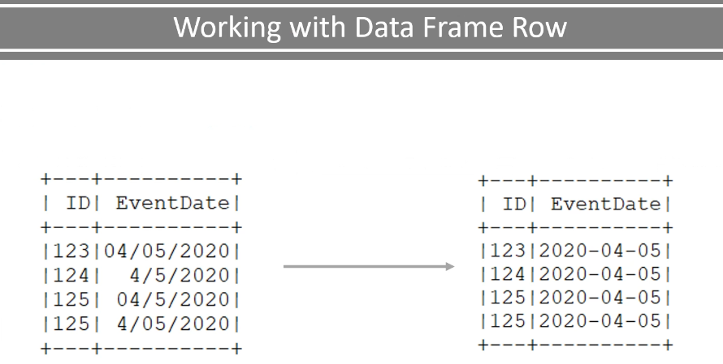

The data type of the EventDate is a string, which is converted to a DateType in the output DataFrame. Now I want to test my function if it works well. Let me import some necessary packages. Your IDE is good at automatically importing things. However, you must take care of these things while working with the Notebooks. Here is my function.

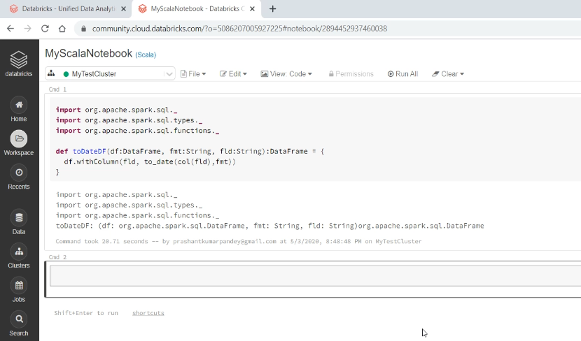

How do I test it? I need a DataFrame so I can pass it here and test it. One approach is to create a data file with some sample data. Then you can load it here to create your DataFrame and use that DataFrame to test your function. However, this approach of loading a DataFrame from a file and executing your test cases has got the following problems. A large project might need hundreds of small sample data files to test your functions. This could be difficult to manage over some time.



Your build pipeline might run slow due to loading hundreds of sample files and increased I/O. The point is straight. You will be using sample data files for testing your application. However, we prefer to use a well crafted and limited number of sample data files to check some of the critical business scenarios. However, for testing such functions, we are going to create a DataFrame on the fly. Let's do it.

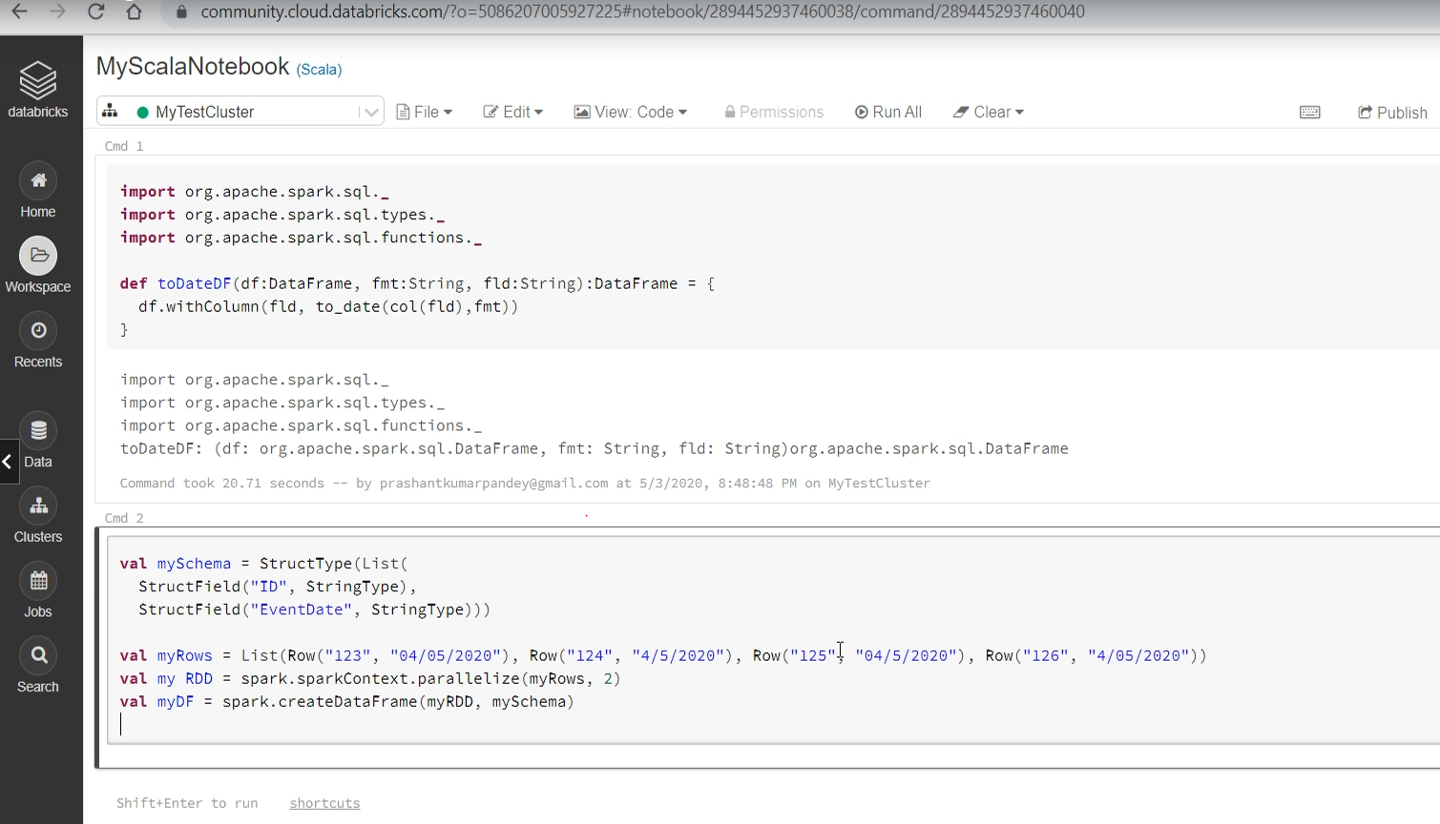

A DataFrame requires a schema. So, let me create a schema. Then I create a List of Row Objects. Your list is not distributed. It is a single list with four records. So, I am going to convert it to an RDD of two parallel partitions. Now, you can use this RDD and the Schema to create a DataFrame. So you have your DataFrame. Now I can test my function. Let me print the before status. Then I am going to call my function. Finally,y I will print the after state. So My before DataFrame shows a String filed. And the after DataFrame shows a DataType filed. Data also looks good.

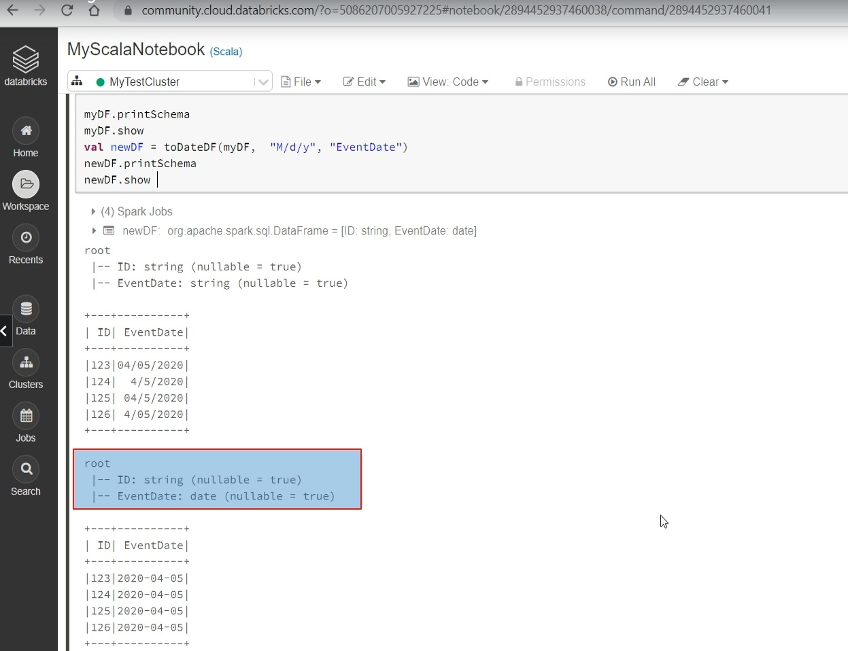

However, all of this was manual verification. Can you convert it to a Unit test?

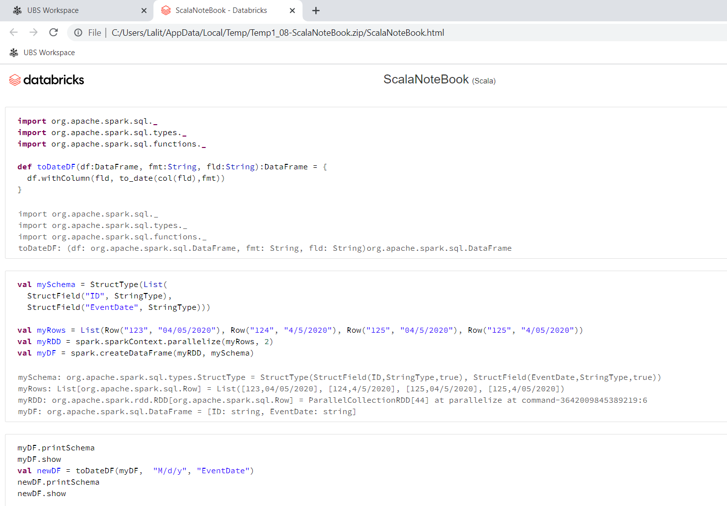

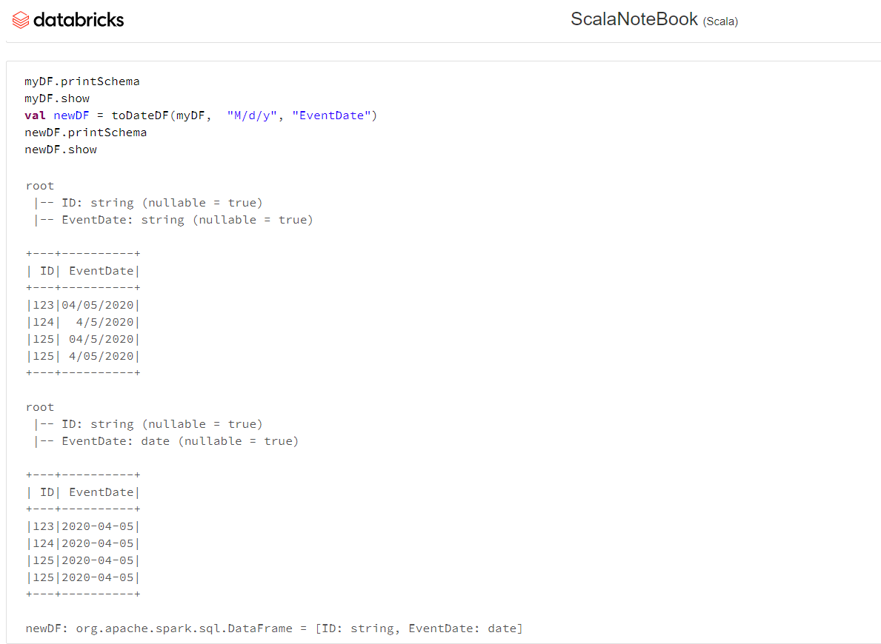

### Dataframe Rows and Unit Testing

In the previous lecture, I talked about the three scenarios when you may have to directly work with the Row objects. We already covered the first scenario. I am going to extend the earlier example and cover the second scenario.

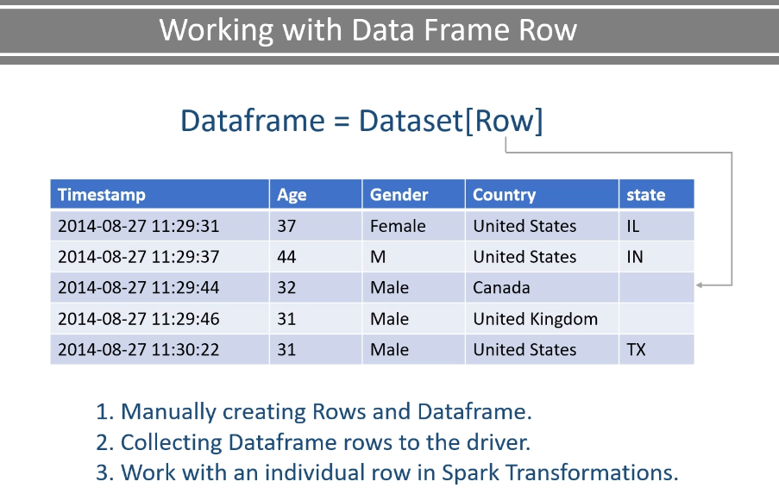

So, let's start. I have taken the Notebook code from the earlier lecture and converted it to a Spark Project. Here it is. So I have this RowDemo object and the main method.

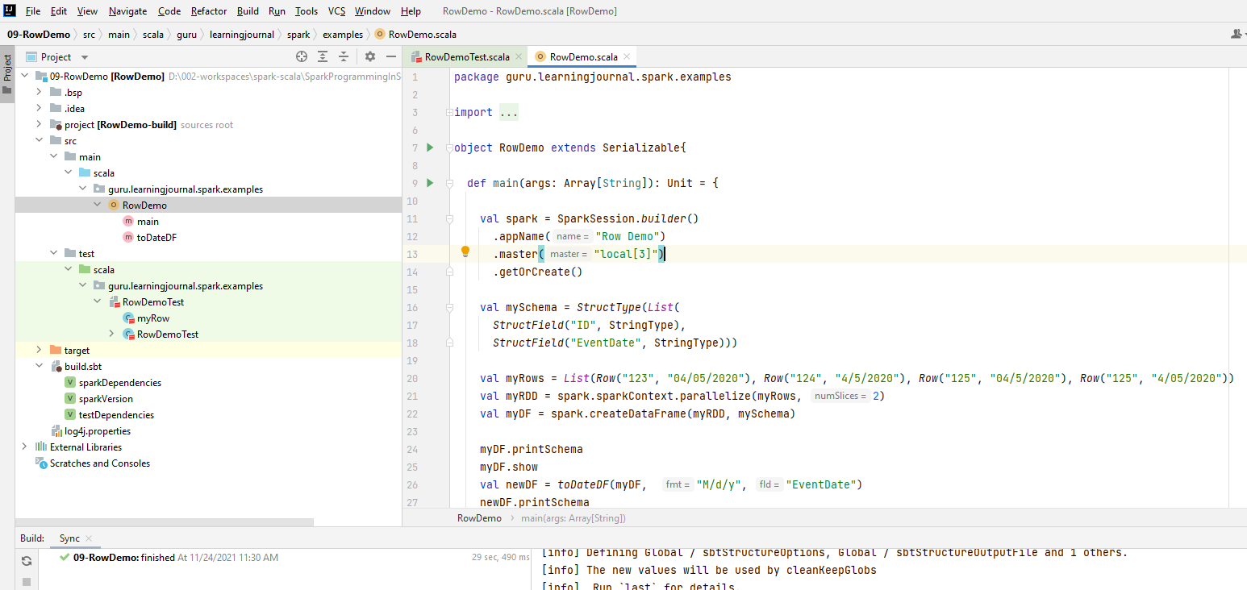

I am creating SparkSession. Creating the schema and manually creating the DataFrame. Here is my function, which we created in the earlier lecture.

**RowDemo.scala**

package guru.learningjournal.spark.examples

import org.apache.spark.sql.{DataFrame, Row, SparkSession}

import org.apache.spark.sql.functions._

import org.apache.spark.sql.types.{StringType, StructField, StructType}

object RowDemo extends Serializable{

def main(args: Array[String]): Unit = {

val spark = SparkSession.*builder*()

.appName("Row Demo")

.master("local[3]")

.getOrCreate()

val mySchema = StructType( List(

StructField("ID", StringType),

StructField("EventDate", StringType)

))

val myRows = List( Row("123", "04/05/2020"),

Row("124", "4/5/2020"),

Row("125", "04/5/2020"),

Row("125", "4/05/2020") )

val myRDD = spark.sparkContext.parallelize(myRows, 2)

val myDF = spark.createDataFrame(**myRDD**, **mySchema**)

myDF.printSchema

myDF.show

val newDF = toDateDF(myDF, "M/d/y", "EventDate")

newDF.printSchema

newDF.show

spark.stop()

}

}

And I am testing it also. Let me run it. It works. I am manually observing the results, and I know my function behaves correctly. However, we want to convert this thing to an automated unit test. How can you do that? Let me explain. Select your object name and press CTRL+SHIFT+T to create a new test. I am going to select ScalaTest in the testing library. I am also selecting the Generate before and after methods. And also select the function which you want to test. Finally,click the ok button.

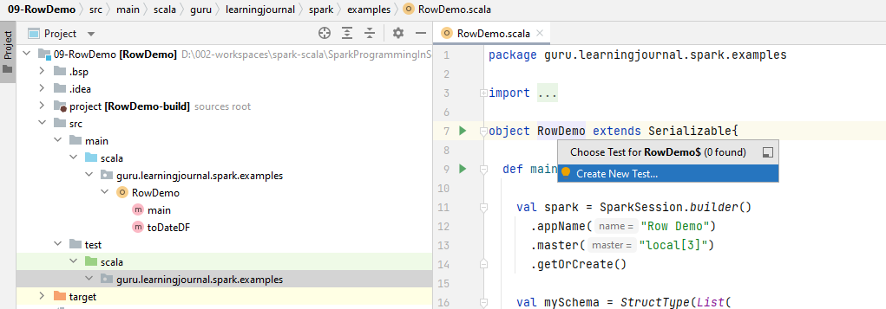

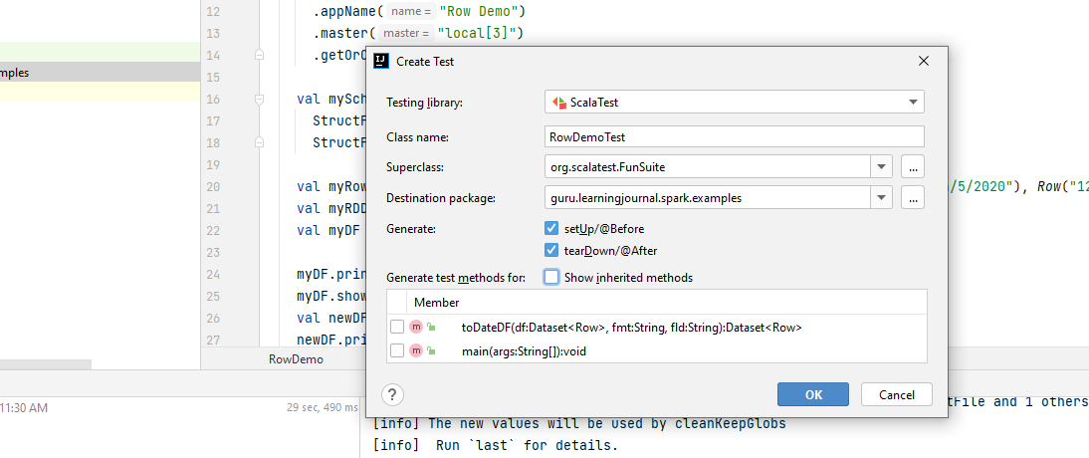

Generates the below code.

This is going to create a Test Class for you. I do not want the BeforeAndAfterEach. Instead, I want BeforeAndAfterAll. So, let me change it. I am going to create two test cases. In the first test case, I will be validating the data type. And in the second test case, I am going to validate the data itself. I will write the assertion in a minute. However, both of these test cases will require a sample data frame. So, the best place to create the sample DataFrame is the beforeAll() method. Let's do it.

package guru.learningjournal.spark.examples

import java.sql.Date

import guru.learningjournal.spark.examples.RowDemo.toDateDF

import org.apache.spark.sql.{DataFrame, Row, SparkSession}

import org.apache.spark.sql.types.{StringType, StructField, StructType}

import org.scalatest.{BeforeAndAfterAll, FunSuite}

case class myRow(ID: String, EventDate: Date)

class RowDemoTest extends FunSuite with BeforeAndAfterAll {

@transient var *spark*: SparkSession = _

@transient var *myDF*: DataFrame = _

override def beforeAll() {

}

override def afterAll() {

}

test("Test Data Type") {

}

test("Test Data Value") {

}

}

I declare a transient SparkSession and a DataFrame. We will create them in the before() method. Now come to the method and create a SparkSession. Then create a DataFrame. You have already seen this code earlier, right?

override def beforeAll() {

spark = SparkSession.builder()

.appName("Demo Row Test")

.master("local[3]")

.getOrCreate()

val mySchema = StructType( List(

StructField("ID", StringType),

StructField("EventDate", StringType)

))

val myRows = List( Row("123", "04/05/2020"), Row("124", "4/5/2020"),

Row("125", "04/5/2020"), Row("125", "4/05/2020") )

val myRDD = spark.sparkContext.parallelize(myRows, 2)

myDF = spark.createDataFrame(myRDD, mySchema)

}

AfterAll() is the place where we do the cleanup activity.

override def afterAll() {

spark.stop()

}

Now we come to the first test case. We are going to call the function. This function will return a DataFrame. However, the actual data of a DataFrame is sitting at the executor. The DataFrame is just a reference to the real data. The point is straight. You cannot assert the DataFrame. If you want to validate the data, then you must bring it to the driver. How? Simple. Collect it. The collect() method will return an Array[Row] to your driver.

test("Test Data Type") {

val rowList = toDateDF(myDF, "M/d/y", "EventDate").collectAsList()

rowList.forEach(r =>

assert(r.get(1).isInstanceOf[Date], "Second column should be Date")

)

}

Once your data is at the driver, you can assert it. If you are more comfortable with the List, then you can use the collectAsList() method. So, I am going to get a List of Row. The rest of the thing is simple. You can use the forEach() method to iterate over the rows. Each iteration will give you a Row. And I am going to assert the Row. So, we use the get() method to point the columns. The column index starts from zero. I want to access the EventDate field, which is in the second position. So, I am going to use the one. Once you get the EventDate field, you can validate it for an isInstanceOf[Date]. This is what I wanted to test. I am expecting my function to return a DataFrame where the EventDate is converted to the DateType. However, we have one important point to notice here. My function uses the field name EventDate, and we were able to access the column using the field. Why can't we do it here? Why do I have to access the field using the index? This is because your schema is attached to the DataFrame. And you collected it as a list of Row. The Row object does not have a schema.

So the only option is to access it using the index. This approach is reasonable for some of the test cases. However, the index notation doesn't make sense in the long term. I mean, I know the EventDate is at the first index. Yet, other developers in my team might not know it. So if they are looking at this code, they might find is confusing and may take some time to figure out that we are referring to the EventDate field. How to fix it? Let's do it in the next test case. Here also, I am going to call my function and collect it as a List of Row. However, we wanted to refer the column names instead of referring to them using an index number. The easiest method is to cast them to a DataSet using a case class. So, let me create a case class. Here it is.

case class myRow(ID: String, EventDate: Date)

test("Test Date Value") {

val spark2 = spark

import spark2.implicits._

val rowList = toDateDF(myDF, "M/d/y", "EventDate").as[ myRow ].collectAsList()

rowList.forEach(r =>

assert(r.EventDate.toString == "2020-04-05", "Date string must be 2020-04-05")

)

}

Now, before I collect it, I am going to convert this DataFrame to a DataSet using my case class. You have already seen this in the HelloDataSet example. This is how we turn a DataFrame to a DataSet. You need the spark implicits. Oops! My SparkSession is a var. I declared it as a var. But importing implicits is only allowed with a stable val type. Nothing to worry. I will copy it to a Â val type. And then we can import the implicits. So now, my List is a List[myRow]. We will again loop through the List and assert each record. But this time, the record is not a Row object. It is a myRow object which also has a schema. So I can refer the fields using a field name. Assert it for the expected value. Nice! This looks more readable. Isn't it? Let me run these test cases. Both tests are passing.

**Complete code for Test Case**

package guru.learningjournal.spark.examples

import java.sql.Date

import guru.learningjournal.spark.examples.RowDemo.toDateDF

import org.apache.spark.sql.{DataFrame, Row, SparkSession}

import org.apache.spark.sql.types.{StringType, StructField, StructType}

import org.scalatest.{BeforeAndAfterAll, FunSuite}

case class myRow(ID: String, EventDate: Date)

class RowDemoTest extends FunSuite with BeforeAndAfterAll {

@transient var spark: SparkSession = _

@transient var myDF: DataFrame = _

override def beforeAll() {

spark = SparkSession.builder()

.appName("Demo Row Test")

.master("local[3]")

.getOrCreate()

val mySchema = StructType( List(

StructField("ID", StringType),

StructField("EventDate", StringType))

)

val myRows = List( Row("123", "04/05/2020"), Row("124", "4/5/2020"),

Row("125", "04/5/2020"), Row("125", "4/05/2020"))

val myRDD = spark.sparkContext.parallelize(myRows, 2)

myDF = spark.createDataFrame(myRDD, mySchema)

}

override def afterAll() {

spark.stop()

}

test("Test Data Type") {

val rowList = toDateDF(myDF, "M/d/y", "EventDate").collectAsList()

rowList.forEach(r =>

assert(r.get(1).isInstanceOf[Date], "Second column should be Date")

)

}

test("Test Date Value") {

val spark2 = spark

import spark2.implicits._

val rowList = toDateDF(myDF, "M/d/y", "EventDate").as[myRow].collectAsList()

rowList.forEach(r =>

assert(r.EventDate.toString == "2020-04-05", "Date string must be 2020-04-05")

)

}

}

### DataFrame Rows and Unstructured Data

I talked about the three scenarios when you may have to directly work with the Row objects. We already covered the first two scenarios. I am going to cover the third scenario. So, let's start. Spark DataFrame offers a bunch of Transformations, Actions, and utility functions. Here are some examples. You can categorize them into two logical groups.

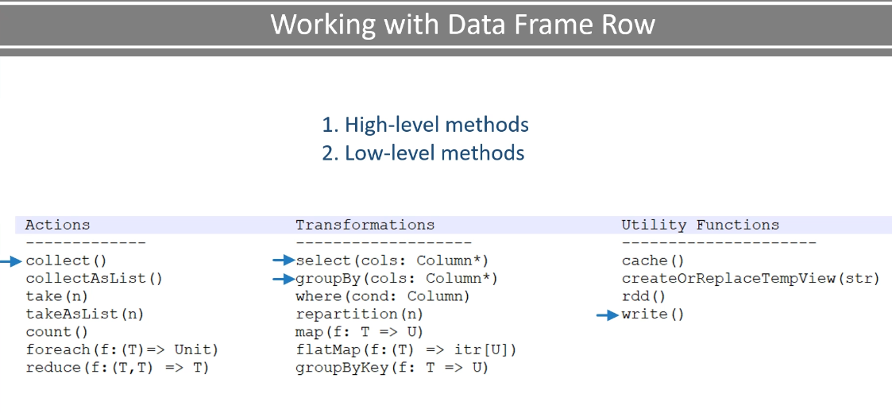

High-level methods and Low-level methods. The high level methods such as collect(), select(), groupBy(), and write() methods are regular tools. Some of them are no argument methods, and others would work on DataFrame columns. More than 90% of your requirement is met by using these methods. We will learn more about it in the following videos. However, we also have some lambda accepting methods such as foreach(), map(), and groupByKey().

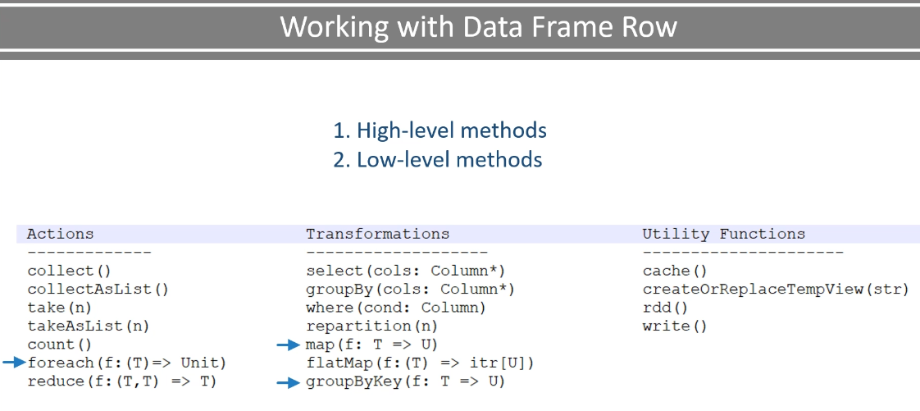

These are low-level methods, and they allow you to supply a lambda function that operates on the Row. So, when do you want to use these low-level tools? The answer is straight. You will be using the high-level methods when your DataFrame has got a schema. However, when your DataFrame doesn't have a column structure, then you are going to use the low-level methods. Why? Because you do not have columns, and you should be processing the Row itself. Let's create an example to help you grab the idea. I created this LogFileDemo example. Most of the things are similar to other examples. However, I have this unstructured data file. Let me show you. The data file is an apache web server log file. Each line in this file is one log entry.

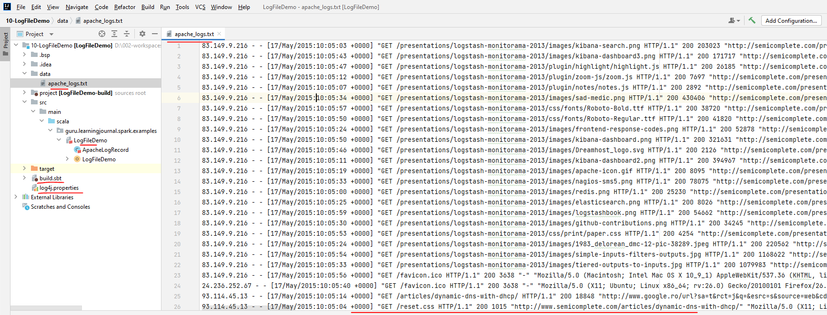

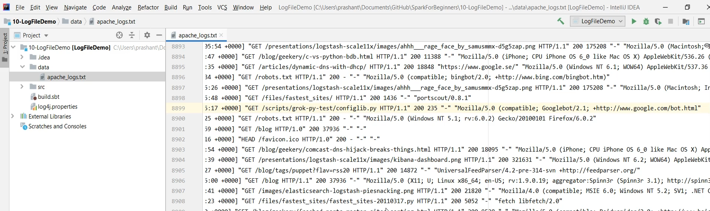

We do have some patterns in the log output. However, this file is not even a semi-structured data file. It is just a log dump. We are going to parse this data file and extract some fields from the log entry. Let's do it. Same as earlier, I created this main() method and also created the SparkSession. Now I am going to create a DataFrame and read the text file. The text file gives me a data set of string. You can convert it to a DataFrame. This is not needed, but let me do it. So now I have a DataFrame.

package guru.learningjournal.spark.examples

import org.apache.log4j.Logger

import org.apache.spark.sql.SparkSession

case class ApacheLogRecord(ip: String, date: String, request: String, referrer: String)

object LogFileDemo extends Serializable {

@transient lazy val logger: Logger = Logger.getLogger(getClass.getName)

def main(args: Array[String]): Unit = {

val spark = SparkSession.builder()

.appName("Log File Demo")

.master("local[3]")

.getOrCreate()

val logsDF = spark.read.textFile("data/apache_logs.txt").toDF()

spark.stop()

}

}

And the DataFrame Row has got only one string field. That's all. No other columns and schema. So, I cannot use any of the higher level transformations. All I am left is some of the lambda accepting transformations. So I am going to use the map method. This method gives me a row to work with. So I have this Row. What do I want to do with it? I am going to create a regular expression. Here it is. This regex is going to match against eleven elements in a given string. And I will be using this regex to extract the fields. Let me take the string out of my Row. Then I can match it against my regex and extract all the eleven fields.

import org.apache.log4j.Logger

import org.apache.spark.sql.SparkSession

object LogFileDemo extends Serializable {

@transient lazy val *logger*: Logger = Logger.*getLogger*(getClass.getName)

def main(args: Array[String]): Unit = {

val spark = SparkSession.*builder*()

.appName("Log File Demo")

.master("local[3]")

.getOrCreate()

val logsDF = spark.read.textFile("data/apache_logs.txt").toDF()

val myReg = """^(\S+) (\S+) (\S+) \[([\w:/]+\s[+\-]\d{4})\] "(\S+) (\S+) (\S+)" (\d{3})

(\S+) "(\S+)" "([^"]*)"""".r

val logDF = logsDF.map( row =>

row.getString(0) match {

case myReg( ip, client, user, date, cmd, request, proto, status, bytes, referrer,

userAgent) => (ip, date, request, referrer)

}

)

What do I do with these fields? I am interested in just four fields. So, I am going to return these four fields. However, this is going to go as a tuple. My initial DataFrame had a single string field but no schema. Now I am going to create a new DataFrame with four fields. However, I will still have no Schema. Can we attach a schema to this DataFrame? Yes, we can? How? You already learned it, right? Yes. Case Class is the only option to attach a schema to a schemaless DataFrame. Let me define a case class. Now I can apply it here.

import org.apache.log4j.Logger

import org.apache.spark.sql.SparkSession

case class ApacheLogRecord(ip: String, date: String, request: String, referrer: String)

object LogFileDemo extends Serializable {

@transient lazy val *logger*: Logger = Logger.*getLogger*(getClass.getName)

def main(args: Array[String]): Unit = {

val spark = SparkSession.*builder*()

.appName("Log File Demo")

.master("local[3]")

.getOrCreate()

val logsDF = spark.read.textFile("data/apache_logs.txt").toDF()

val myReg = """^(\S+) (\S+) (\S+) \[([\w:/]+\s[+\-]\d{4})\] "(\S+) (\S+) (\S+)" (\d{3})

(\S+) "(\S+)" "([^"]*)"""".r

import spark.implicits._

val logDF = logsDF.map( row =>

row.getString(0) match {

case myReg( ip, client, user, date, cmd, request, proto, status, bytes, referrer,

userAgent) => ApacheLogRecord(ip, date, request, referrer)

}

)

But do not forget to import the spark implicits. So most of the scenarios where you will be forced to use the lower level transformations are like this. I mean, working with schemaless DataFrame will force you to apply lambda accepting transformations such as map() or groupByKey(). However, you should always try to come out of this problem as quickly as possible. I mean, attach a schema to your data as soon as you can. And the rest of the processing is going to be super simple. Let me show you some simple analysis here. Now I have this DataFrame. I can easily group by the referrer, take a count, and show it. Let me run it.

package guru.learningjournal.spark.examples

import org.apache.log4j.Logger

import org.apache.spark.sql.SparkSession

case class ApacheLogRecord(ip: String, date: String, request: String, referrer: String)

object LogFileDemo extends Serializable {

@transient lazy val logger: Logger = Logger.getLogger(getClass.getName)

def main(args: Array[String]): Unit = {

val spark = SparkSession.builder()

.appName("Log File Demo")

.master("local[3]")

.getOrCreate()

val logsDF = spark.read.textFile("data/apache_logs.txt").toDF()

val myReg = """^(\S+) (\S+) (\S+) \[([\w:/]+\s[+\-]\d{4})\] "(\S+) (\S+) (\S+)" (\d{3})

(\S+) "(\S+)" "([^"]*)"""".r

import spark.implicits._

val logDF = logsDF.map(row => ➀

row.getString(0) match {

case myReg( ip, client, user, date, cmd, request, proto, status, bytes,

referrer, userAgent) =>

ApacheLogRecord(ip, date, request, referrer)

}

)

import org.apache.spark.sql.functions._

logDF

.where( "trim(referrer) != '-' ") ➂

.withColumn( "referrer", substring_index($"referrer", "/", 3) ) ➁

.groupBy( "referrer" ).count().show( truncate = false )

spark.stop()

}

}

Okay! So this count doesn't make a good sense. I mean, these three URLs are the same referrer. However, they are aggregating as three different websites. How can I fix it? Simple. I will transform this referrer column taking only the website's home URL. Here is the code. I am using this function, so let me import the spark SQL functions. However, you might be wondering about this column transformation. We haven't learned these things yet. I am going to explain column level transformation ➁ starting from the next video. So nothing to worry. I am using it here to show you the benefits of having a schema for your DataFrame. Let me run it once. Here are 4K plus hits that are not coming from any referrer. If you want, you can filter them out. ➂ Here is the code. The point is straight. I started with an unstructured dataset. So, I used one of the most powerful transformations - ➀ The map() method. I used it to give a structure to my data and attach a schema. Once I have a schema, I can easily use column transformations to do a lot of things. If I do not have a schema, then the simple stuff like grouping and counting is also going to depend upon the low-level methods such as groupByKey() and reduce(). So, the point is straight. Consider using low-level methods when you are operating on unstructured data but try coming out of the limitation giving structure to your data as early as possible.

### Working with Dataframe Columns

In the earlier lectures, we learned to work with the DataFrame Rows. However, most of the DataFrame transformations are all about transforming the columns. we will learn some foundational things to work with the Columns. So, let's start. Working with DataFrame requires you to have clear answers to the following questions.

|  |  |
| --- | --- |
|  | What is a Column and How to reference it? How to create column expressions? Let's try to answer these questions and explore them using some simple examples. We will be using DataBricks cloud for learning Column basics. Why? Well, notebooks are excellent for learning and exploration. So, log in to your DataBricks community cloud and create a new cluster. While the Cluster is starting, let's create a new Notebook. Give a name to your notebook, select a language, and create it. DataBricks community cloud comes with some public data sets. Let me show you. |

Here it is.

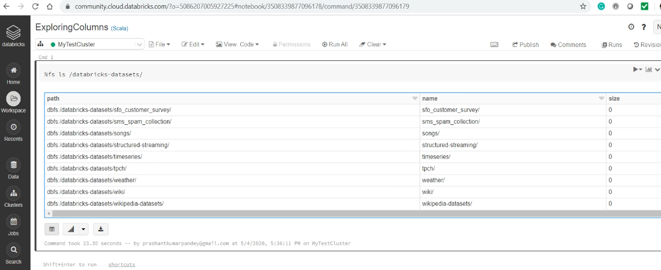

If you scroll the list, you will see a bunch of datasets to play with. I am going to use the airline's data. Here it is. Well, the data set is humongous, and my community cluster is not capable of handling such volumes.

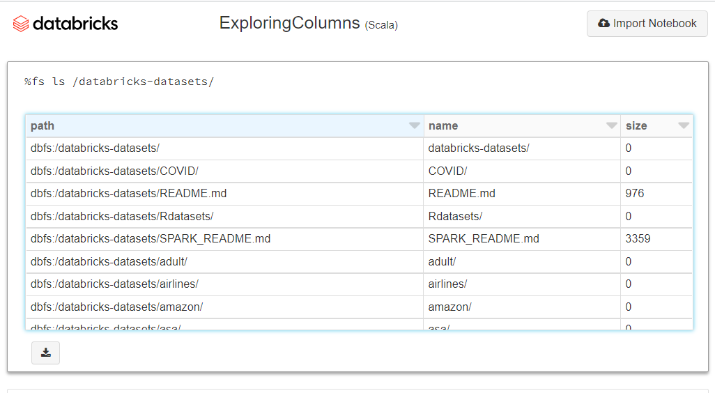

So, I am going to use just one file out of all these. Let me show you the data. It is a CSV format data, and it comes with a header row.

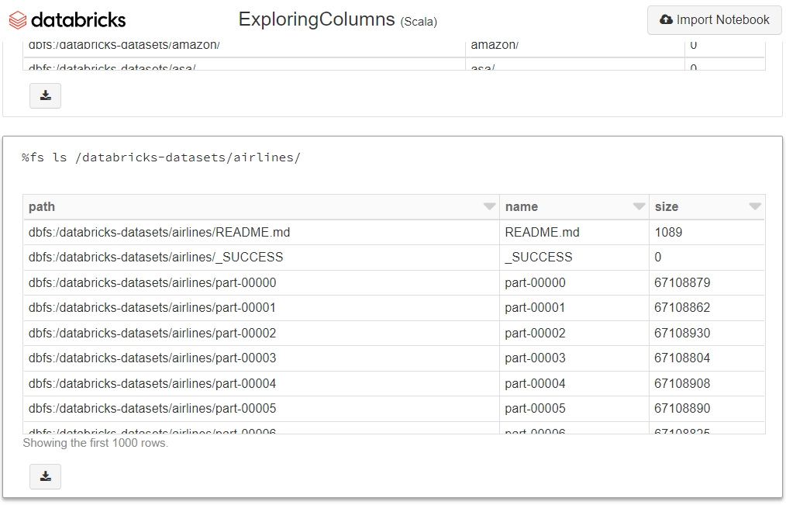

I can quickly load it and infer schema to create my DataFrame.

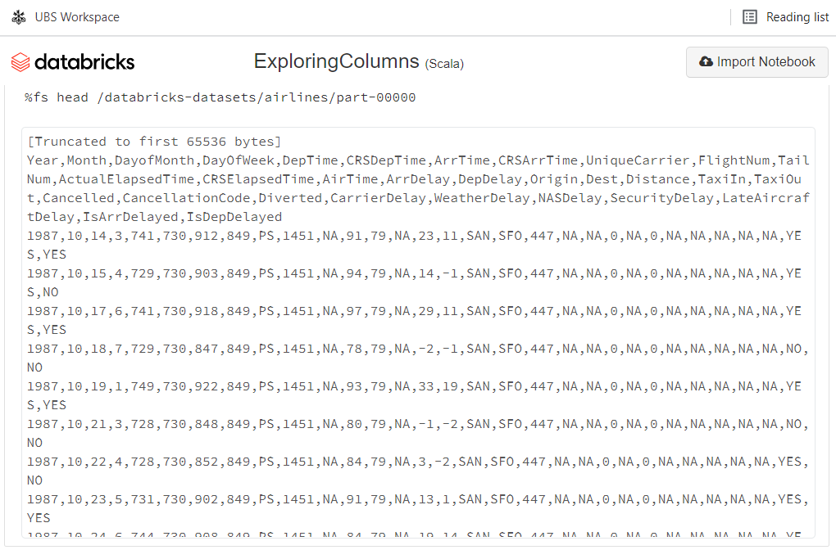

Let's do it. Here is the code. I am inferring schema with a small sampling ratio to make sure that this command runs quickly.

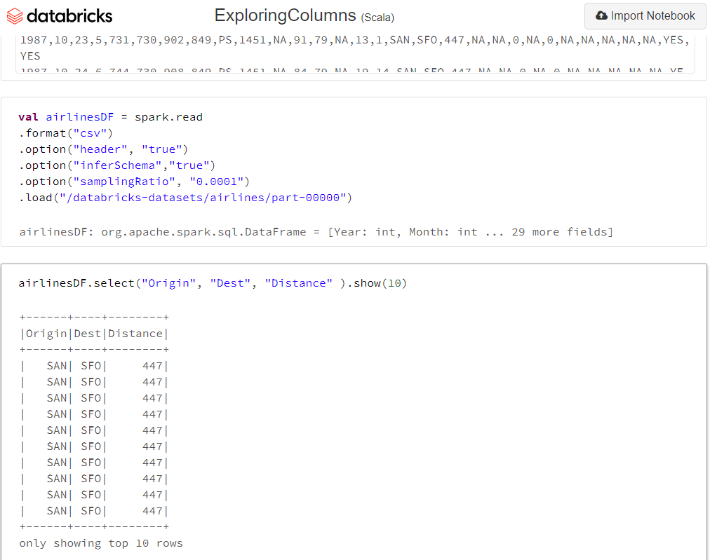

**val** airlinesDF = spark.read

.format("csv")

.option("header", "true")

.option("inferSchema","true")

.option("samplingRatio", "0.0001")

.load("/databricks-datasets/airlines/part-00000")

So we now have a DataFrame to explore and learn the column expressions. Spark DataFrame columns are objects of type Column. However, they do not make any sense outside the context of a DataFrame, and you cannot manipulate then independently. Columns are always used within a Spark Transformation. There are two ways to refer to columns in a DataFrame Transformation. Column String and Column Object. Column String is the simplest method to access a column. Here is an example.

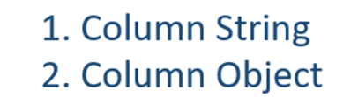

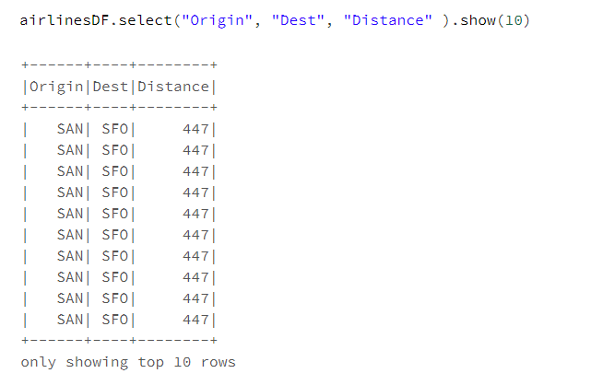

In this example, I am using a column name string. Spark offers a bunch of DataFrame transformations that are designed to accept column strings. You have already seen the select() method. You can use column strings with the drop(), orderBy(), groupBy(), cube(), rollup() and few more. The second option is to access your columns using the column object. And this one is a bit confusing because you have a bunch of ways to create column objects. However, the most common method is to use the column() or the col() function. Here is an example. So, I used four different methods to reference a column. All of these methods are the same. They all are creating a column object.

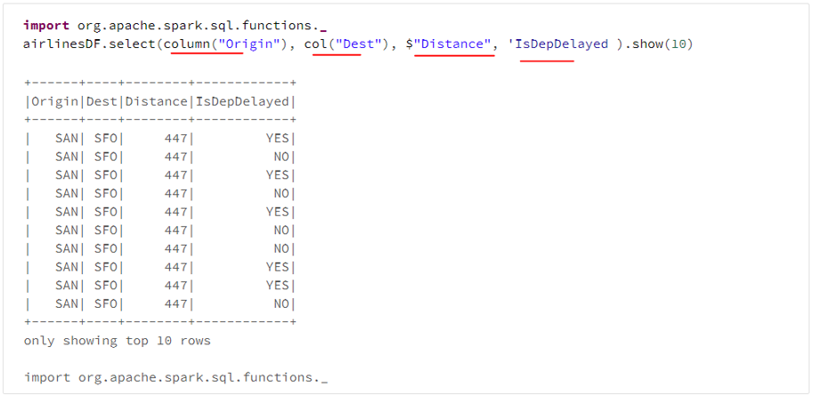

The first one is using the column() function, and the second one is using the shorthand of the same, i.e., the col() function. The third and fourth methods are Scala specific shorthands. We call them syntactic sugar in Scala terminology. These two options are not available in other languages, but all of the four methods shown here have the same meaning and the same effect. It is your choice to use any of these. One more critical point. You cannot mix Column String and Column Object in the same transformation. So, here is an incorrect way of referring to a column.

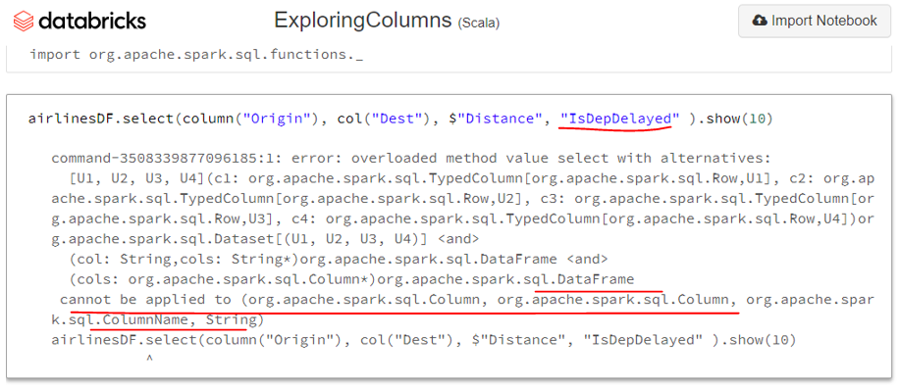

The first three column references are using the column object. Still, the last one is trying to refer it using the Column String. This is not allowed. Good. So now you understand two methods to refer to individual columns. Column String and Column Object Most of the Spark Transformations will support both the approaches. It is your comfort to use whatever you find more intuitive. So now let's move on to the next question. How to create column expressions? Spark DataFrame offers multiple ways to create column expressions. However, you can again group them into two types. String Expressions or SQL Expressions And the second one is the Column Object Expressions These two types are based on the earlier two methods for referencing the column. Let's try to understand the first one.

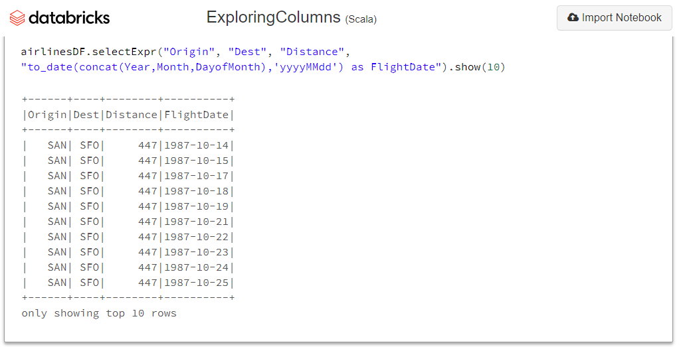

Let's assume I have this select expression. I am selecting three columns here, and I am using Column String. I want to add one more column for the flight date.



I have three fields in the DataFrame for a year, month, and day of the month. I want to combine these three fields and create a single field for the date of the flight. If you know SQL, you can easily create an expression like this. However, this is an expression string and not a plain column name string. Try running it, and you will get an error. Why? Because the select method accepts column strings or column objects. They do not take expressions. How to fix this problem? Simple. You can use the expr() function to convert an expression to a column object. Here it is.

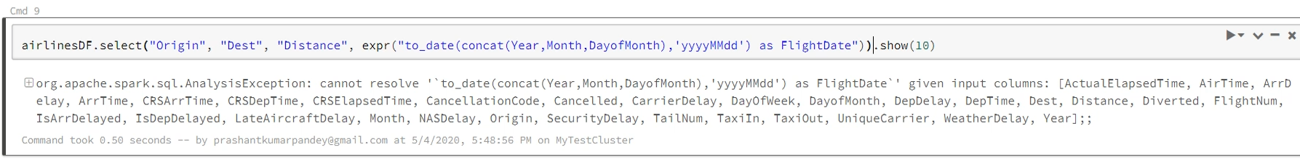

Now, this expr() function is going to parse the expression and return a column object. Will it run now? No. Why? Because these three-column references are using column string, and the fourth one is going to return a column object. We already learned that we cannot mix column strings and column objects. So, we still have the problem. But the solution is simple. Convert these references also to a column object. How to do it? Simple. You can use the col() function. You can also use the scala syntactic sugar. The expr() function also works. Run it now, and it should work. Using plain column names and combining it with the column expression strings a typical pattern, and you find it irritating to add these col() function everywhere.

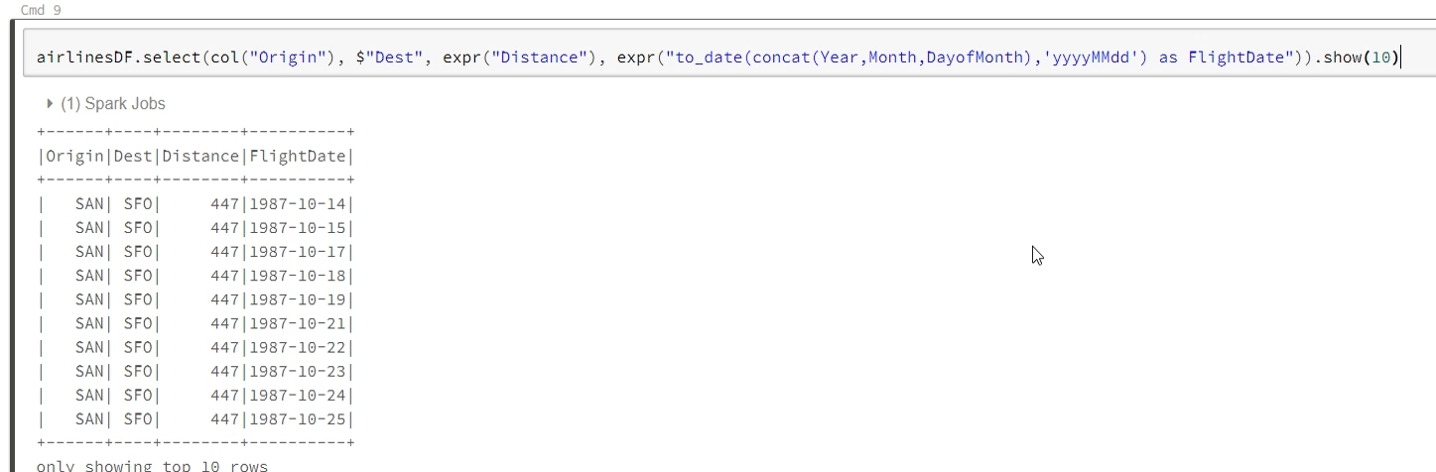

Spark understands that requirement, and it also offers you a selectExpr() transformation, which automatically converts the column strings to an expression. So, you can remove all these functions and directly use the selectExpr() instead of select() function. Good.

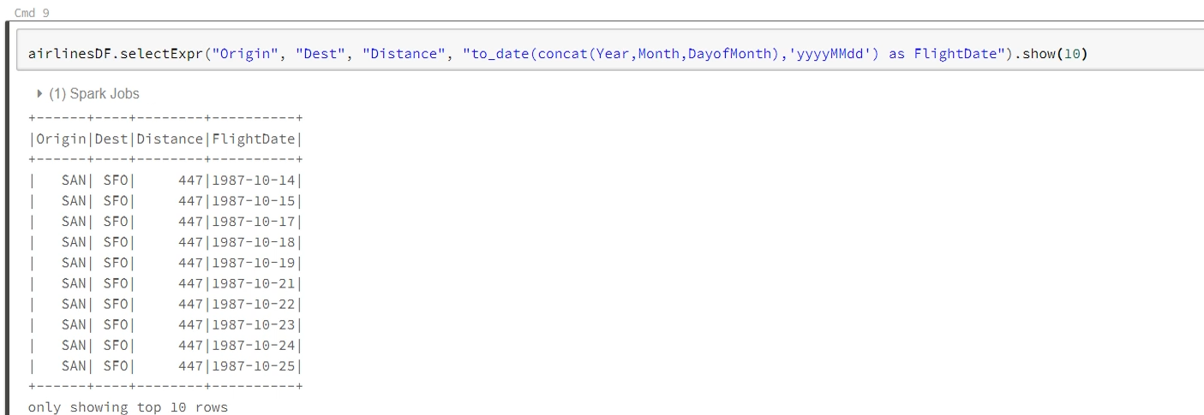

So we talked about two approaches and learned the first one. This first approach is more like using SQL expressions, and I have seen this approach is preferred by most of the programmers. Now let's learn the second approach. The second method is to use column objects and build your expression. Everything remains the same. The only difference is to avoid using strings and apply column objects and functions. Can you try converting this select() transformation using the column objects? Let me do it. The first three columns are already using object notation. The problem is the last one.



Let's fix it. I am going to remove this expr() function. Now I am going to do something that the expr() function was doing it for me. Remove these double-quotes. We have a to_date(), and the concat() functions that we can directly use. However, these functions do not understand the column strings. They take column objects. So, I will convert these column names to column objects.



So, we are now good with the concat() and the to_date() functions. The concat() function is going to combine these three columns and return a new column. The new column goes to the to_date() function whireturs a Date column. Now you can apply the as() function to rename it. Simple. No? Don't worry. We will do a few more examples. Let me run it. Works. Creating your expressions using the column object might look complicated. However, it is the same as building your expressions using SQL statements.

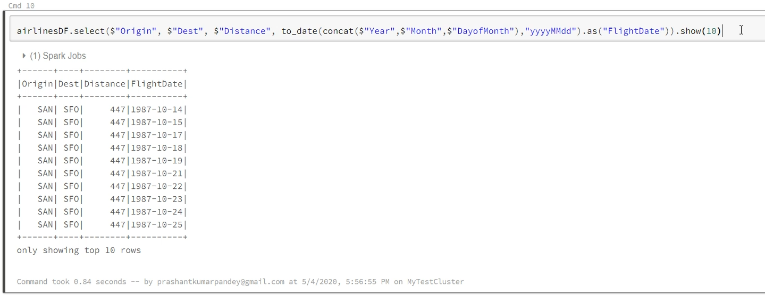

A little practice can give you the needed comfort. The good this is that you have both the options. Use whatever you feel natural. Most of the Spark transformations are designed to accept both the forms. Let me show you some documentation, so you understand the place for referring and knowing the list of available tools. You should be referring to three places. Dataset, Column and Built-in Functions

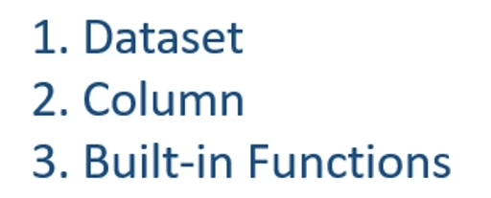

Go to the Spark documentation. Search for the Dataset. You will see a list of actions, some utility functions, Typed transformations, and finally, the Untyped transformations.

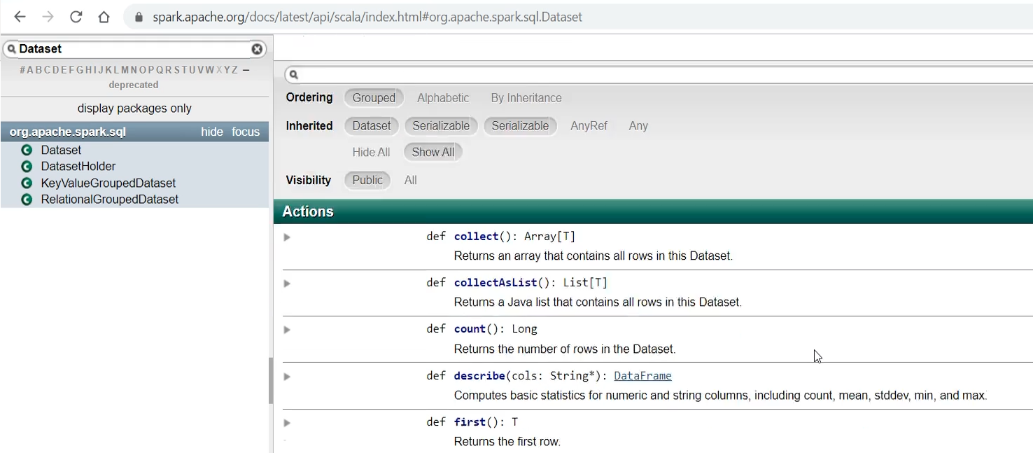

All of these are available to you. Let's look at some examples. Search for the where() method. So you have two variations. The first one takes an expression string. This is like selectExpr(), so you do not need to use the expr() function. It simply takes a string and converts it to expression. Here is an example. The second variation takes a column object. So, you can do the same thing creating an expression using the column object.

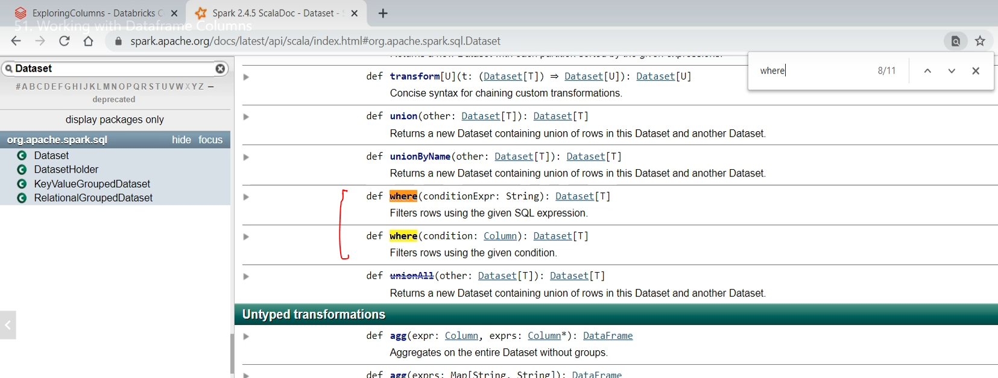

Here is an example. And how does it works? Simple. The $Distance is a column object. The number 500 is an Integer. The greater than is an operator defined on the Column object.

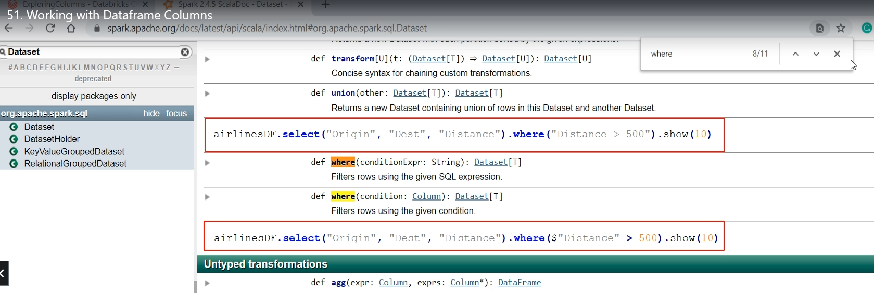

Let's look at the column object documentation. Here is the greater-than operator. You can use it like this. Similarly, you can use the < and <=. However, be careful with the === and =!= operators.

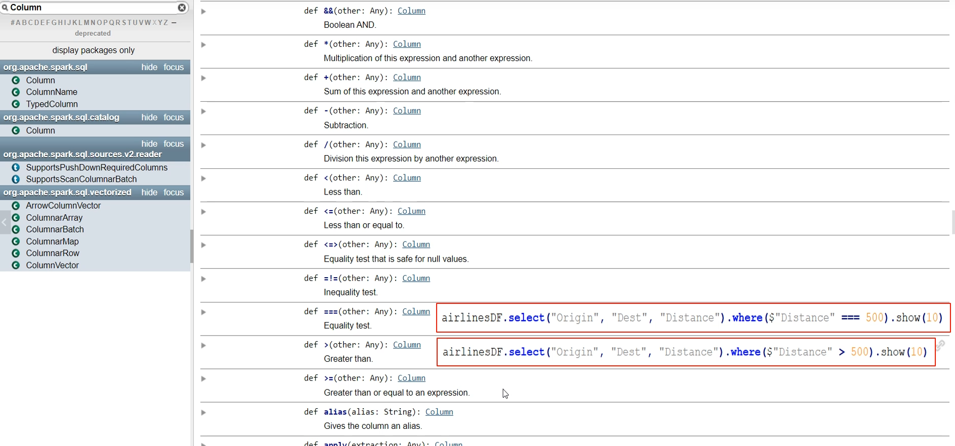

These are a little different in Scala. So, if you want to use === 500, then it shows to be like this. But this doesn't apply to a string expression. The string expression uses the SQL operators. So, it should be like this.



There are many other methods available to the columns. We already used the as() method. So the point is straight. You can use SQL like expressions, or you can leverage functions defined at three places. Dataset, and you will get the list in the Dataset documentation. Column and you can get the list here in the Column documentation. Built-in functions and you will get the list in the org.apache.spark.sql.functions package.

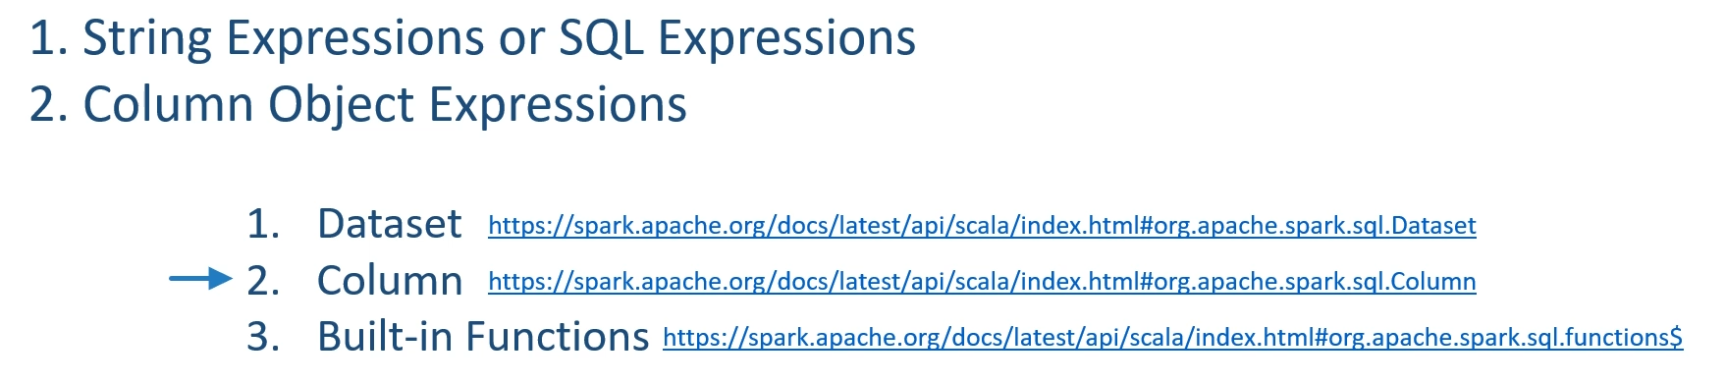

Â All these built-in functions are also available in the SQL expressions. If this is not enough, you can create user-defined functions and use them. We will learn about UDFs in the next lecture.

### Creating and Using UDF

We learned to refer columns and create expressions. I showed you examples to create expressions using the following two methods. String Expressions or SQL Expressions and Column Object Expressions We already learned to refer Dataframe columns, applying some maths, and using built-in functions. However, Spark also allows you to create user-defined functions and use them in these two types of expressions.

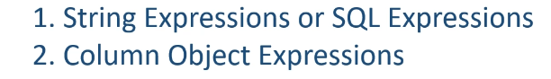

In this lecture, we will learn to create UDF and use them in our expressions. So, let's start. I created this UDFDemo example.

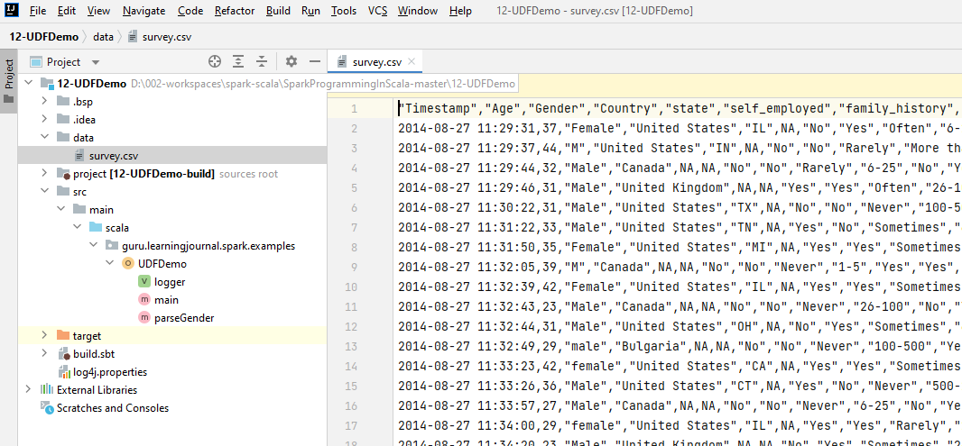

I have this sample data file. I am creating a Spark session and loading this data file into a Dataframe.

package guru.learningjournal.spark.examples

import org.apache.log4j.Logger

import org.apache.spark.sql.SparkSession

object UDFDemo extends Serializable {

@transient lazy val *logger*: Logger = Logger.*getLogger*(getClass.getName)

def main(args: Array[String]): Unit = {

if (args.length == 0) {

*logger*.error("Usage: UDFDemo filename")

System.*exit*(1)

}

val spark = SparkSession.*builder*()

.appName("UDF Demo")

.master("local[3]")

.getOrCreate()

val surveyDF = spark.read

.format("csv")

.option("header", "true")

.option("inferSchema", "true")

.load(args(0))

}

}

Let me show you the Dataframe. Good. Can you see this gender column? We have a different kind of text here. However, I want to standardize it to one of the following values. Male Female and Unknown

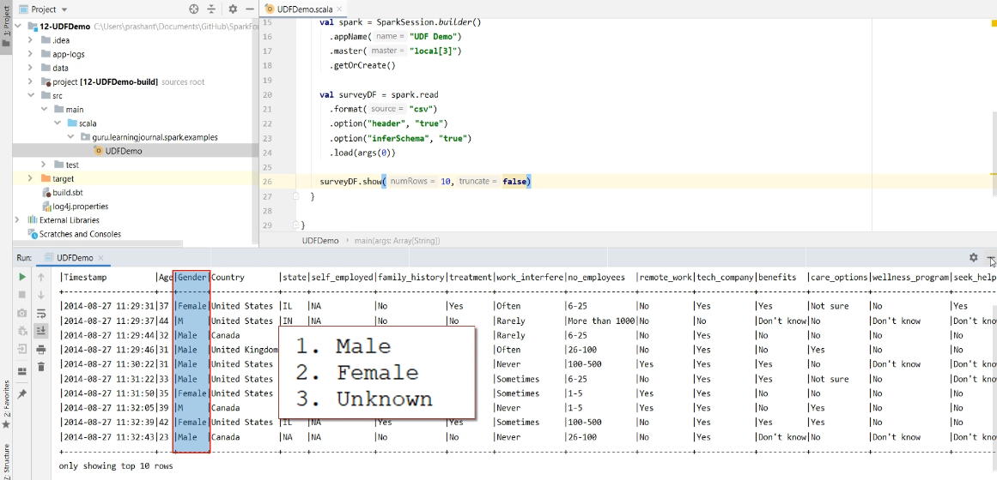

How to fix it? We have many ways to do this transformation. However, I want to create a custom function to fix this problem. So, let's define the function. Let me call it the parseGender function. This function takes a string and returns a string. So, I intend to use this function where I will pass the gender column, and it should return one of the desired values, i.e., male, female, or Unknown. Let's create the function body. I am going to use a regular expression to infer gender. Here is the regular expression for females. And here it is for the male. What does it mean? I have three patterns to infer the female gender.

def parseGender(s:String):String = {

val femalePattern = "^f$|f.m|w.m".r

val malePattern = "^m$|ma|m.l".r

if(femalePattern.findFirstIn(s.toLowerCase).nonEmpty) "Female"

else if (malePattern.findFirstIn(s.toLowerCase).nonEmpty) "Male"

else "Unknown"

}

And all those three patterns are combined with an OR condition. Let me quickly explain these patterns The string is a single character 'f.' It contains f followed by some character and letter m. It contains w followed by some other letter and m. Similarly, the pattern for the male gender is also designed. These patterns may not be a perfect gender match pattern, but it works for the given data. Now let's test it. Here is the code. If we can find the lower case of the string in the female pattern, then it is a female. Similarly, we check for male else we return Unknown. Good. So my function is now ready. How do I use it? We can create an expression and use it. However, we have two approaches to develop the expression Column Object Expression And String Expression Let's learn both. The first one is the Column Object Expression. I am going to create a new Dataframe transforming the existing Dataframe. And I am going to use the withColumn() transformation.



What is withColumn()? And why am I using it? Let me explain. The withColumn() transformation allows you to transform a single column without impacting other columns in the Dataframe. It takes two arguments. The first argument is the column name that you want to transform. So, in my case, it is the Gender column. We want to transform the gender. The next argument is a column expression. So, what I want to do is to use the parseGender() function and supply the Gender column. My parseGender() function will fix the gender string and return a standardized gender string. That's all we want to do here. However, we cannot simply use a Scala function in a Column Object Expression. I need to register my custom function to the driver and make it a UDF. Let me do it. I am going to use the UDF() function to register it. So, let me import the functions. Now, I can use the UDF function to register my Scala function using the signature of my local function. What does it mean? Simple. It takes one argument of type String and returns a String. That's all.

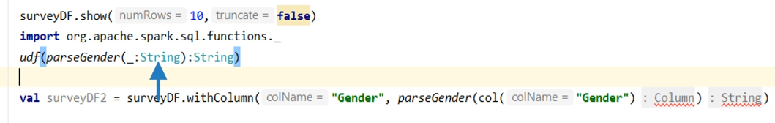

The UDF() function will register it and returns a reference to the registered UDF. Now you can use the UDF reference here. That's all. Let me show the new Dataframe. So, we can see the before and after state. So what exactly are we doing? It is a three-step process to use a user-defined function. Create your function. Register it as UDF and get the reference. Now your function is registered in the Spark Session. And your driver will serialize and send this function to the executors. So, executors can smoothly run this function. Finally, use your function in your expression. That's all.

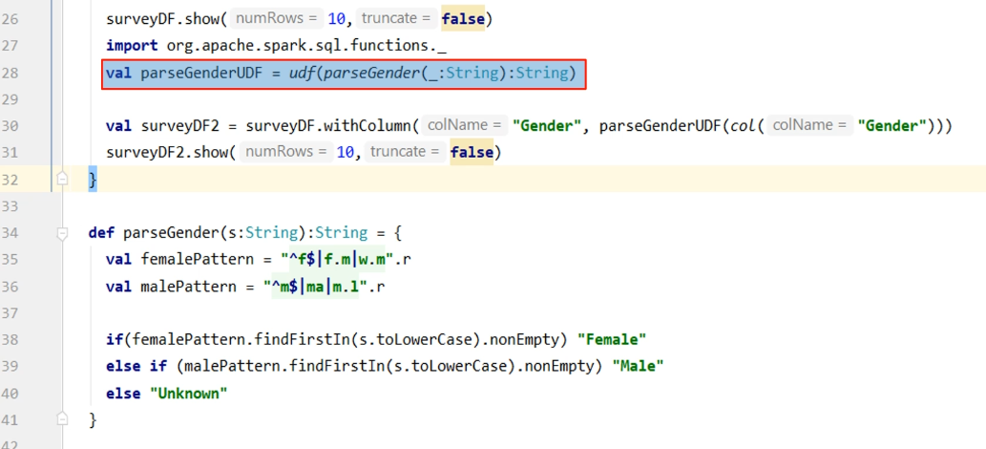

So we learned to create and use a UDF in a Column Object expression.

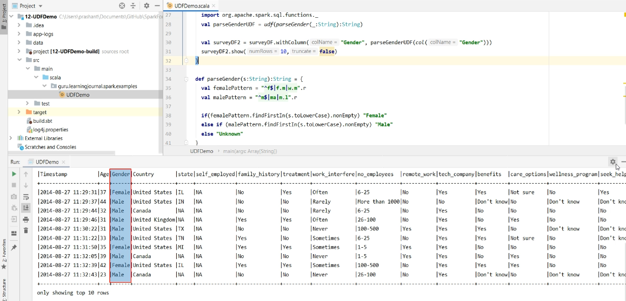

Can we use it in a string or SQL expression? Yes, we can. However, the registration process is different. We need to register it as a SQL function, and it should go to the catalog. And that is done using Spark Session UDF registration method. The first argument is the name of the UDF, and the second argument is the signature of your function. So, these two registrations are different. The first one is to register your function as a Dataframe UDF. This method will not register the UDF in the catalog. It will only create a UDF and serialize the function to the executors. The second type of UDF registration is to register it as a SQL function.

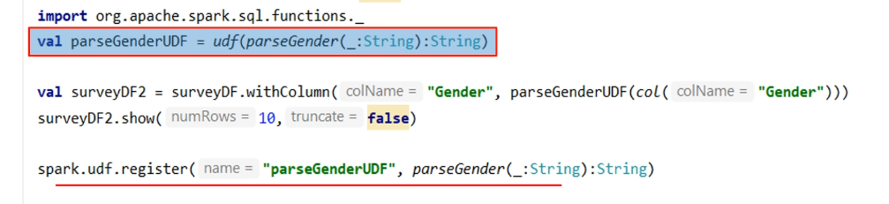

This one will also create one entry in the catalog. Let me query the catalog after the first kind of registration and once again after the second kind of registration. If you want to use your function in a Dataframe column object expressions, then you must register it like this. But if you want to use your function in a SQL expression, then you must register it like this. Now let's come to the expression creation. I am going to create an equivalent SQL expression. I will copy this line and modify it. So, the first thing is to place a double quote around the expression and make it a string.

package guru.learningjournal.spark.examples

import org.apache.log4j.Logger

import org.apache.spark.sql.SparkSession

object UDFDemo extends Serializable {

@transient lazy val *logger*: Logger = Logger.*getLogger*(getClass.getName)

def main(args: Array[String]): Unit = {

if (args.length == 0) {

*logger*.error("Usage: UDFDemo filename")

System.*exit*(1)

}

val spark = SparkSession.*builder*()

.appName("UDF Demo")

.master("local[3]")

.getOrCreate()

val surveyDF = spark.read

.format("csv")

.option("header", "true")

.option("inferSchema", "true")

.load(args(0))

surveyDF.show(10,false)

import org.apache.spark.sql.functions._

val parseGenderUDF = *udf*(*parseGender*(_:String):String)

spark.*catalog*.listFunctions().filter(r => r.name == "parseGenderUDF").show()

val surveyDF2 = surveyDF.withColumn("Gender", parseGenderUDF(*col*("Gender")))

surveyDF2.show(10,false)

spark.udf.register("parseGenderUDF", *parseGender*(_:String):String)

spark.*catalog*.listFunctions().filter(r => r.name == "parseGenderUDF").show()

val surveyDF3 = surveyDF.withColumn("Gender", *expr*("parseGenderUDF(Gender)"))

surveyDF3.show(10, false)

}

def parseGender(s:String):String = {

val femalePattern = "^f$|f.m|w.m".r

val malePattern = "^m$|ma|m.l".r

if(femalePattern.findFirstIn(s.toLowerCase).nonEmpty) "Female"

else if (malePattern.findFirstIn(s.toLowerCase).nonEmpty) "Male"

else "Unknown"

}

}

We do not this col() function in a SQL expression. However, we have a small problem. The withColumn() doesn't take a SQL expression. But that's not a big problem, right? We can use the expr() function here. You already learned it in the earlier video. Now, the Spark engine will parse this string at runtime and resolve the UDF and the column name from the catalog.



Let me run it and show you the outcome. Good.

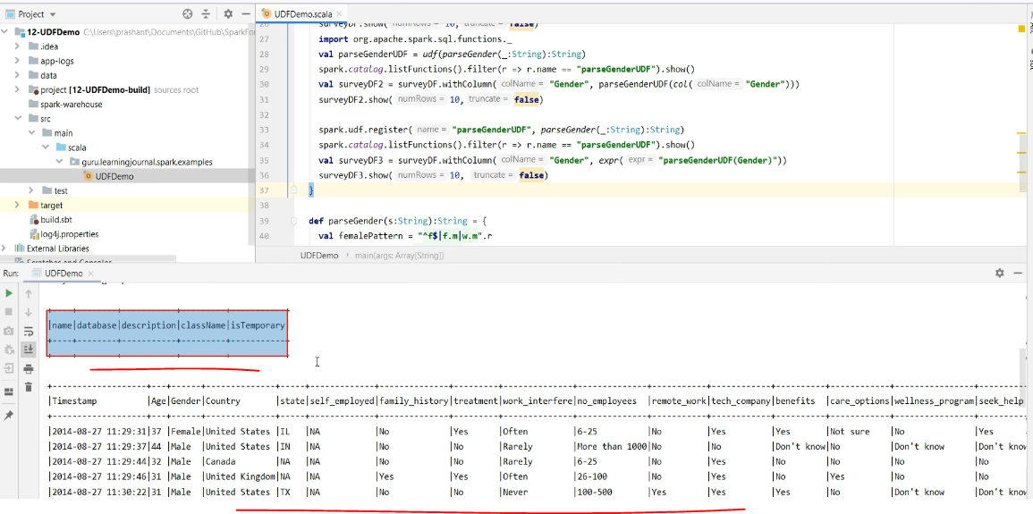

So the first output is showing the catalog. We registered parseGender() using the UDF() function, but we don't see it in the catalog. The following output is for the initial Dataframe. You can see some gender strings. Then we again see the catalog. This time you will find your UDF here. Finally, you will see the new Dataframe. We used the withColumn() transformation, which affected only the Gender field. The rest of all fields remained unchanged.

### Miscellaneous Transformations

We learned a bunch of transformation tools. However, I still have a few more commonly used techniques to cover. I am going to cover the following things.

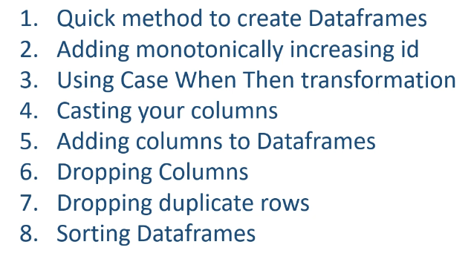

So, let's start with the first item Quick method to create DataFrames I created this MiscDemo example, which is structured like the earlier examples.

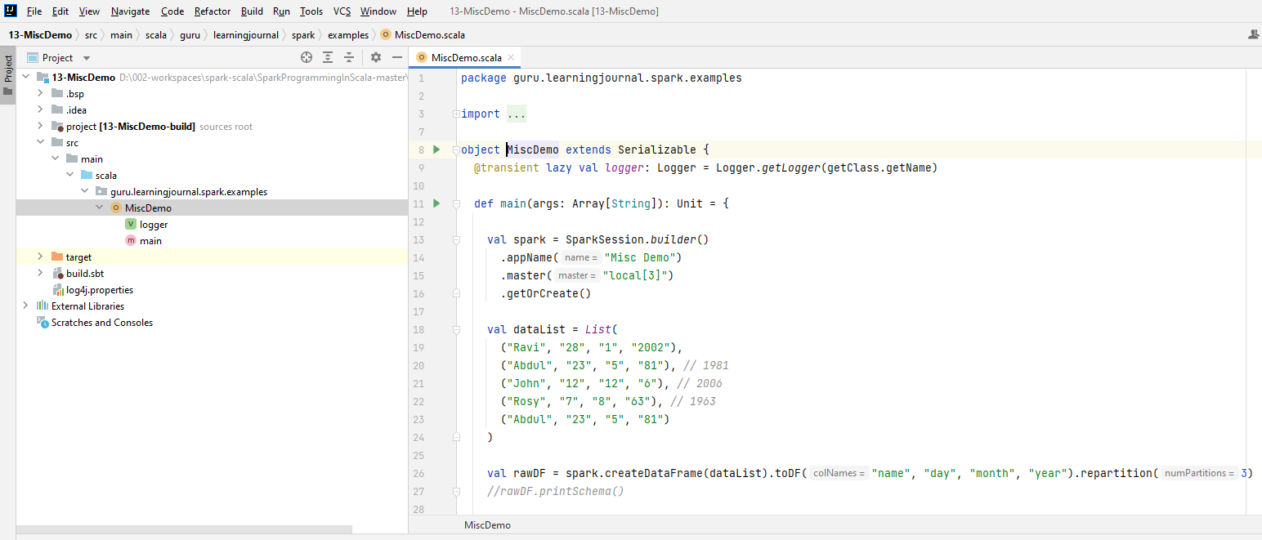

I have already created this SparkSession. Now I want to programmatically create a DataFrame. We already learned to create a DataFrame on the fly and also learned that we use them in unit testing our code. However, we also have a quick and dirty method for creating a Dataframe. Let me show you. Let me create a list with some sample data elements. Here it is. So, I am creating five sample records, each having four fields. The first field is the name, then we have a day, month, and year. Some of the year fields are four-digit year, and others are only two digits. We have a duplicate record also in this sample data set. We will learn to fix all these problems and also learn a few other things.

But before that, we need a data frame. So let me create a new DataFrame using the data list. I am using the CreateDataFrame() method without any schema. So this data frame is actually a dataset of four columns. The data type of the column is automatically inferred from the list. However, we do not have a meaningful column name because we didn't attach a schema. But I want to connect a schema to it. How to do it? Case Class. That's the only method we learned. You can definitely define a case class and apply it here. However, we also have a quick method to attach the column names. You can use the toDF() method and give a list of column names. That's all. Now, this DataFrame is as good as we created in the earlier lecture for unit testing our function. In this method, we skipped multiple things like parallelizing your data, creating RDD, creating schema definition, etc. This approach could be more convenient for quickly creating a data frame for testing or exploring some techniques. Good.

def main(args: Array[String]): Unit = {

val spark = SparkSession.*builder*()

.appName("Misc Demo")

.master("local[3]")

.getOrCreate()

val **dataList** = List(

("Ravi", "28", "1", "2002"),

("Abdul", "23", "5", "81"), *// 1981*

("John", "12", "12", "6"), *// 2006*

("Rosy", "7", "8", "63"), *// 1963*

("Abdul", "23", "5", "81")

)

val rawDF = spark.createDataFrame(**dataList**)

.toDF("name", "day", "month", "year")

.repartition(3)

// rawDF.printSchema()

You can print the schema of this data frame and quickly check it. Let me run it. So, all these fields are integer, which is good. However, I wanted to show you some specific problems dealing with incorrect data types.

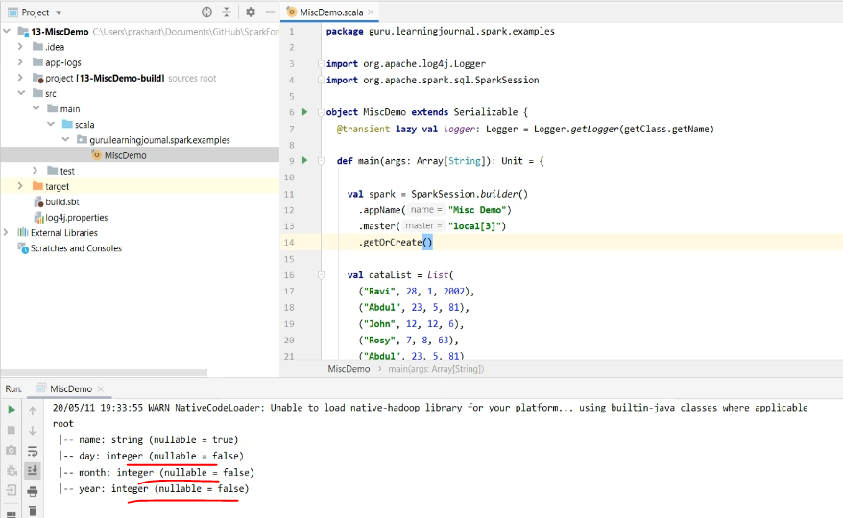

So, let me come back to the example and change these fields to string. Re-run it. Now, these fields are inferred as a string.

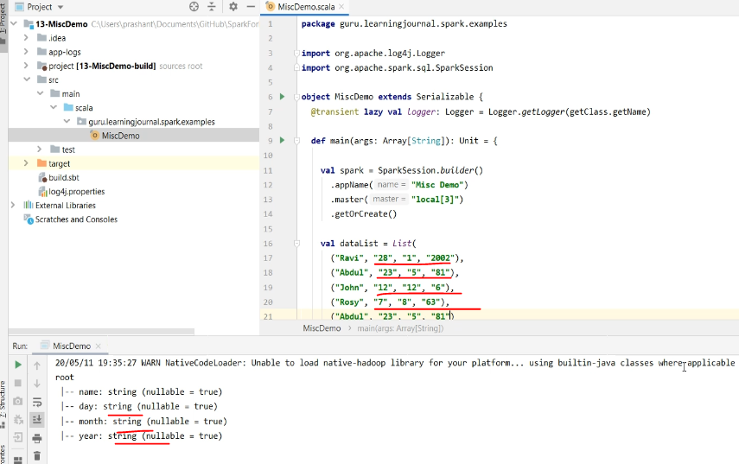

So you learned to quickly create DataFrame and adjust their data types without using the case classes.

Let's move on to the next item. So, I have this data frame, and I want to add one more field in this data frame to create a unique identifier for each record. You can do it using a built-in function monotonically increasing id. The function generates a monotonically increasing integer number, which is guaranteed to be unique across all partitions. However, don't expect a consecutive sequence number. It could be any integer number, but you won't get a duplicate. I recommend that you look at the list of available built-in functions at least once and learn what tools do you have in your hand.

import org.apache.spark.sql.functions.monotonically_increasing_id

I already shared the documentation link in the earlier video. Let's add an id filed. But before that, let me repartition this data frame and make three partitions. While working on a local machine, we always make sure that we have more than one partition so we can sense a realistic behavior. However, you should remove these unnecessary partitions from your final code. Good. Now I will create a new data frame and use the withColumn() transformation. We already learned to use the withColumn() for transforming an existing column. You can also use this method to add a new column in the data frame. So, I am going to transform the column id. Since column id does not exist in the data frame, it will be added.

val rawDF = spark.createDataFrame(dataList).toDF("name", "day", "month", "year").repartition(3)

And the value of the column will come from the monotonically_increasing_id function. That's all.

val finalDF = rawDF.withColumn("id", *monotonically_increasing_id*)

Let me run it and show you. So, I have a new column, and the values are filled by the function call. Good. Let's move to the next item. The Case When Then is a popular construct in programming languages. It is commonly known as switch case, and we prefer to use it to avoid lengthy if-else statements. It is trendy among SQL developers as well. I want to use it to fix the year digit problem. So, I have these two-digit years, and I want to make it four-digit. Well, it is almost impossible to fix it correctly, but we can make some assumptions to correct it. Let's assume that the year between 0 to 20 has an intention to be a post-2000 year. And anything between 21 to 99 is in the previous century.  So, this one should be 2006, and the other two are the 1981 and 1963. This one is a duplicate. Can create a case expression for this. Let's do it. I will add one more withColumn() to work with the year filed. Then I am going to create an expression using a multi-line string.

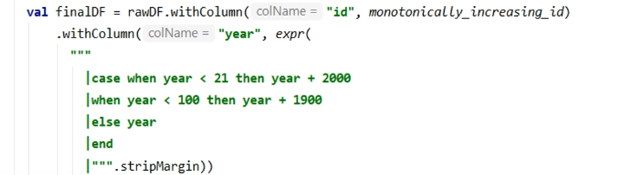

So now, I can write the case expression. It is as simple as the case when year < 21 then take year + 2000. When year < 100, then take year + 1900 else take the year without any change. Close the case with the end. Let's run it. Do you see any problem? The year becomes decimal. This is caused by the incorrect data type and the automatic type promotion.

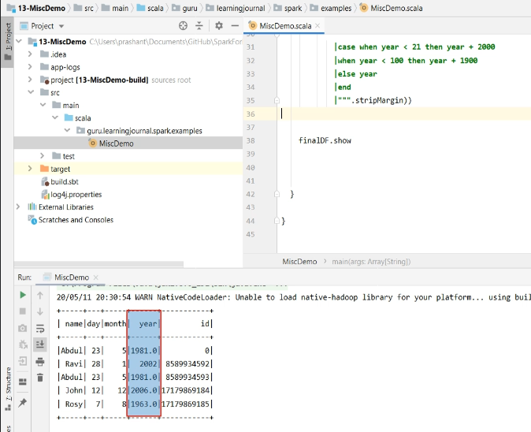

The year field in the data frame is a string. However, we performed an arithmetic operation in the year field. So, the Spark SQL engine automatically promoted it to decimal. And after completing the arithmetic operation, it is again demoted back to string because the data frame schema is for a string field. However, in all this, we still keep the decimal part, and that's how you see a decimal value in the result. How to fix it? There comes the next item. Casting your data frame columns is a common requirement. In this example, we have such a need. We have a bunch of ways to do it. However, I am particularly interested in two commonly used approaches. The first option is to make sure that the Spark doesn't automatically promote or demote your field types. Instead, we can write code to push it to an appropriate type. Let me do it.

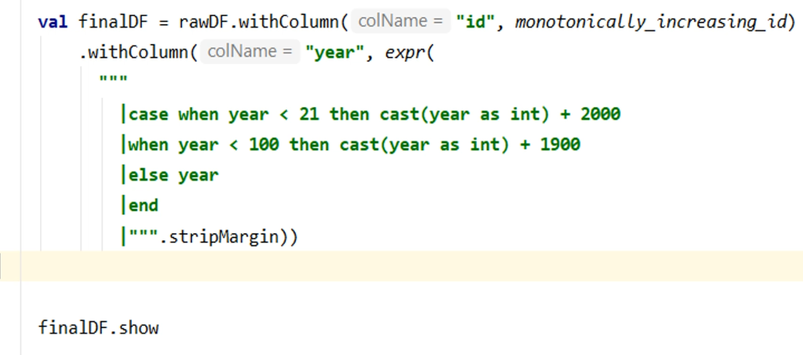

Simple. I am casting the year to an int. Same thing here also. Now the Spark SQL engine does not need to promote it and cause problems for us. This is the recommended approach for casting your fields. Cast it right at the place you want to cast. Let me run it and show you the result. Good. Now you see four-digit years.

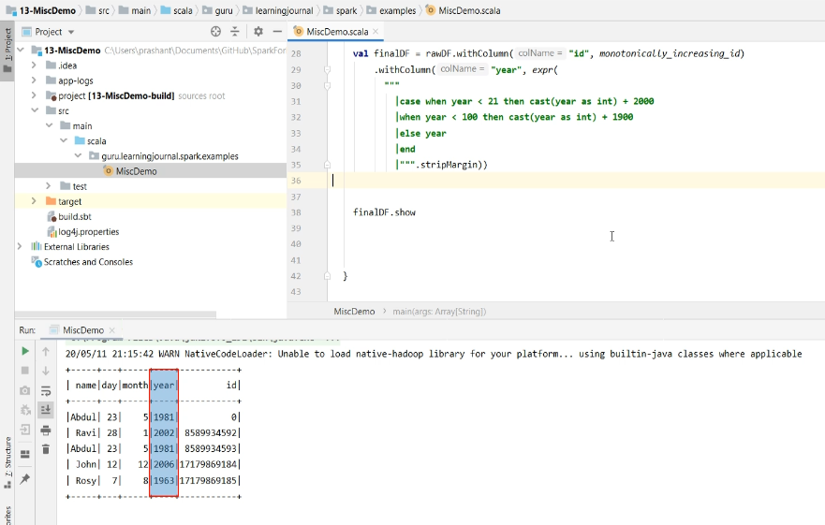

We also have a second approach to casting your field. Let me remove this cast. Good. Let me run it. So we are back to the original state. All that calculation happened, and we got decimal values. I didn't cast the year field where it should have been done.

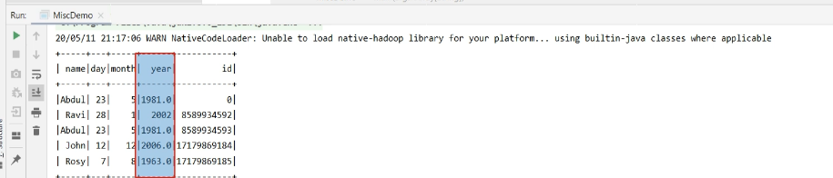

However, I can cast it now. So, this withColumn() is going to give me a modified year column. I can use the column functions here and cast it to IntegerType. And this casting will truncate the decimal part. However, since I am converting the column itself so my data frame schema will also change. Changing your schema is a choice that you need to make. In my case, changing the year field to an integer is perfectly fine.

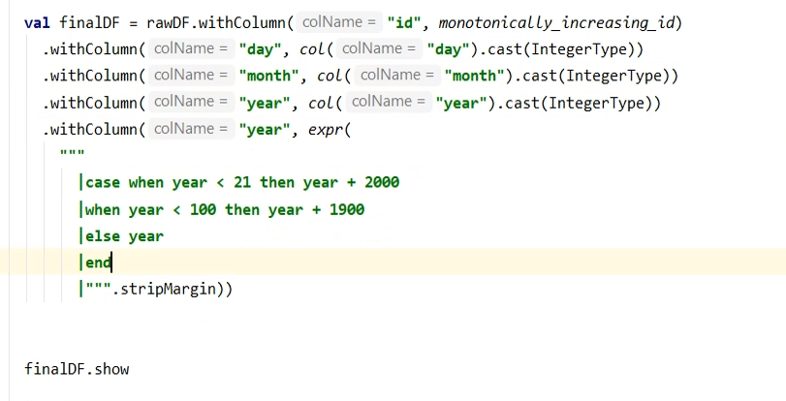

val finalDF = rawDF.withColumn("id", *monotonically_increasing_id*)

.withColumn("day", *col*("day").cast(IntegerType))

.withColumn("month", *col*("month").cast(IntegerType))

.withColumn("year", *col*("year").cast(IntegerType))

In fact, I should have fixed the data types in the beginning and avoided this casting altogether. Let's do it the right way. So, I am assuming that my initial data frame had an incorrect schema. Now I want to fix the types for the day, month, and year. So, I am going to cast all the three fields. That's all. Once I have the appropriate types, I can do all these arithmetics correctly. Good. So you learned two common approaches to fix your data frame schema. Both the methods are good, but all you need to remember is the incorrect types might give you some unexpected results. So, make sure you understand your data frame types and the kind of operations that are allowed. The explicit casing is always a good option to avoid unexpected behavior. Before we move on to the next item, let me show you an alternative method for the implementation case expression. SQL like expression is a more convenient approach, and I personally prefer it. However, we also learned to build our expressions using columns and functions. So let me show you the column object expression for the case expression. I am going to comment on this part and recreate it using column object expression. We are going to use the same withColumn() method and work with the year field. Now I am going to implement these two when conditions. So we will be using the when() function. The first argument is the condition, and the second argument is the return value. So, when column year is less than 21, then return the column year plus 2000. Let's add the second condition. When column year is less than 100, then return the column year plus 1900. Otherwise, return the column year. Simple.

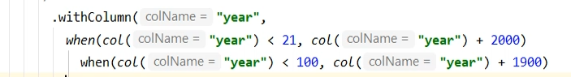

So you have both the options. You can use whatever you feel natural for you. Now the next item in our list is Adding and removing columns. We already learned to add a new column. We did it using monotonically_increasing_id.

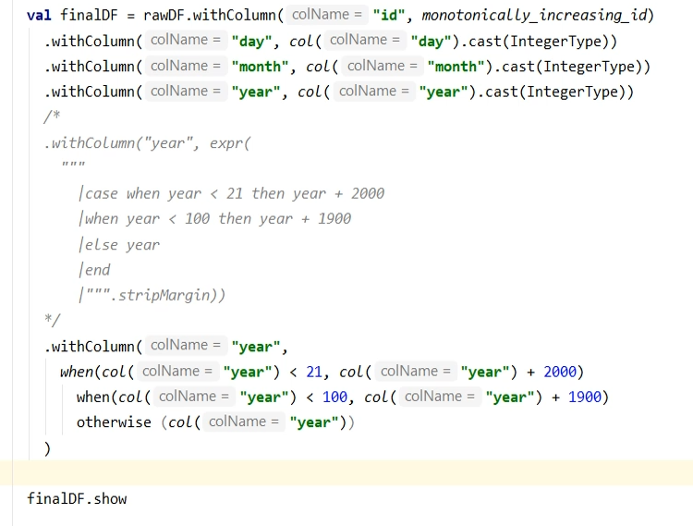

Right? I want to add one more column combining the day, month, and year. Let's do it. We again use the withColumn(). Create a new field for the date of birth. Create an expression to concat all the three fields and a field separator. However, this is going to give me a string. And I want to make it a date filed. So, I can use the to_date() function. Where to use the to_date? Well, you can use it inside your SQL expression. Like this. Or, you can use it on the column. Both options are valid and work in the same way. Let me run it. Good. So we have the dob field.

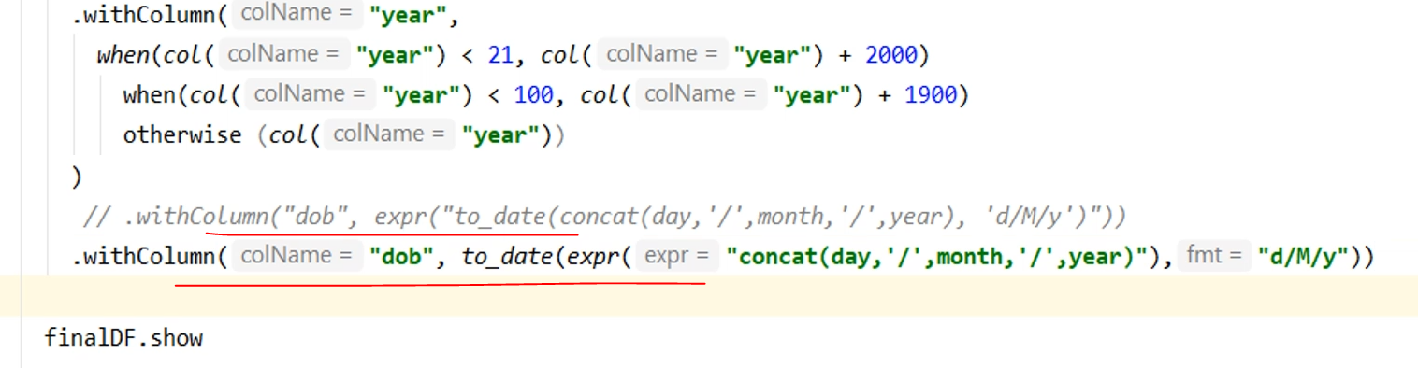

However, these three fields are now useless. Can I drop them from my data frame? Yes, we can. Let me do it. Drop the day, month, and year. That's all. Let me rerun it. Looks good.

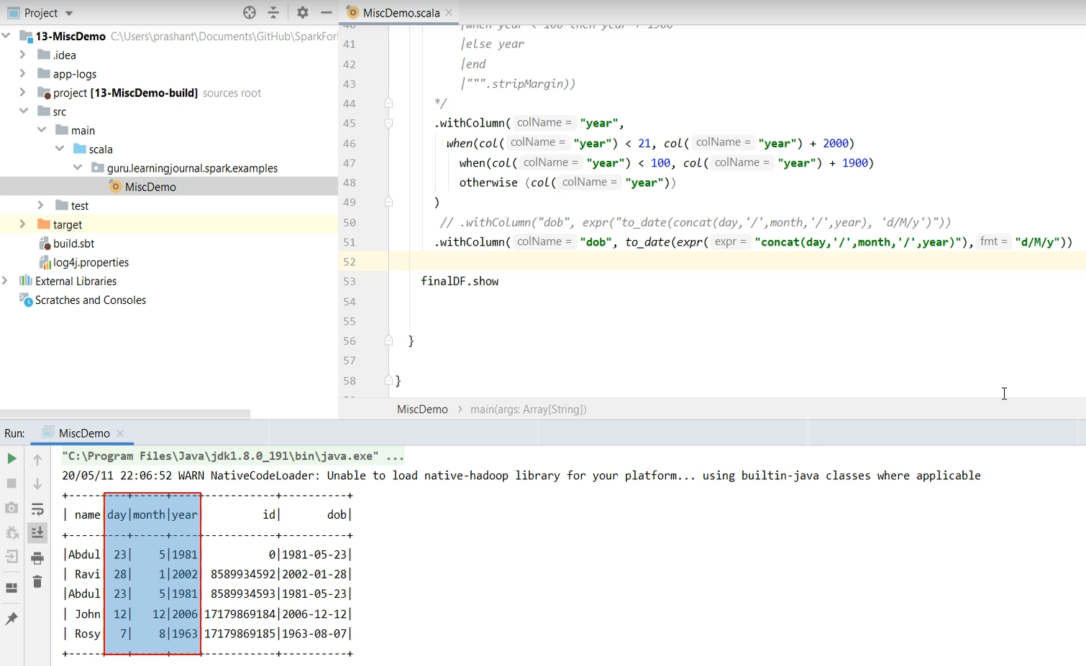

However, if we consider name and dob, then we have one duplicate record. Can I drop the duplicate? Yes, we can. Let me do it. Drop duplicates using name and dob. Let me rerun it. Looks good now.

package guru.learningjournal.spark.examples

import org.apache.log4j.Logger

import org.apache.spark.sql.SparkSession

import org.apache.spark.sql.functions._

import org.apache.spark.sql.types.IntegerType

object MiscDemo extends Serializable {

@transient lazy val logger: Logger = Logger.getLogger(getClass.getName)

def main(args: Array[String]): Unit = {

val spark = SparkSession.builder()

.appName("Misc Demo")

.master("local[3]")

.getOrCreate()

val dataList = List(

("Ravi", "28", "1", "2002"),

("Abdul", "23", "5", "81"), // 1981

("John", "12", "12", "6"), // 2006

("Rosy", "7", "8", "63"), // 1963

("Abdul", "23", "5", "81")

)

val rawDF = spark.createDataFrame(dataList)

.toDF("name", "day", "month", "year").repartition(3)

//rawDF.printSchema()

//case when year < 21 then cast(year as int) + 2000

//when year < 100 then cast(year as int) + 1900

val finalDF = rawDF.withColumn("id", monotonically_increasing_id)

.withColumn("day", col("day").cast(IntegerType))

.withColumn("month", col("month").cast(IntegerType))

.withColumn("year", col("year").cast(IntegerType))

/*

.withColumn("year", expr(

"""

|case when year < 21 then year + 2000

|when year < 100 then year + 1900

|else year

|end

|""".stripMargin))

*/

.withColumn("year",

when(col("year") < 21, col("year") + 2000)

when(col("year") < 100, col("year") + 1900)

otherwise (col("year"))

)

// .withColumn("dob", expr("to_date(concat(day,'/',month,'/',year), 'd/M/y')"))

.withColumn("dob", to_date(expr("concat(day,'/',month,'/',year)"),"d/M/y"))

.drop("day", "month", "year")

.dropDuplicates("name", "dob")

.sort(expr("dob desc"))

finalDF.show

}

}

Can I sort it by dob in descending order? Yes, we can. Let me sort it using the dob. By default, it is ascending. However, we wanted to sort it using descending. Well, that is simple. But now, this string is no longer a filed name. It became an expression. So, I will apply the expr() function. Let me run it. Looks good.

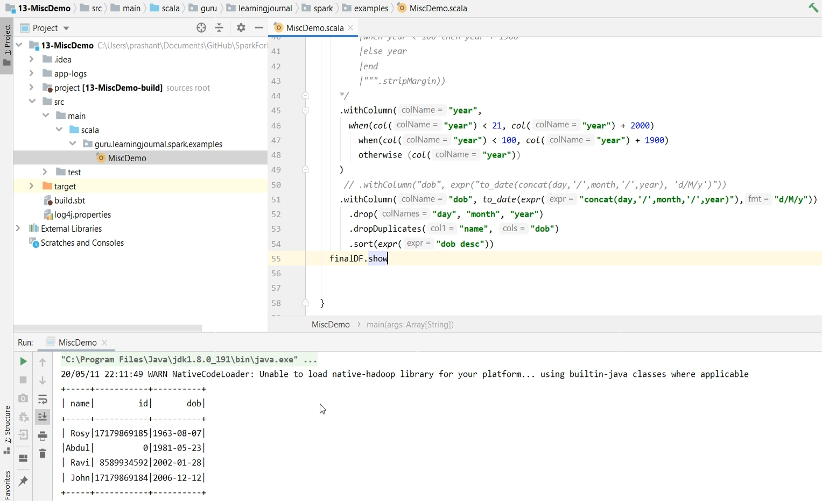

## Aggregations in Apache Spark

### Aggregating Dataframes

I am going to talk about the aggregations in Apache Spark. So, let's start. Aggregations can be classified into three broad categories. Simple Aggregations Grouping Aggregations And finally, Windowing Aggregations and summarization. We have techniques beyond this level, which are mostly used by Analysts and Data Scientists. However, we are going to limit our discussion to these three types of aggregations.

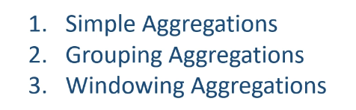

One more important thing. All aggregations in Spark are implemented via built-in functions. So if you look at the Spark documentation for built-in functions, you will see many functions listed under the aggregate functions. These functions include avg(), count() max(), min(), sum() and many other things.

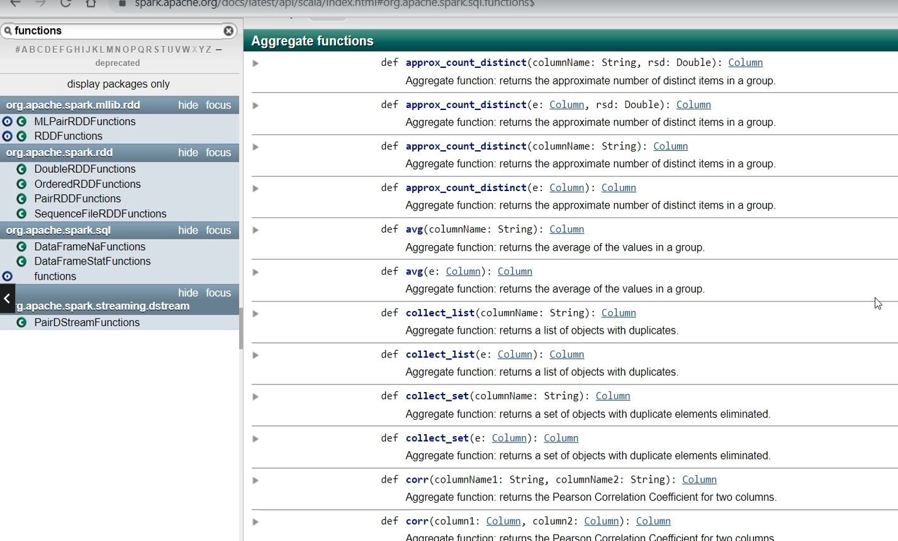

These aggregate functions are used for simple and grouping aggregations. You will also find another category for window functions. These are used for windowing aggregates.

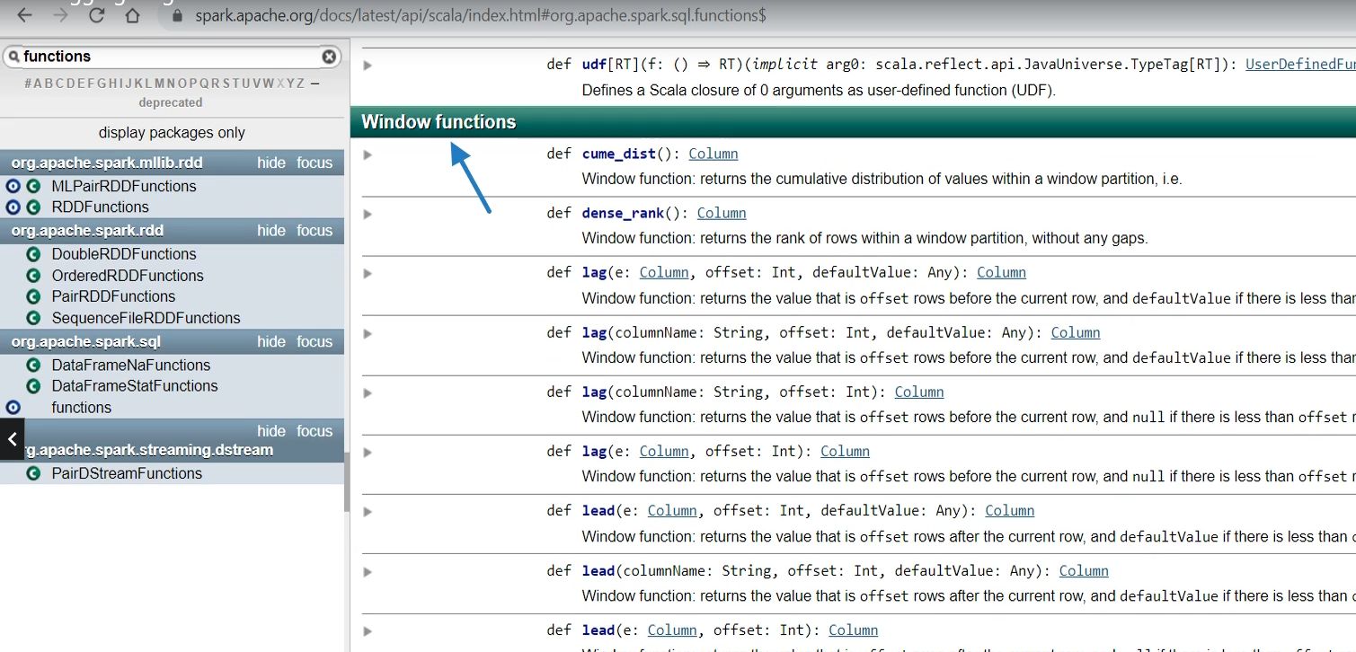

We will learn about implementing all three categories. So, let's start with the first one. I created this example project named aggregate demo. And I will be using this CSV data file. This data file contains the list of invoice line items. So, we have the invoice number, stock code, and stock item description. We also have some other things like Quantity, Date, UnitPrice, CustomeriD, and Country.

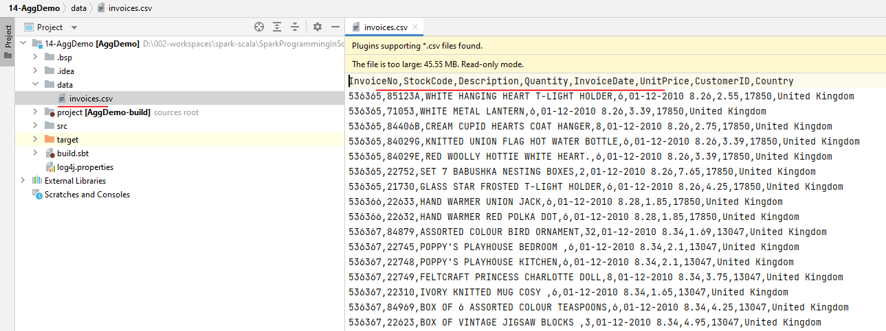

Invoice numbers are repeating, so all these items belong to the same invoice. Now let's come to the application code. I am reading the data file to a DataFrame. I am also importing all functions here because aggregation is all about using aggregate and windowing functions.

package guru.learningjournal.spark.examples

import org.apache.log4j.Logger

import org.apache.spark.sql.SparkSession

import org.apache.spark.sql.functions._

object AggDemo extends Serializable {

@transient lazy val *logger*: Logger = Logger.*getLogger*(getClass.getName)

def main(args: Array[String]): Unit = {

val spark = SparkSession.*builder*()

.appName("Misc Demo")

.master("local[3]")

.getOrCreate()

val invoiceDF = spark.read

.format("csv")

.option("header", "true")

.option("inferSchema", "true")

.load("data/invoices.csv")

invoiceDF.selectExpr(

"count(1) as `count 1`",

"count(StockCode) as `count field`",

"sum(Quantity) as TotalQuantity",

"avg(UnitPrice) as AvgPrice"

).show()

. . .

summaryDF.show()

}

}

Now we are ready to do some aggregation. Let's start with the simplest one. The simplest form of aggregation is to summarize the complete Data Frame, and it is going to give you a single row in the result. For example, you can count the number of records in this DataFrame, and it will return you a single row with the count of records. Let me show you. We start with the DataFrame and use the select() method and apply the count(*) function. You can also give an alias to the summary column. You can also add one more summary column for the sum() of the quantity. In fact, you can add as many columns as you want. Let me compute the average price. We also have a countDistinct() function. Let me count the unique values of an invoice number. The countDistinct() will give you the number of unique invoices in this DataFrame. The select method will return you a new DataFrame, and you can show it. Do you want to run it? Let me do it.

invoiceDF.selectExpr(

"count(1) as `count 1`",

"count(StockCode) as `count field`",

"sum(Quantity) as TotalQuantity",

"avg(UnitPrice) as AvgPrice"

).show()

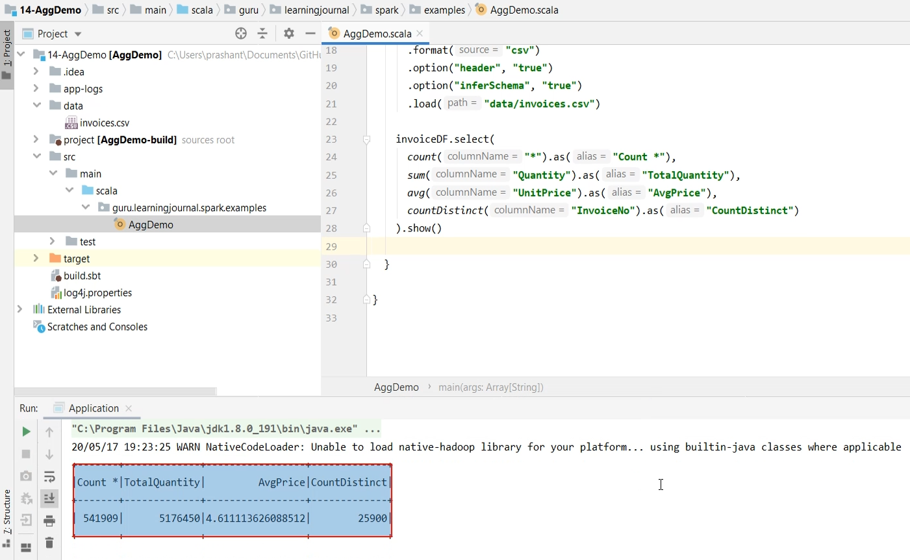

So as expected, we summarized the whole DataFrame and got one single row in the result. And that's what we call the simple aggregation. These aggregates are nothing but functions. So you can use them in column object expression like we are using here. And you can also use them in SQL like string expressions. Let me show you. Now I am going to use the selectExpr(), so I can pass in the SQL like expressions. This time, I want to use the count(1) instead of the count(*). I often get this question. What is the difference between count(*) and count(1)? The answer is - Nothing.

invoiceDF.createOrReplaceTempView("sales")

val summarySQL = spark.sql(

"""

|SELECT Country, InvoiceNo,

| sum(Quantity) as TotalQuantity,

| round(sum(Quantity*UnitPrice),2) as InvoiceValue

| FROM sales

| GROUP BY Country, InvoiceNo

|""".stripMargin

)

summarySQL.show()

In Spark, they both work in the same way and give the same answer. No difference at all. However, counting a column field has a difference. Let me count the Stock Code. So, the count(*) and count(1) will count all the rows even if you have null values in all the columns. However, counting a field such as StockCode will not count the null values. We will see it in the result. You can also add sum(), avg(), and other aggregations if you want to. Let me run it. Good. So we got the summary. The count(1) gives you the same value as count(). However, the count() field is one lesser. Why? Because we have one record where stock code is null. So, when you are counting a field, it doesn't count the nulls. Let's move on to the next one. The simple aggregation will always give you a one-line summary. However, you may want a more detailed summary. For example, I am looking to summarize my DataFrame like this. So, what do we want here? We still want to compute two aggregates. The first one is the sum(Quantity). And the second one is the sum(Quantity * UnitPrice). However, instead of summarizing them for the whole DataFrame, we want to group them into the country and invoice number. And then apply these two aggregates.

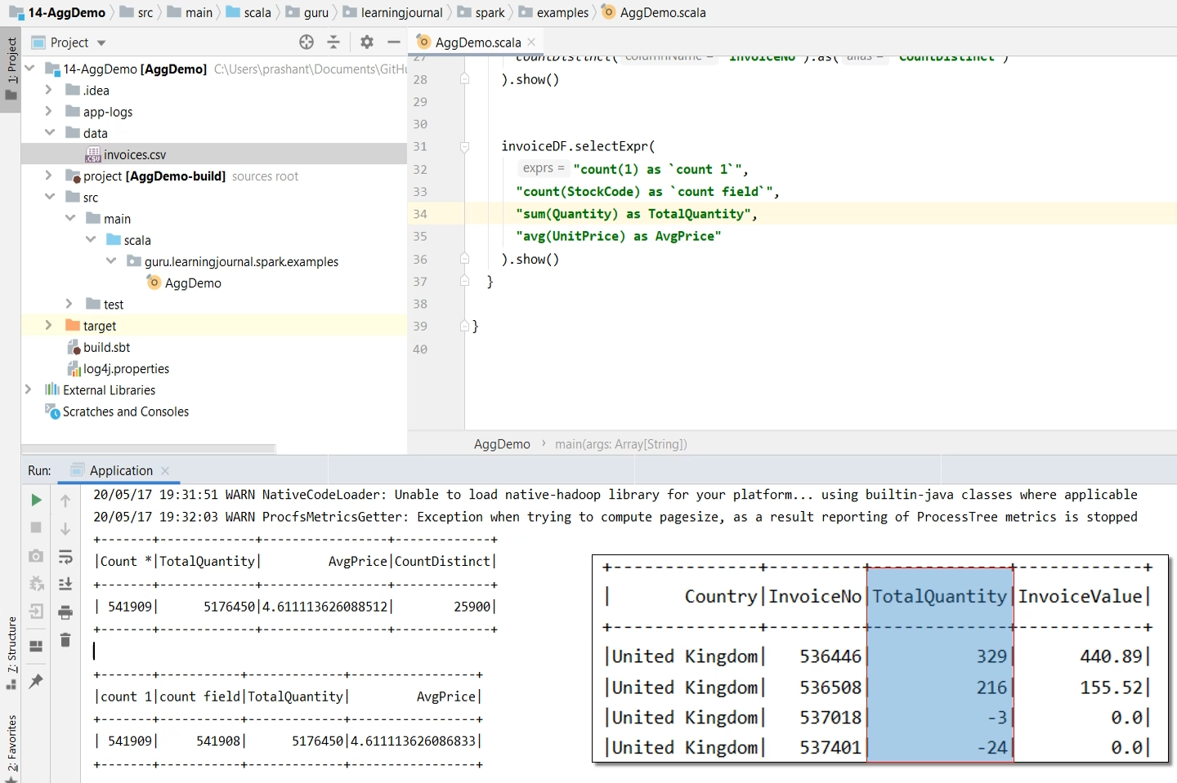

If you have some good background in SQL, you can quickly write a SQL expression for this aggregation. Here it is. And if you can create a SQL expression, then you can run it in Spark as well. We already learned it. You can use your DataFrame to create a temp view. And then, you can use the Spark SQL. I am going to use a multiline string here. Why? The multiline string looks more readable. That's it. Let me paste the SQL here. The SQL expressions will return a DataFrame, and you can use it in whatever way you want. I am going to show it. That's all. Let me run it and show you the result. It works. Spark SQL is an excellent and easy method to run your grouping aggregations. However, you can do the same using Dataframe expressions also. Let me show you.

val summaryDF = invoiceDF.groupBy("Country", "InvoiceNo")

.agg( *sum*("Quantity").as("TotalQuantity"),

*round*(*sum*(*expr*("Quantity*UnitPrice")), 2).as("InvoiceValue"),

*expr*("round(sum(Quantity*UnitPrice),2) as InvoiceValueExpr")

)

summaryDF.show()

We start with the DataFrame and use the groupBy() to group the records. Same as the SQL, I am grouping it on the country and the Invoice number. Now, all we are left with is to apply the sum() functions. So, you can use the agg() transformation. The agg()transformation is specifically designed to take a list of aggregation functions. So my fist aggregation is the sum(Quantity). I can also give an alias. The next aggregation is a little complex. Can you make a column expression for this SQL expression? Let me show you. We start with the innermost expression. But this is not a single column name. It is an expression. So, we wrap it around the expr(). Then, you can take a sum(), then round() it. And finally, give an alias(). That's all. However, if you are getting confused, take this whole expression. And wrap it around the expr(). That's all. Both approaches are the same. Let me run it. It works. Now let me give you a simple exercise. Considering the same invoice data file. Can you create a DataFrame that aggregates to show the following? I have five columns in the result.

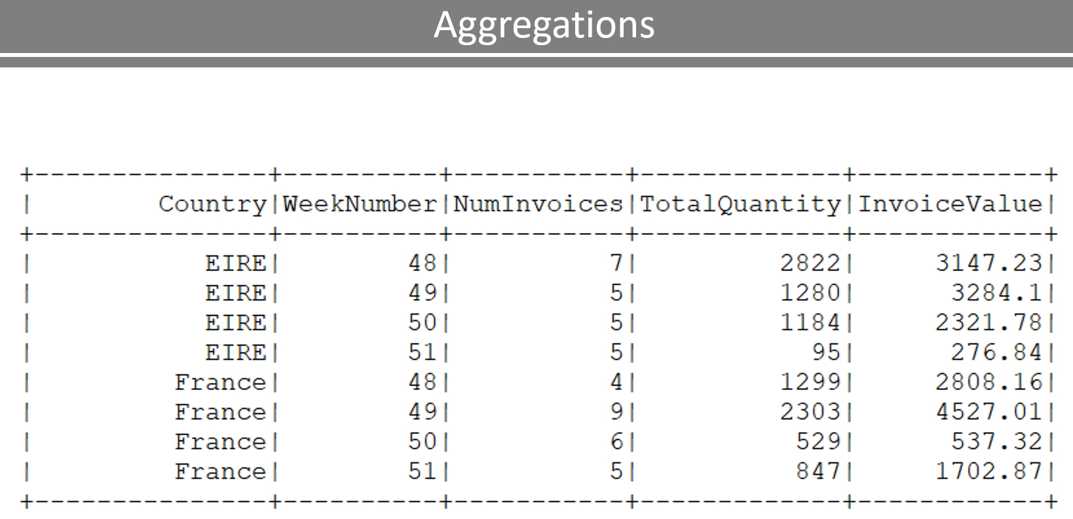

The first two are grouping columns, and the remaining three are aggregations. So, we want to group it by country and the week number of the year. Grouping on the country is simple. You already have a country column in the input DataFrame. However, you don't have the week number. But you have the Invoice Date, and you can transform the date to a week number. We have a built-in function for this. Now let's come to the aggregates. So the first aggregate is the number of unique invoices. You already learned the count Distinct(). You can get this easily. The total quantity is the sum("Quantity"), and the total value is the sum(Quantity * Unit Price). Take the challenge and do it yourself. I will show you the solution in the next video and extend this example to learn the windowing aggregates.

### Grouping Aggregations - Solution

We learned to compute simple, and grouping aggregates in the earlier video. I also gave you a simple exercise to create the following DataFrame. In this lecture, I am going to show you the solutions and also extend this example to compute windowing aggregates.

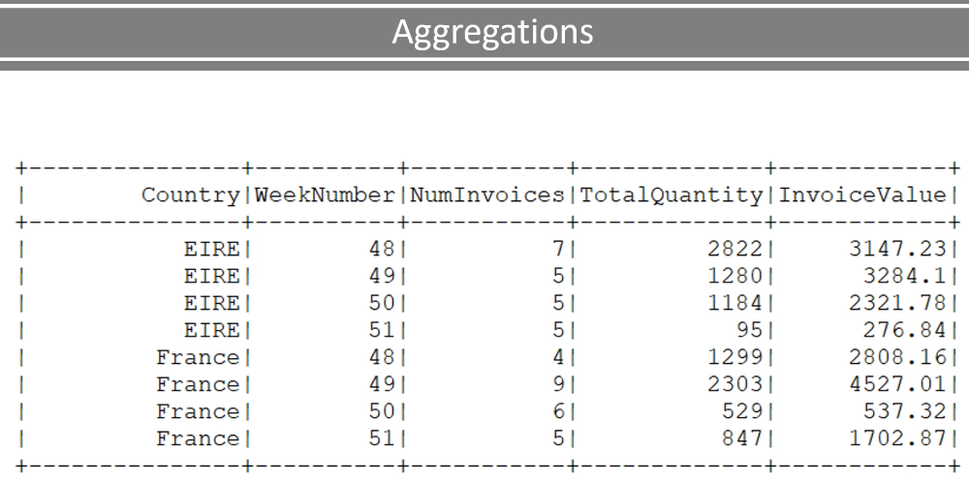

Let's start. So, I created this new example project.

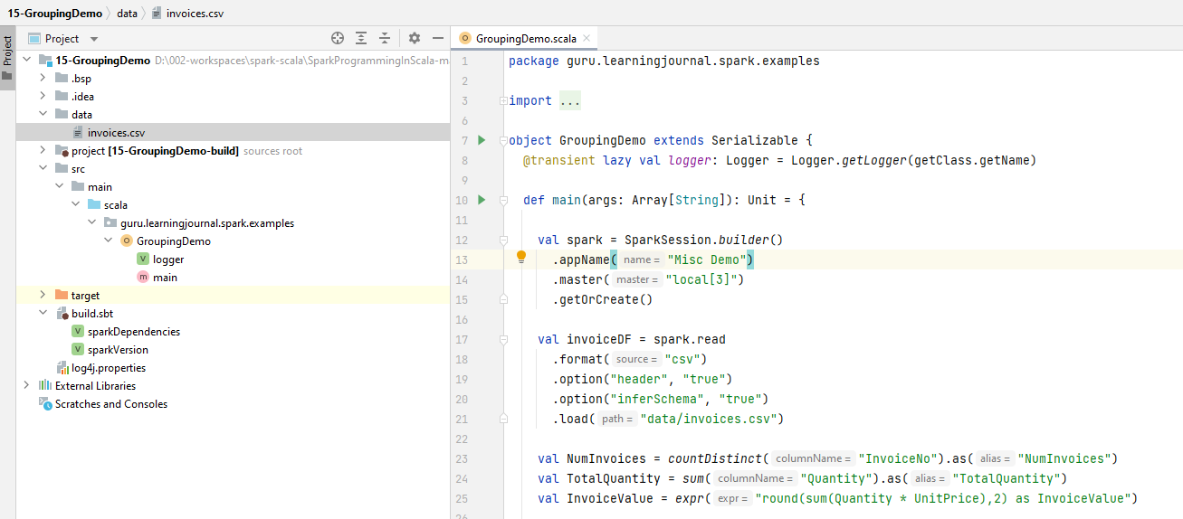

It is a copy of the Aggregation Demo project, and we will be working with the same data file. Let's look at the code. I am creating the spark session and loading the raw data to a DataFrame. Now we want to compute the grouping aggregates as per the table shown here. How to proceed? Let's look at the requirement. We want to group the initial raw DataFrame by two columns - Country and Week Number. We already have a country field in the source DataFrame. However, we do not have the week number field. However, we do not have the week number field. We can extract the week number from the InvoiceDate. We have a built-in function called weekofyear(), which will give us the week number. However, the weekofyear() expects a Date field, and Invoice Date is a string in our data frame. So, the first thing is to convert the Invoice Date to a proper date field. Let's do it. We start with the invoice data frame, and we will be using the withColumn() transformation to convert the InvoiceDate. All you need to do is to apply the to_date() function. That's all. Now the InvoiceDate will change to a proper date type. The sample data is a little big for aggregating on a single computer, so let me filter it for 2010 only.

package guru.learningjournal.spark.examples

import org.apache.log4j.Logger

import org.apache.spark.sql.SparkSession

import org.apache.spark.sql.functions._

object GroupingDemo extends Serializable {

@transient lazy val logger: Logger = Logger.getLogger(getClass.getName)

def main(args: Array[String]): Unit = {

val spark = SparkSession.builder()

.appName("Misc Demo")

.master("local[3]")

.getOrCreate()

val invoiceDF = spark.read

.format("csv")

.option("header", "true")

.option("inferSchema", "true")

.load("data/invoices.csv")

val NumInvoices = countDistinct("InvoiceNo").as("NumInvoices")

val TotalQuantity = sum("Quantity").as("TotalQuantity")

val InvoiceValue = expr("round(sum(Quantity * UnitPrice),2) as InvoiceValue")

val exSummaryDF = invoiceDF

.withColumn("InvoiceDate", to_date(col("InvoiceDate"), "dd-MM-yyyy H.mm"))

.where("year(InvoiceDate) == 2010")

.withColumn("WeekNumber", weekofyear(col("InvoiceDate")))

.groupBy("Country", "WeekNumber")

.agg(NumInvoices, TotalQuantity, InvoiceValue)

exSummaryDF.coalesce(1)

.write

.format("parquet")

.mode("overwrite")

.save("output")

exSummaryDF.sort("Country", "WeekNumber").show()

}

}

This filtering is not part of the requirement. However, I am doing it to restrict the sample size. Now, you can again use the withColumn() to add a new column for the week number. Extracting week number is as simple as using the weekofyear() function. Now we are ready to group it. So let's do a groupBy() for country and then week number. Done. We are now ready for the aggregation. How to aggregate? You already learned the agg() method. So let me use it. The first aggregation is as simple as using the countDistinct() for InvoiceNo. We also need an alias. So, this is my expression for the first aggregation. You can build your expression here in the agg() method. Or, you can define this aggregation as a scala val and use the val in the agg() method. Let me show you. So, I am defining a scala val and initializing it with the expression. Now, I can use this val here. Simple, Isn't it. This approach can make your code more readable. Let me define the second aggregation. The second one is the total quantity, which you can calculate using the sum() function. Let's do the third one also. Here it is.

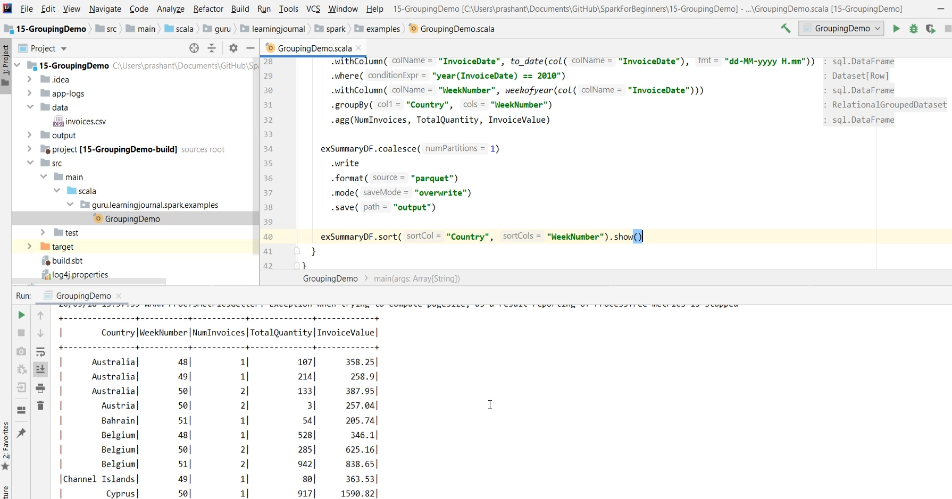

We build this expression in the previous example. Now we place all the three expressions in the agg() method. Good. We are done. However, I want to save this data frame as a parquet file and use it for my next example. So, let me hold this data frame in a variable. Then, I can write the output in the parquet format. Let me set the mode to overwrite and save it to the output directory. However, I want to coalesce() this data frame before saving. We haven't learned to coalesce() yet, and I will cover it in a separate video. For now, let's use it here. I am also going to sort() this data frame and show it. Let's run it once. So we achieved the expected result.

### Windowing Aggregates

Lets now talk about window aggregates. So, let's start. We computed grouping aggregates and created the following Dataframe in the earlier video. However, I want to extend this summary to meet the following requirement.

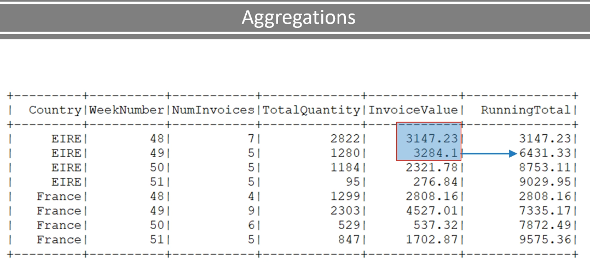

Compute week by week running total for each country, So the outcome should look like this. Let's assume we are starting with week 48. So the running total of week 48 is the same as the invoice Value. But for week 49, it is the sum of these two. Similarly, for week 50, it will be the sum of these three.

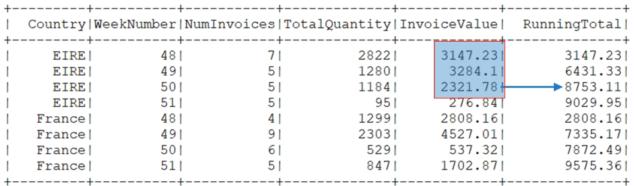

And it goes on in the same way for each country. However, the whole logic restarts when you get a new country.

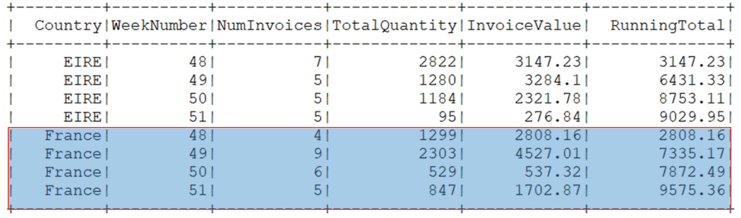

So how do you do it? We cannot achieve this requirement using simple grouping and aggregation. These kinds of aggregates are called window aggregates. Why? Let's try to understand it. We want to compute running totals for each country. The running total should restart for each country. So the first thing is to make sure that we break this Dataframe by the country.

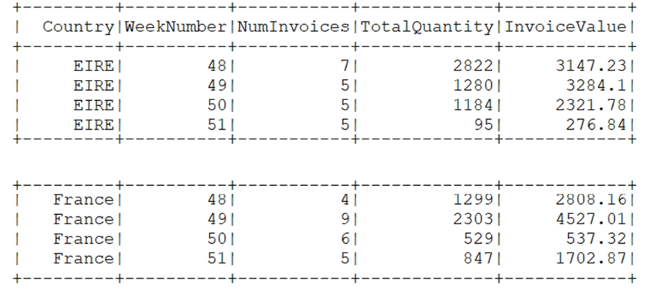

It is like partitioning your data frame by country. Now the next critical thing is to make sure that we order each partition by the week number. Why?

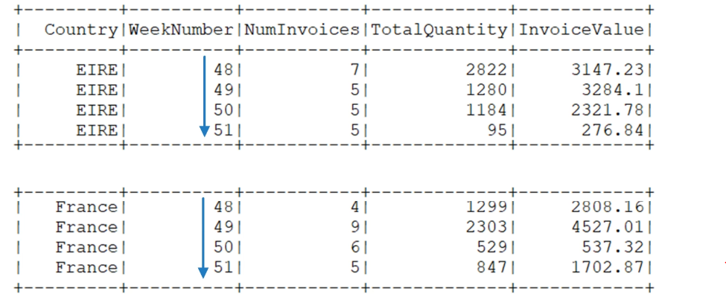

Because we want to compute week by week totals. So the running total for week 50 should be the sum of the week 48+49+50 in the same sequence.

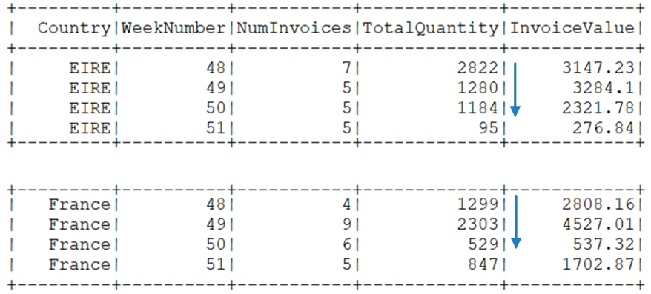

Right? So, the order of weel number is another critical thing. Now the last thing is to see how to compute the running total. And we can calculate the totals using a sliding window of records. So, the running-total window starts with one record. We take the total and extend the window to two records. Take the sum once again. Then extend the window to three records. Take the total once again. And this goes on for the entire partition. The same logic repeats for the other partition.

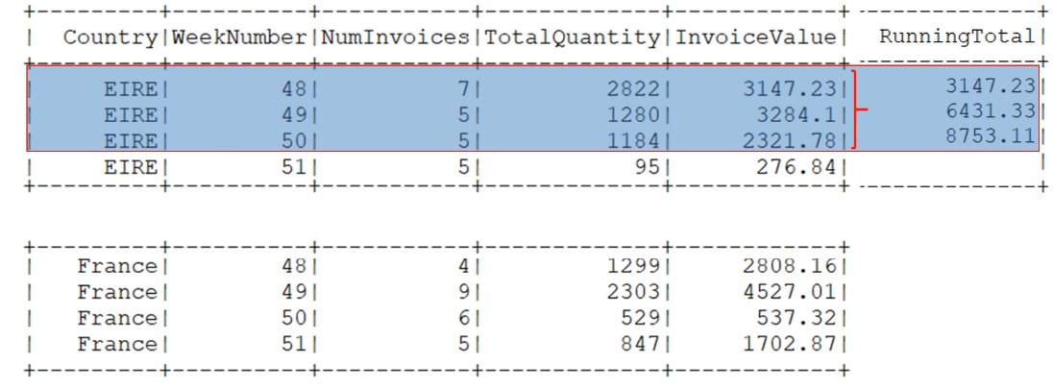

This windowing can help you compute a whole new class of aggregations. And using them is a three-step process.

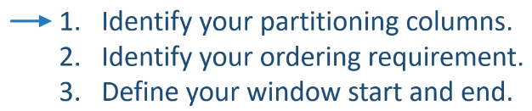

Identify your partitioning columns. In our example, it was the country. Identify your ordering requirement. And we wanted it to order by week number. Finally, define your window start and end. In our case, The window starts at the first record and includes everything till the current record. For example, when computing the running total for week 50, the window begins at the first record, which is week 48. And it ends at the current record, which will be week 50.

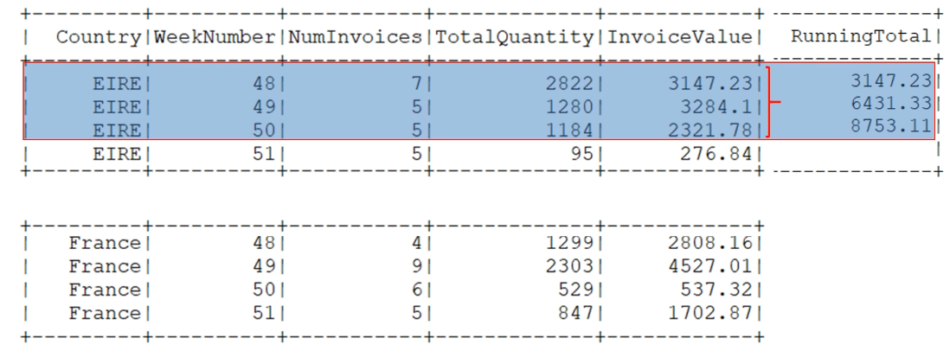

Now let's come back to the code and implement it. I have this new example created here. This example comes with a parquet data file. Let's come back to the code.

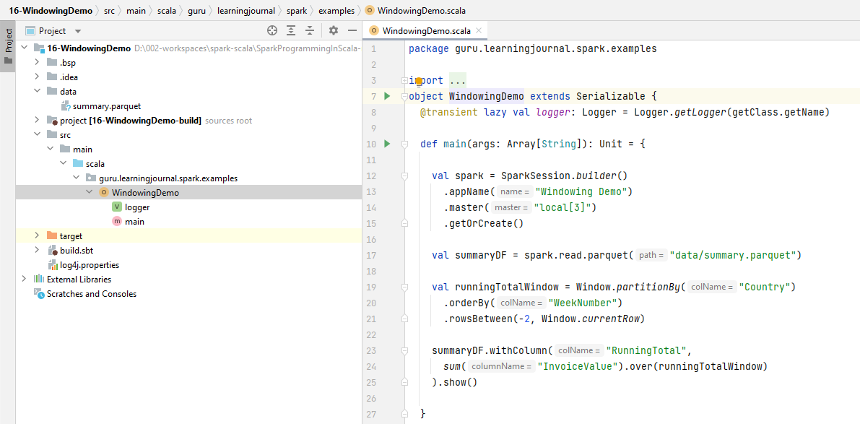

So, I am loading the parquet data to a data frame. Now, we are ready to aggregate the data frame and compute the running total. Aggregation is super simple. However, before we do that, let's define our window. So, I am going to create a runningTotalWindow. And you can set it using the Window Object. We have three things to define here. Partition Ordering And the window start/end. Let's define the partition. So we want to partitionBy the country. And order by the week number. Finally, we want to consider rows between unboundedPreceding and currentRow. That's all. We have the window definition. Now computing aggregate over this window is straight.

package guru.learningjournal.spark.examples

import org.apache.log4j.Logger

import org.apache.spark.sql.SparkSession

import org.apache.spark.sql.expressions.Window

import org.apache.spark.sql.functions._

object WindowingDemo extends Serializable {

@transient lazy val logger: Logger = Logger.getLogger(getClass.getName)

def main(args: Array[String]): Unit = {

val spark = SparkSession.builder()

.appName("Windowing Demo")

.master("local[3]")

.getOrCreate()

val summaryDF = spark.read.parquet("data/summary.parquet")

val runningTotalWindow = Window.partitionBy("Country")

.orderBy("WeekNumber")

.rowsBetween(-2, Window.currentRow)

summaryDF.withColumn( "RunningTotal", sum("InvoiceValue")

.over(runningTotalWindow) )

.show()

}

}

We start with the Dataframe and use the withColumn() to add a new column for running total. And the value of the running total is the sum(InvoiceValue) over the runningTotalWindow. That's all. We are done. Let me show it now.

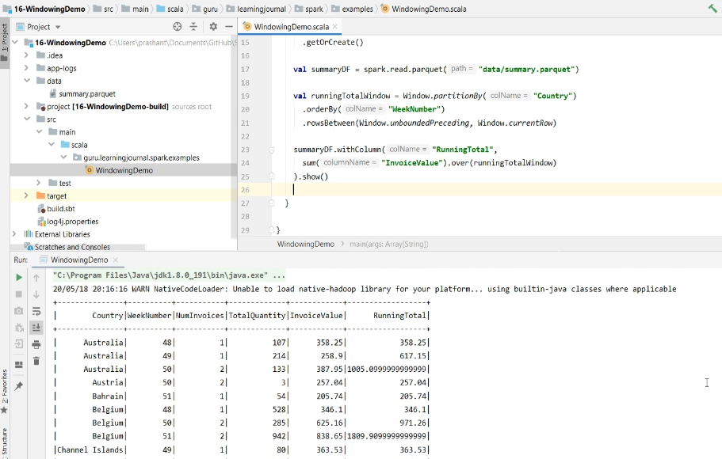

Let me run it and show you the output. So this unboundedPreceding means to take all the rows from the beginning. However, you can give any numeric value here. For example, If I can give -2 as the start of the window. So, the window will now start from the two rows before the current row. The end of the window is the current row. So, you will be calculating the running total for a three-week window. Let me run it and show you. Good! So now the running total is the sum of these three only.

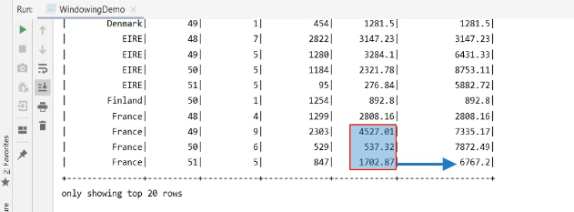

Right? We used the sum for aggregating over the window. However, you can use any of the available aggregation functions, such as avg() or mean(). You can also use one of the analytical functions such as dense_rank(), lead(), and lag(), etc.

## Spark DataFrame Joins

### Dataframe Joins and column name ambiguity

So far, in this course, we have been working with a single data frame. However, your Spark applications are going to bring together a large number of different data frames. And hence, you may need to join them together. In this section, we will talk about the Spark Joins and how to use them. I will also cover some of the essential internals to help you understand how things happen on the cluster. Some basic knowledge of internals can help you avoid running out of memory and other problems even before they arrive. So, Let's start. Joins are all about bringing together two data frames. Here is an example. And these two data frames are termed as a left data frame and the right data frame. Correct? It is up to you to decide which one do you want to make left and which one to take as the right data frame. And we combine these left and right data frames using two things. The join condition or the join expression. And the join type Right?

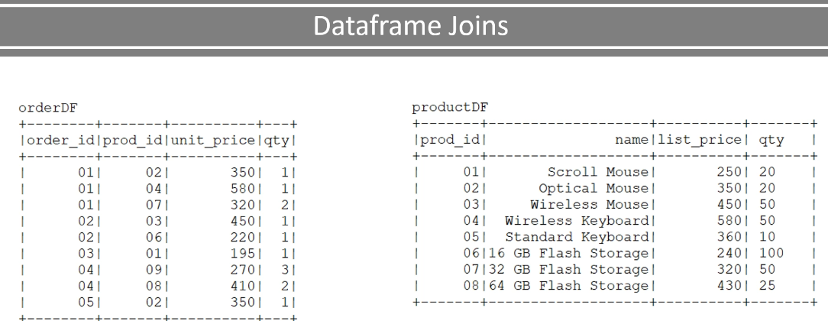

Here is an example of join expression and join type. And you can perform the join using the following code. I will run this example in a minute and show you the outcome. But before that, let us try to understand a few things. I wanted to consider the orderDF as my left data frame. So, I start with the orderDF. We always start with the left data frame and pass-in the right data frame as the first argument to the join method.

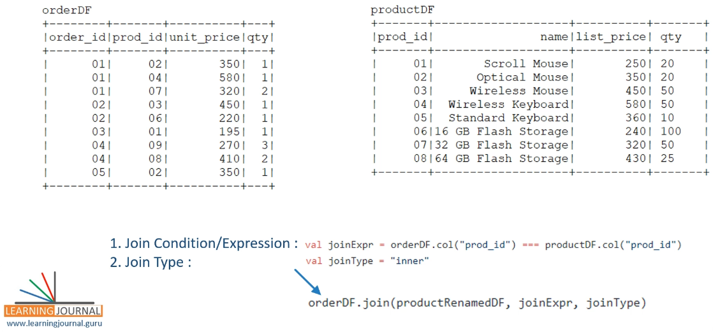

The join method takes two more arguments. Join Expression and Join Type. You can define a variable and pass it here. Or you can type in the expressions directly. It works both ways. The inner join is the default join type. So you can skip the third argument if you want to perform an inner join. So what do you expect? What is going to happen? Spark is going to take one row from your left data frame. And evaluate the join expression for all the rows in the right data frame to find a match.

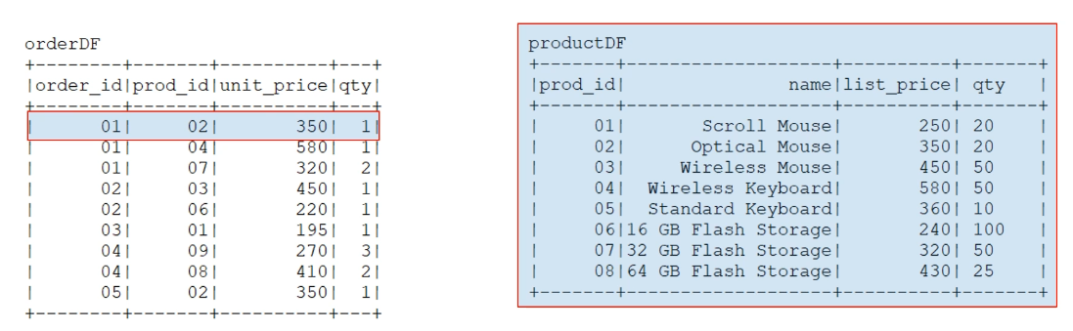

Then it goes to the second row and repeats the same. And so on. The next step is to combine these matching records from the left and the right data frames to create a new data frame. That's where the join type comes into the play. The default inner join type will take only those records which are matched with at least one record on the other side.

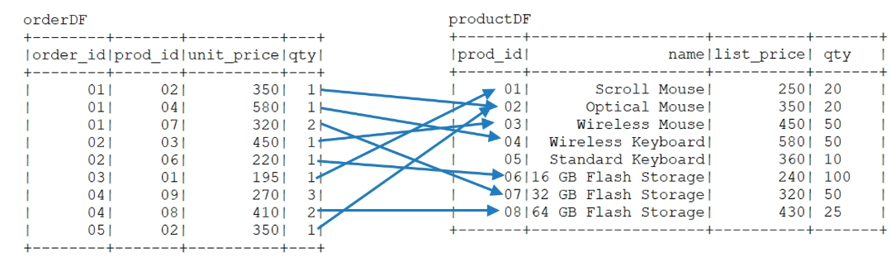

So, in our example, everyone got a match except one. This guy doesn't have a matching product. So, we can expect all the other rows in the result except this one.

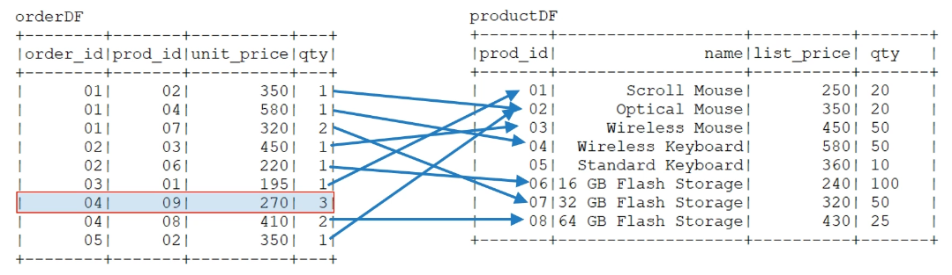

Let's try implementing this example. So, I have this example setup. I am creating a spark session. Then I am creating this orderDF from a list of sample records. We already learned this. Similarly, I am also creating a productDF. Let me show you the data frames. So, here is the orderDF

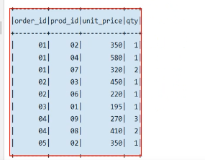

and here is the productDF

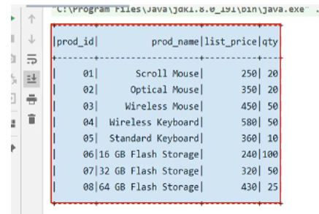

Now we are ready to perform the join.. Let's define the join expression Then we perform the join. Simple. Isn't it.

package guru.learningjournal.spark.examples

import org.apache.log4j.Logger

import org.apache.spark.sql.SparkSession

object SparkJoinDemo extends Serializable {

@transient lazy val logger: Logger = Logger.getLogger(getClass.getName)

def main(args: Array[String]): Unit = {

val spark = SparkSession.builder()

.appName("Spark Join Demo")

.master("local[3]")

.getOrCreate()

val ordersList = List(

("01", "02", 350, 1),

("01", "04", 580, 1),

("01", "07", 320, 2),

("02", "03", 450, 1),

("02", "06", 220, 1),

("03", "01", 195, 1),

("04", "09", 270, 3),

("04", "08", 410, 2),

("05", "02", 350, 1)

)

val **orderDF** = spark.createDataFrame(ordersList)

.toDF("order_id", "prod_id", "unit_price", "qty")

val productList = List(

("01", "Scroll Mouse", 250, 20),

("02", "Optical Mouse", 350, 20),

("03", "Wireless Mouse", 450, 50),

("04", "Wireless Keyboard", 580, 50),

("05", "Standard Keyboard", 360, 10),

("06", "16 GB Flash Storage", 240, 100),

("07", "32 GB Flash Storage", 320, 50),

("08", "64 GB Flash Storage", 430, 25)

)

val **productDF** = spark.createDataFrame(productList)

.toDF("prod_id", "prod_name", "list_price", "qty")

productDF.show()

orderDF.show()

val joinExpr = orderDF.col("prod_id") === productDF.col("prod_id")

val joinType = "inner"

val productRenamedDF = productDF.withColumnRenamed("qty", "reorder_qty")

orderDF.join(productRenamedDF, joinExpr, joinType)

.drop(productRenamedDF.col("prod_id"))

.select("order_id", "prod_id", "prod_name", "unit_price", "list_price", "qty")

.show()

}

}

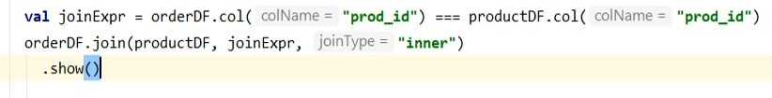

The result of a join is a new data frame, and I can show it.

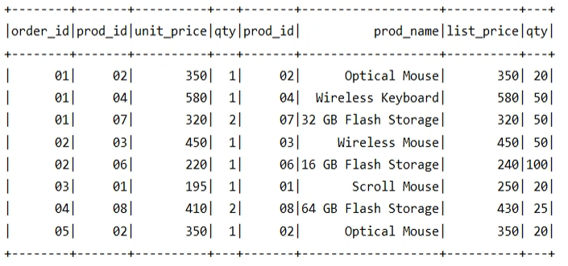

So we got eight records. As expected. However, I don't want all these columns. I am only interested in 4 columns. Order id, product name, unit price, and the order quantity. Looks good. However, this code is not going to run. Why? Let's try it.

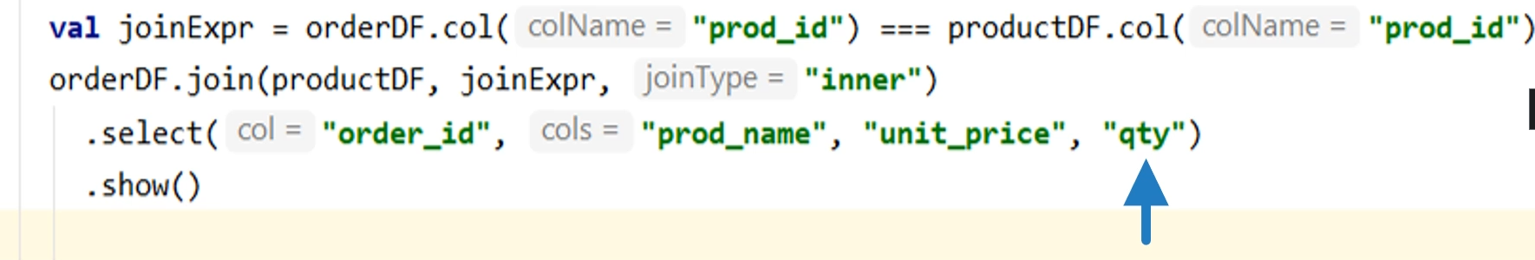

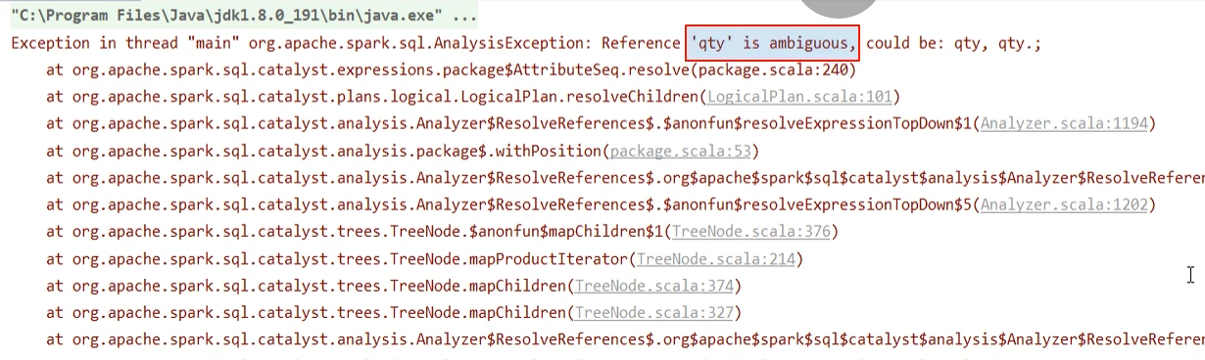

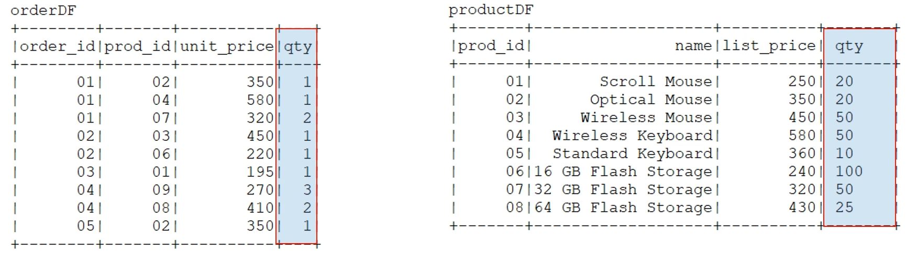

What is the error? 'qty' is ambiguous And that's obvious. We have two quantities. One is the order quantity, and the other one is the product reorder threshold quantity. But unfortunately, both have the same column name. So, when we ask for the quantity, the spark gets confused and throws this error. Quantity is ambiguous. But I am still wondering with one question. This ambiguity didn't happen when I selected all the columns. I am seeing both. In fact, the product id is also coming twice because it was present in both the left and right data frames.

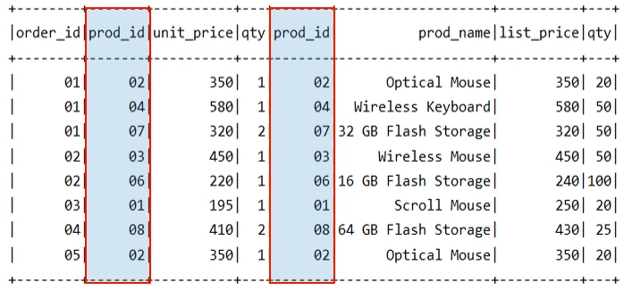

Why do we have this select * working perfectly fine, but Spark complaining about ambiguity when we explicitly refer a column name. The answer is simple. Every Dataframe column has a unique ID in the catalog, and the Spark engine always works using those internal ids. These ids are not shown to us, and we are expected to work with the column names. However, the spark engine will translate these column names to ids during the analysis phase. When I refer the column name in my expression, then the Spark engine will internally translate the column names to the column id. And that's where it complains about ambiguity. But when we are using select *, it takes all the column ids and shows them. Translation from column names to column id is not needed. So, column name ambiguity is a common mistake in join operations. We must take some extra care to avoid these mistakes. We have two approaches to avoid such ambiguity. The first approach is to rename ambiguous columns, even before joining these two data frames. Let's try it. So, I am using withColumnRenamed() transformation to rename the product quantity to the reorder_quantity. Now, I should be using this renamed data frame for my join. Let's try running it.

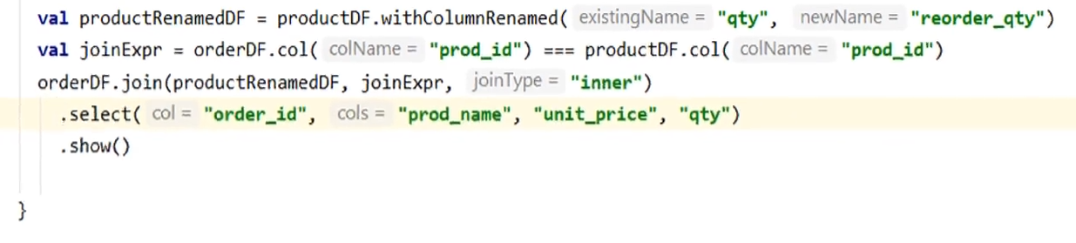

Worked. We have another approach. Drop the ambiguous column after the join. Let's try that one also. We still have one ambiguous column. What is it? product_id. So if I am selecting prod_id here, I am still going to get the ambiguity exception. And that's obvious because we didn't rename the product_id. So, we should have two prod_id after the join. We want to drop one of those after joining the data frames. Let's do it. Which one do you want to drop? I want to remove the product_id, which comes from the productDF.

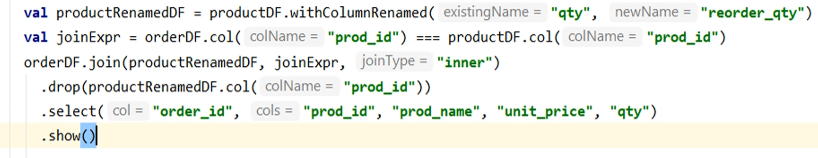

Let's run it. Worked. So we learned to join two data frames and apply inner join. Spark supports a bunch of other join types. And I will cover them in the next lecture. We also learned to avoid column name ambiguity which might arise after joining two data frames. In the next lecture, we will learn some more internals to join operations.

**SparkJoinDemo.scala**

package guru.learningjournal.spark.examples

import org.apache.log4j.Logger

import org.apache.spark.sql.SparkSession

object SparkJoinDemo extends Serializable {

@transient lazy val *logger*: Logger = Logger.*getLogger*(getClass.getName)

def main(args: Array[String]): Unit = {

val spark = SparkSession.*builder*()

.appName("Spark Join Demo")

.master("local[3]")

.getOrCreate()

val ordersList = *List*(

("01", "02", 350, 1),

("01", "04", 580, 1),

("01", "07", 320, 2),

("02", "03", 450, 1),

("02", "06", 220, 1),

("03", "01", 195, 1),

("04", "09", 270, 3),

("04", "08", 410, 2),

("05", "02", 350, 1)

)

val orderDF =

spark.createDataFrame(ordersList).toDF("order_id", "prod_id", "unit_price", "qty")

val productList = *List*(

("01", "Scroll Mouse", 250, 20),

("02", "Optical Mouse", 350, 20),

("03", "Wireless Mouse", 450, 50),

("04", "Wireless Keyboard", 580, 50),

("05", "Standard Keyboard", 360, 10),

("06", "16 GB Flash Storage", 240, 100),

("07", "32 GB Flash Storage", 320, 50),

("08", "64 GB Flash Storage", 430, 25)

)

val productDF =

spark.createDataFrame(productList).toDF("prod_id", "prod_name", "list_price", "qty")

productDF.show()

orderDF.show()

val joinExpr = orderDF.col("prod_id") === productDF.col("prod_id")

val joinType = "inner"

val productRenamedDF = productDF.withColumnRenamed("qty", "reorder_qty")

orderDF.join(productRenamedDF, joinExpr, joinType)

.drop(productRenamedDF.col("prod_id"))

.select("order_id", "prod_id", "prod_name", "unit_price", "list_price", "qty")

.show()

}

}

### Outer Joins in Dataframe

In the earlier lecture, you learned about inner joins in Apache Spark. In this lecture, we will learn about some other types of join. So, let's start. We created the following data frames in the earlier video. And we performed an inner join on these two data frames to get the following outcome. I am not sure if you noticed the missing record in the final result. Order_id 4 had two products. However, we got only one in the final outcome. The other record is missing. Why? Because we performed an inner join, and product id 9 is not present in the product master.

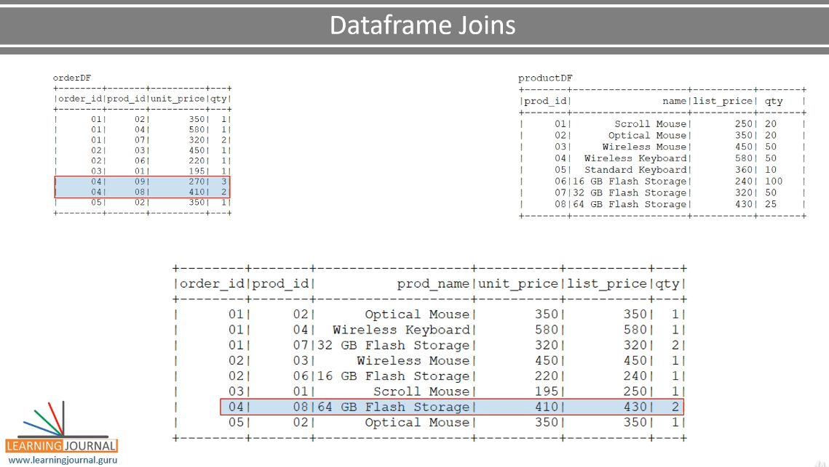

This record is skipped because the inner join could not find a matching record on the right side. Similarly, the Standard Keyboard doesn't show up in the outcome because none of the orders had a reference to the standard keyboard. What does it mean? The inner join is going to take only those records that are matched on both sides. Everything else is left behind. So, the inner join makes sense in only those requirements when you know that your data will match on both sides, and you purposefully want to skip the missing records. However, in this example, a missing record doesn't make much sense. We sold three units of something called product id 9. We don't know the name of the item, but we made a transaction. So, we cannot lose it from the final result. How to fix it? There comes an outer join. The outer join will take up all the records even if they do not have a matching pair. Let's try it. I copied the earlier example and created a new one. The code is the same as earlier. I am going to change the join type. Let's see what do we get using an outer join. Let me take all the columns so we can see the full result of the join.

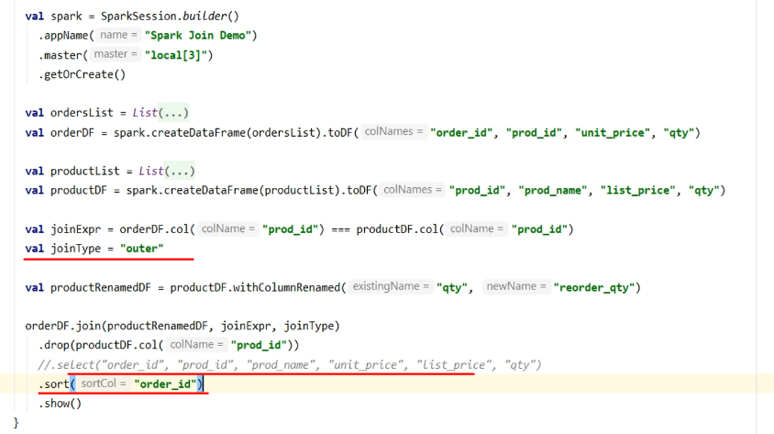

I am going to sort the output by order_id. The sorted outcome will be easier to compare and understand. Let me run it. What do we have? Let me bring it to a slide.

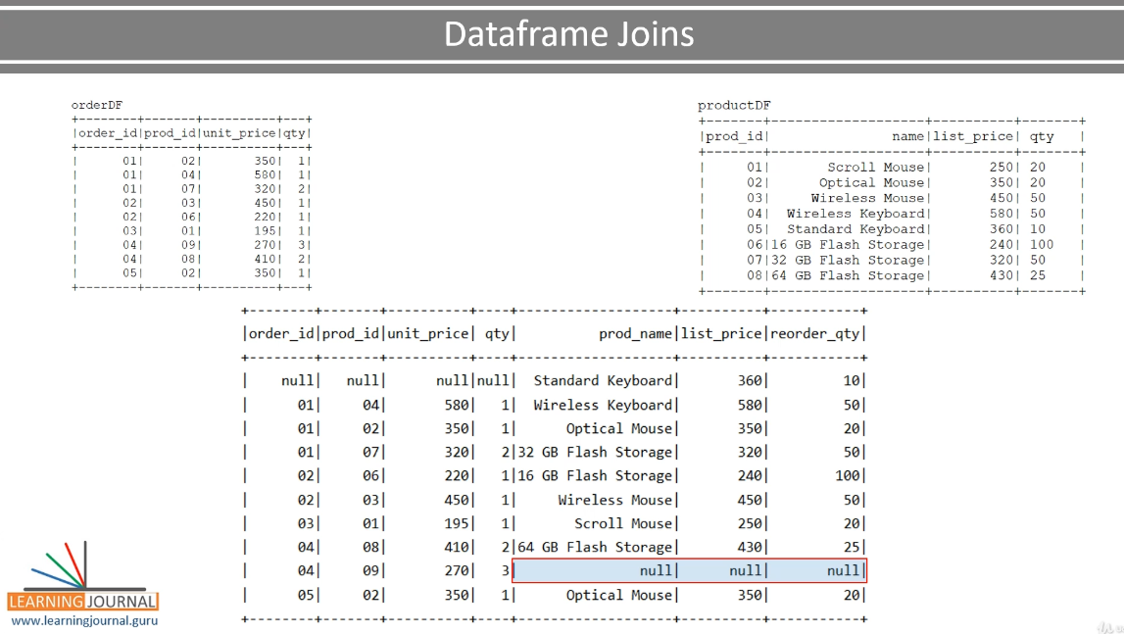

It's gonna be easy to understand. We got three records of order id 1. They were expected because we have a matching record on the right side. So, these four columns are from the left side, and the remaining three columns are from the right side. Correct? Similarly, these three rows are also coming because we had a match on the right side. Up to here, everything works like an inner join. However, we are also getting the product id 9. This item doesn't have a matching record on the right side. But you still get this thing here because we used outer join. And since we do not have a match on the right side, so we do not know anything about these column values. Hence, these values are null. So, we got the record from the right side even if the left side is missing. Similarly, we also got one record from the right side even though non of the left side orders referred to the standard keyboard. What does it mean? The outer join will ensure that we get each record from both sides at least once, even if there is no match on the other side. This record had no match on the right side. And the first one had no match on the left side.

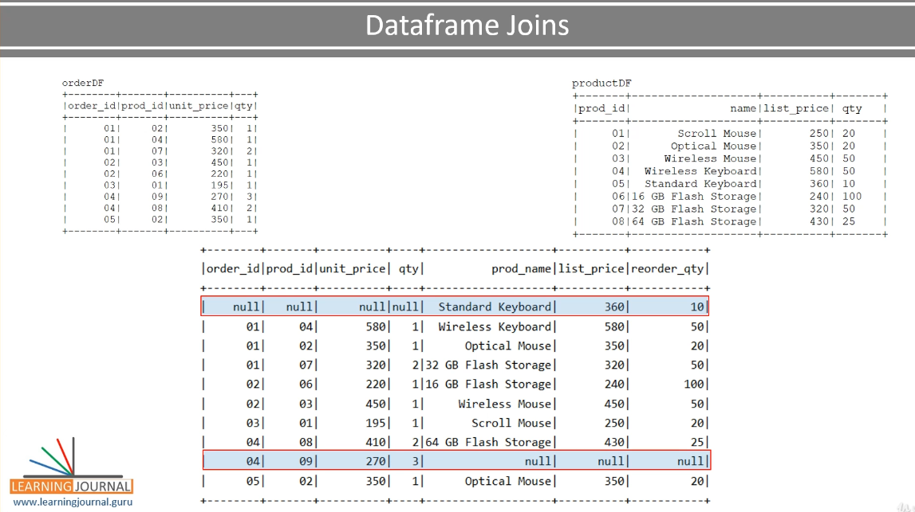

But both of these will show up in the join result. And this join is known as full outer join. Why full? Because we take every record from the left and right both. However, for our example, this guy doesn't make any sense. Why? Let's try to look at our select statement. Here it is. So, what is my intention in this output? I wanted to get a sales report. I haven't sold a single unit of a standard keyboard. So, this record doesn't make any sense in my report. I want to remove this guy. How to fix it? There comes a variation of the outer join. Spark offers you three types of out joins. outer join, or we call it the full outer join. Then you have left join, or we call this one a left outer join.

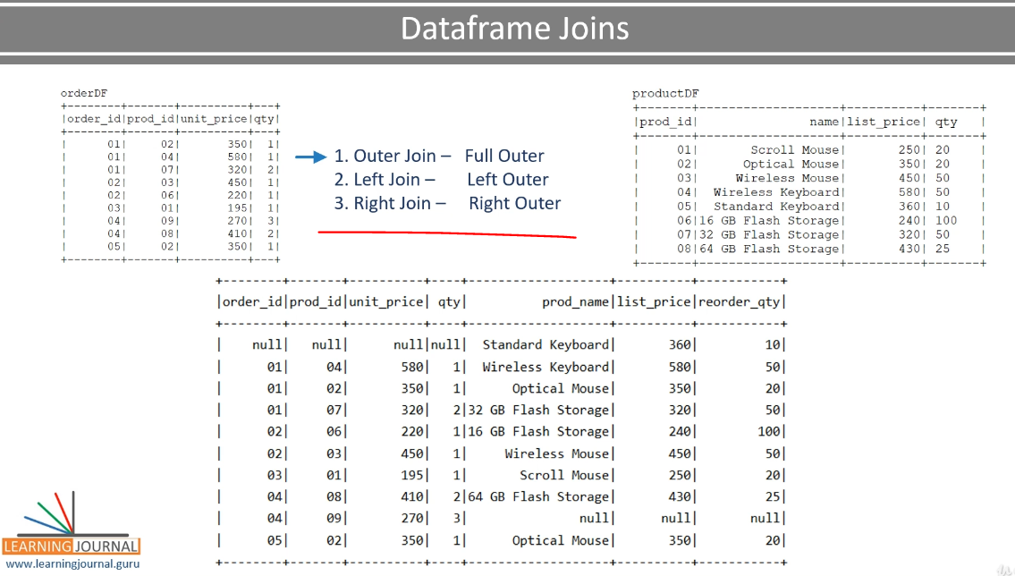

Finally, you have a right join, or you can say right outer join. The full outer join will bring all the records from both sides, even if we do not have a match. The left outer join will bring all the records from the left side even if we do not have a matching pair on the right side. Similarly, the right join will bring all the records from the right side even if we do not have a matching record on the left side. But remember, the matching records will always appear. No matter you are using inner, full outer, left outer, or the right outer. Join is all about matching the records on two sides. So the matching records always appear. All four types of join that we talked about are there to play with the records that are not matching. So how do we lose this record? This record is present on the right side but not on the left side. Correct?

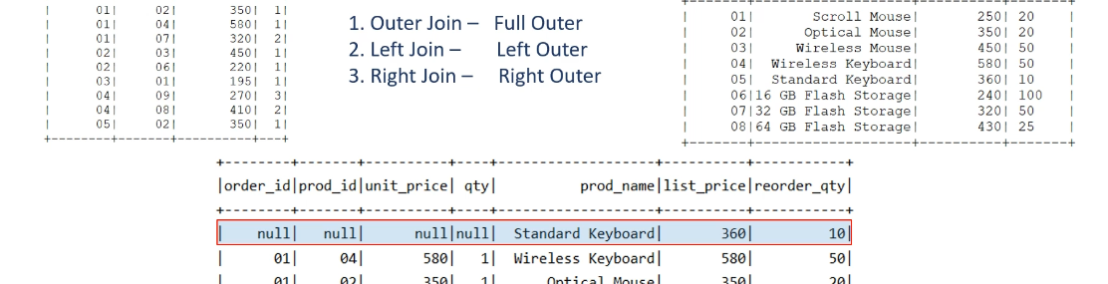

We want all the records from the left side because we want to see all the sold items. But we do not care about the right side. So, the left join makes a perfect sense here. Well, the idea is simple. You want all the records from the left, use the left join. If you want all the records from the right, and do not care about the left side, use the right join. What if we want the records from both sides? Use the full outer join. Correct. So, let's change this join to left join. Now it looks better. However, I still see a small problem. Do you see these two nulls? I don't like these nulls in my report. I know these values are missing on the right side and so we are getting these nulls.

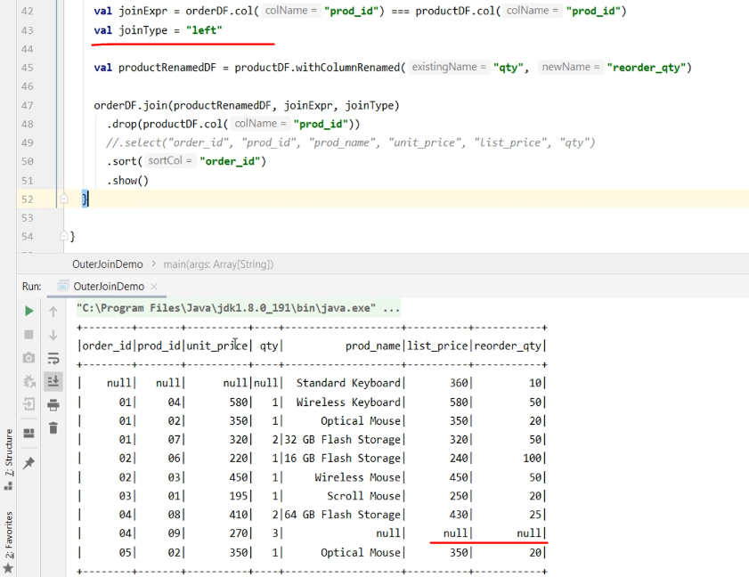

But still, can I get some meaningful value here. One option could be to use the product id. I mean, if we do not know the name, we can show the product id here. Similarly, if we do not know the list price, we should consider showing the unit price. Can you fix this? We already learned to use built-in functions and column transformations. You can use the coalesce() function to transform these two columns. Let me do it. Let me transform the product name. The coalesce() function will take the first non-null value from the given list of columns. We take the product name, but if that one is null, we show the product id. Similarly, we fix the list price also. Done. Let me run it. Looks good now.

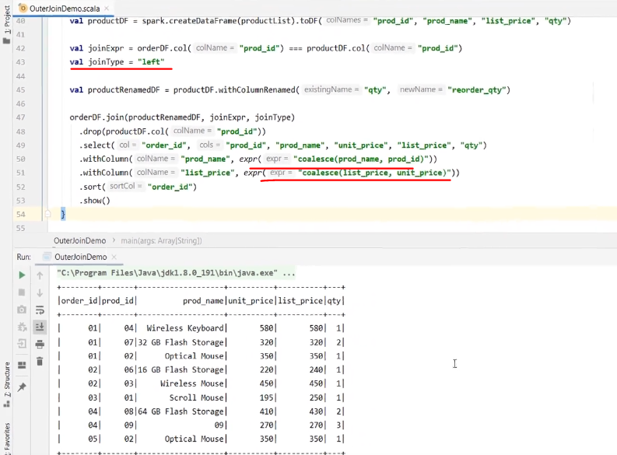

### Internals of Spark Join and shuffle

We learned to join two data frames in Apache Spark. However, Spark joins are one of the most common causes for slowing down your application. In this lecture, I will talk about some internals of the Spark data frame joins. We will also learn about some options to optimize or tune your join operations. So, let's start. Spark implements two approaches to join your data frames. Shuffle Join Broadcast Join



Let's try to understand how these two Join operations are performed. The shuffle join is the most commonly used join type. And the internal implementation goes back to the notion of the Hadoop MapReduce implementation. Let's assume you have two data frames. Both of these are partitioned, and I am considering three partitions for each. In reality, these data frames could be huge and may have hundreds of partitions. But for simplicity and to understand the idea, let's assume they have three partitions.

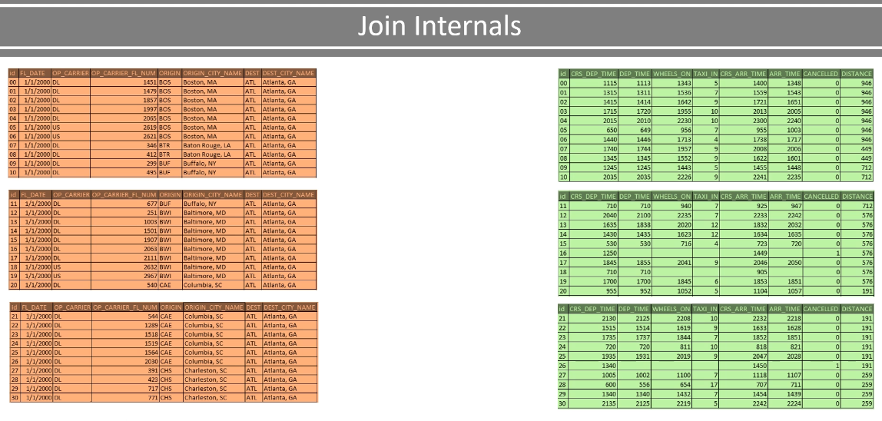

Now we want to join them using a key. All these partitions are distributed across different executors in the cluster. They may or may not reside on the same system. Let me assume that we have three executors, and these partitions are equally assigned to these three executors. So, each executor has got 2 partitions, one from each data frame. So, this is how it looks. We have three executors and two data frames. Each data frame is made up of three partitions, which are evenly distributed among the three executors. So each executor owns two partitions - one from each data frame.

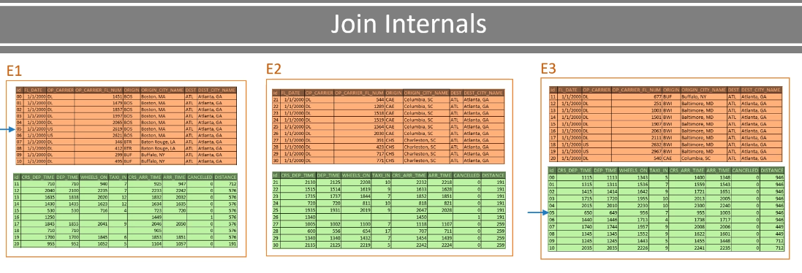

Can we perform a join? No. we cannot. Why? Because this key has got a matching key here. And these two records are on two different executors. We cannot join them unless we have both the records on the same executor. So how can we do it? The join is performed in two stages. I the first stage, each executor will map these records using the join key and send it to the exchange. And this is the map() phase of the MapReduce implementation.

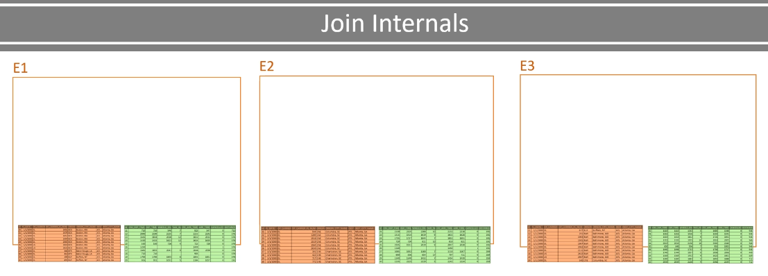

so let's call these exchanges as the map exchange In this first stage, all records are identified by the key, and they are made available in the map exchange to be picked up by the Spark framework. The map exchange is like a record buffer at the executor. Now the Spark framework will pick these records and send them to the reduce-exchange. And this is where all the magic happens. A reduce-exchange is going to collect all the records for the same key. I mean, all the records for the key-value 01 will go to the same exchange. These exchanges are known as shuffle partitions. And, it is up to you to decide the number of shuffle partitions?

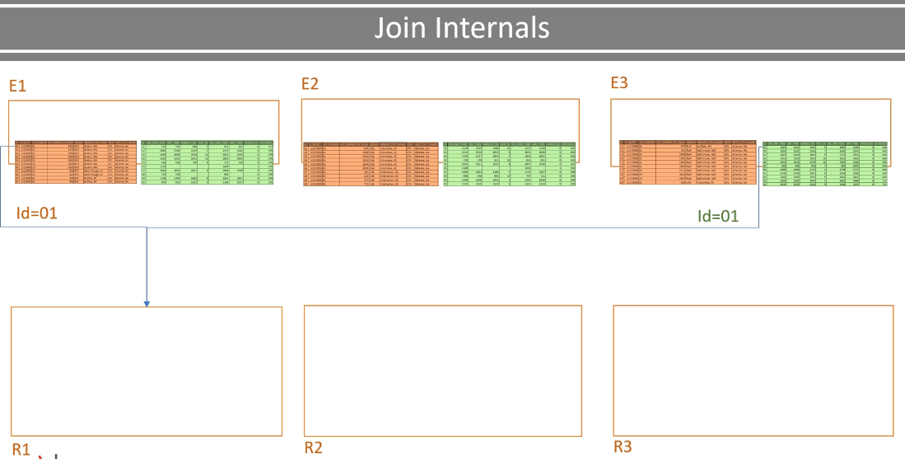

Let's assume I configured for three suffle partitions. Why three? Because I am running on three node cluster. And the best case scenario for me is to have three shuffle partitions where each partition is handled by one executor. So, all my three partitions can be processed in parallel. Now let's assume I have 30 unique join keys. So, in this case, each reduce-exchange should get 10 keys. So, it could be something like this. Key-value 01 to 10 should go to this exchange. Similarly, key-value 11 to 20 will go to this exchange, and so on. And all this transfer of data from a map exchange to the reduce-exchange is what we call a shuffle operation.

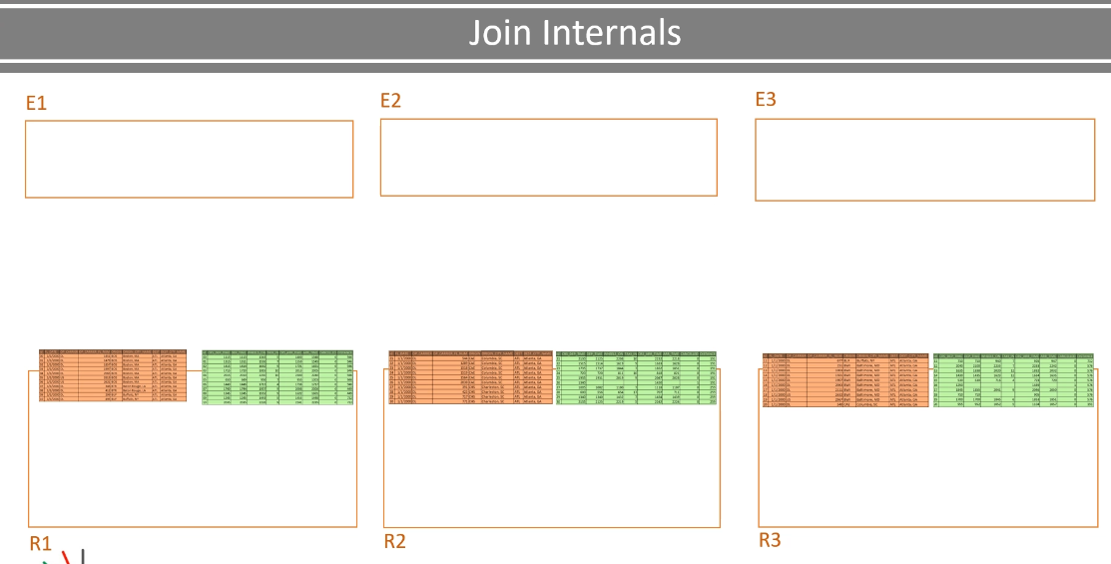

This shuffle operation can choke your cluster network and slow down your join performance. The shuffle is the main reason why spark joins could be slow and non-performant. Tuning your join operation is all about optimizing the shuffle operation. Now let's assume shuffle is complete, and you got your records at the reduce-exchange. Now each exchange is self-sufficient to join the records. Why? Because all the records for key-value 01 from both data frames are now present at this exchange. Now it is all about combining those records and create a new data frame partition.

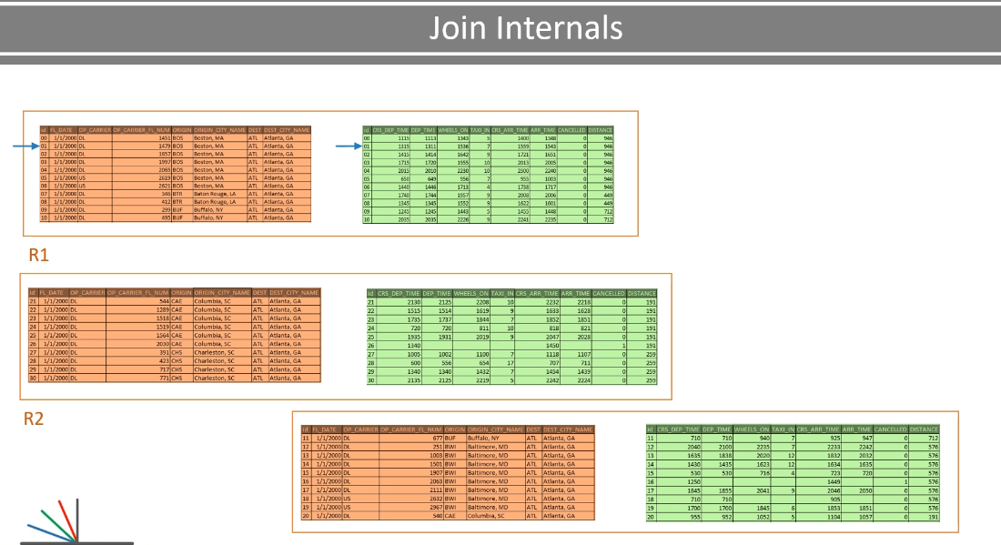

And there comes the second stage of applying a sort-merge join algorithm and finish the job. Now let's go and create an example to see all this happening in real sense. I created this super simple example. I have two data sets d1 and d2. I have three data files in both of these data sets. I purposefully created three files because I wanted to make sure we get three partitions when we read them.

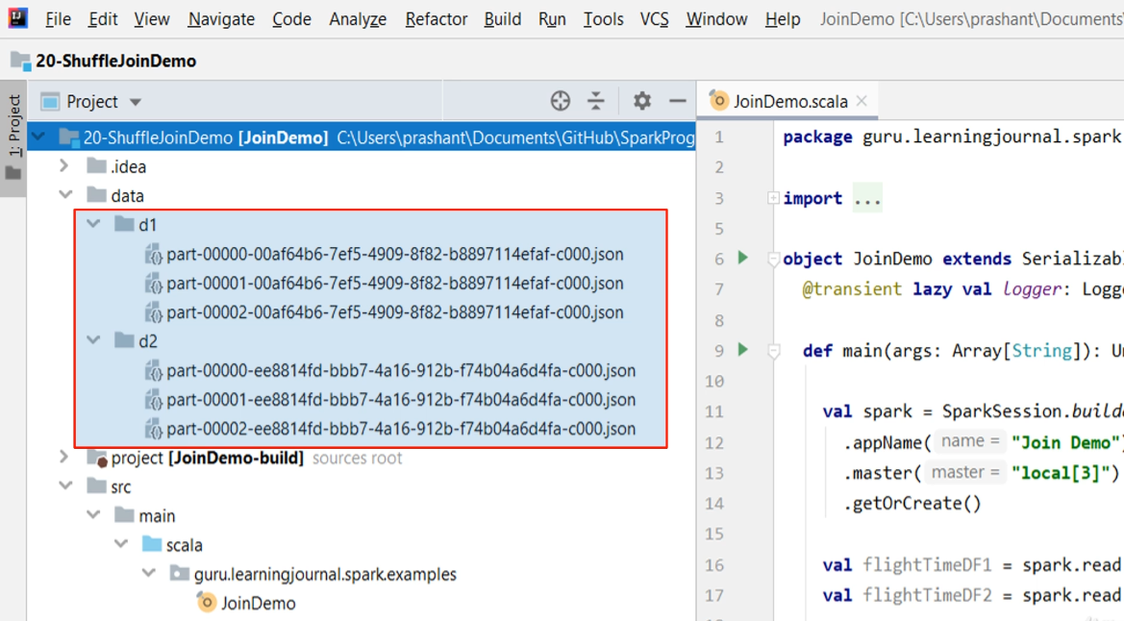

Here is the code.

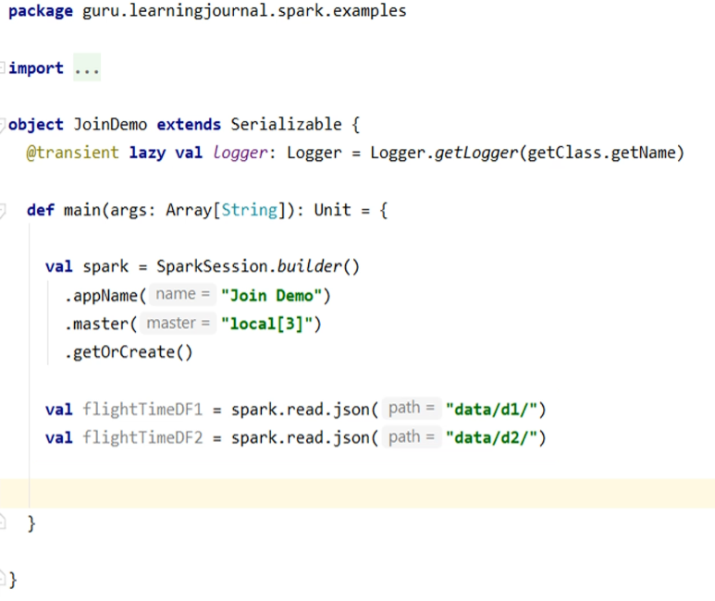

So, I am creating a spark session with 3 three parallel threads to do my work. I am also reading these two datasets in two different data frames. Since I have three files in each data set, I expect three default partitions for both the data frames. So we are going to join these two data frames in a well-controlled setup. I made sure that I get three executors, three partitions for both of these data frames. But we still have one more thing to fix. The shuffle partitions. Let me set the shuffle partition configuration.

You already learned this config in an earlier video. This config will ensure that we get three partitions after the shuffle, which means having three reduce exchanges. Now let's define the join condition. Then perform the join operation I am going to do an inner join. But join is a transformation. So, nothing is going to actually happen until we take action. So, let me add a dummy action here. I am not doing anything but simply adding a useless dummy action. Then we hold the job here to look at the Spark UI and understand what's going on there.

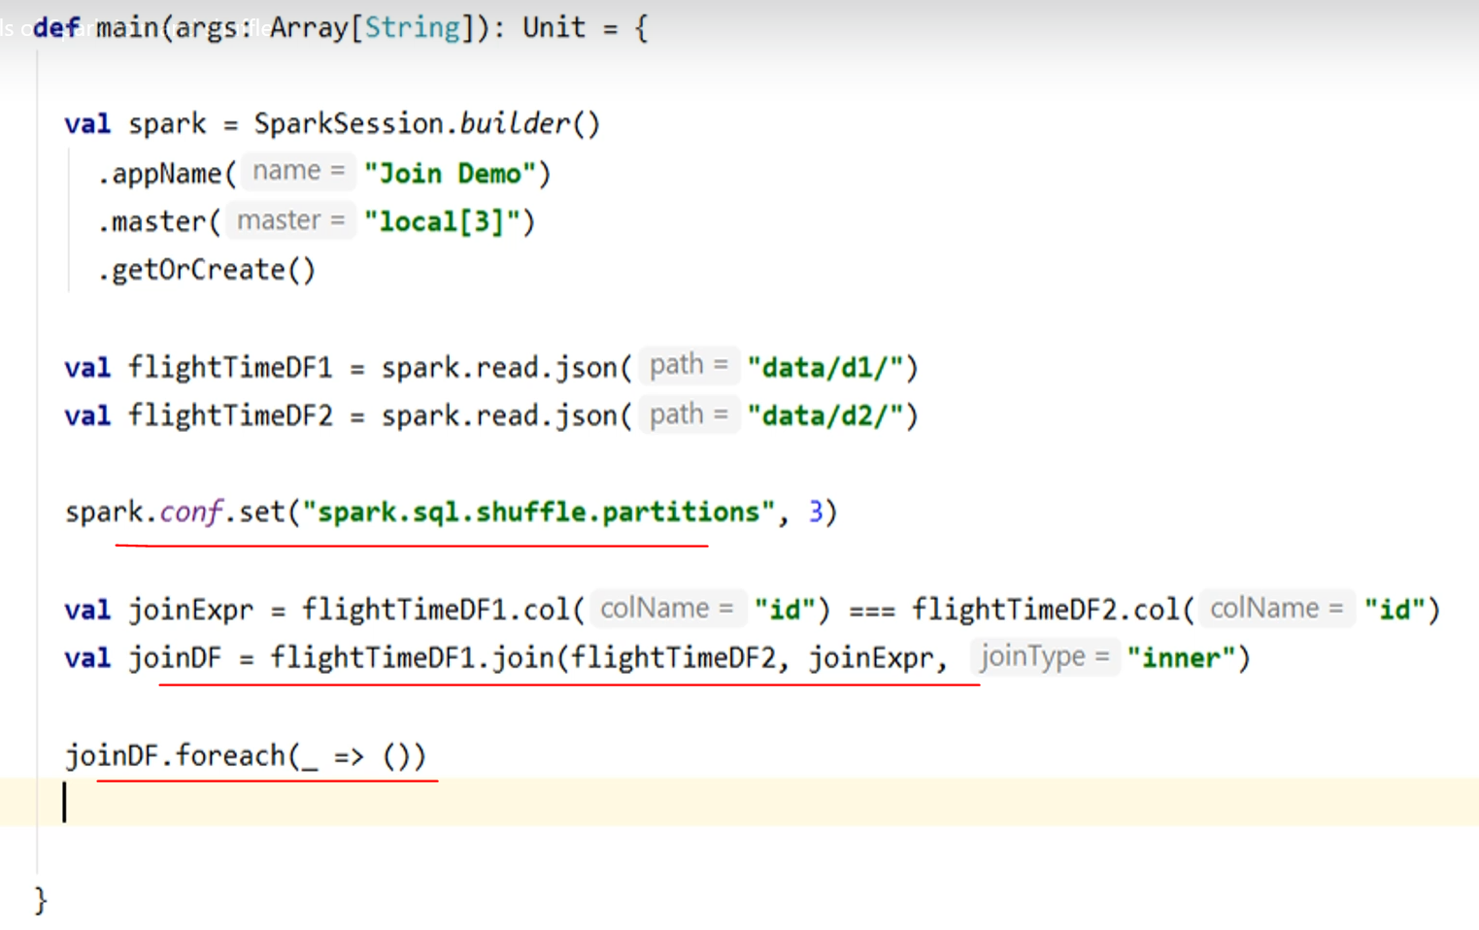

Let me run it. Start the Spark UI. So we have three jobs. You already know all this. I explained it in an earlier video. The first job is to read the first data frame. Reading a data frame is a single-stage and straightforward operation. So, we have a single stage for this job. We had three files, or you can say three partitions for the data frame, so the read happened in three parallel tasks.

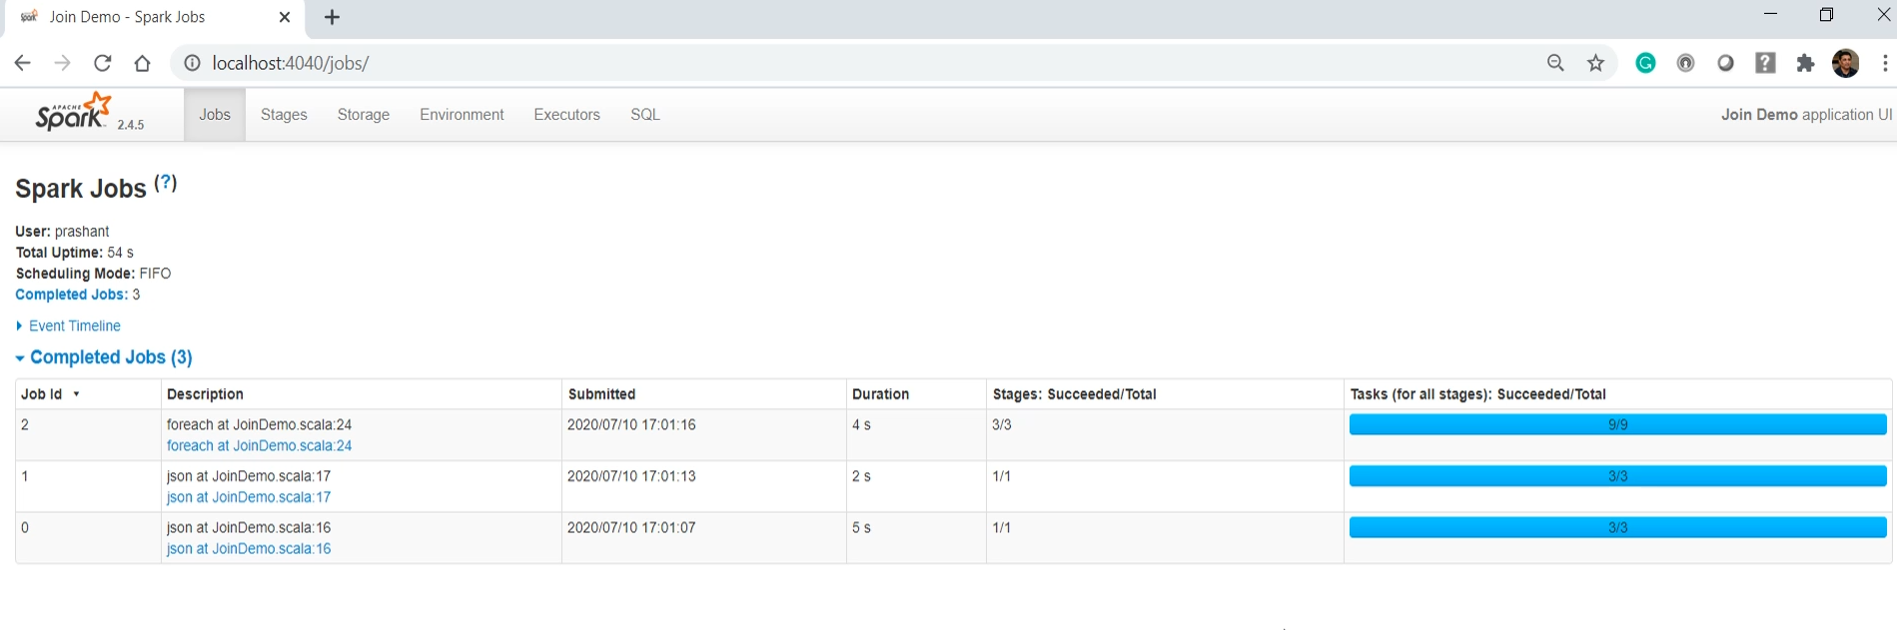

The same happened for the second data frame. The join operation happened here.

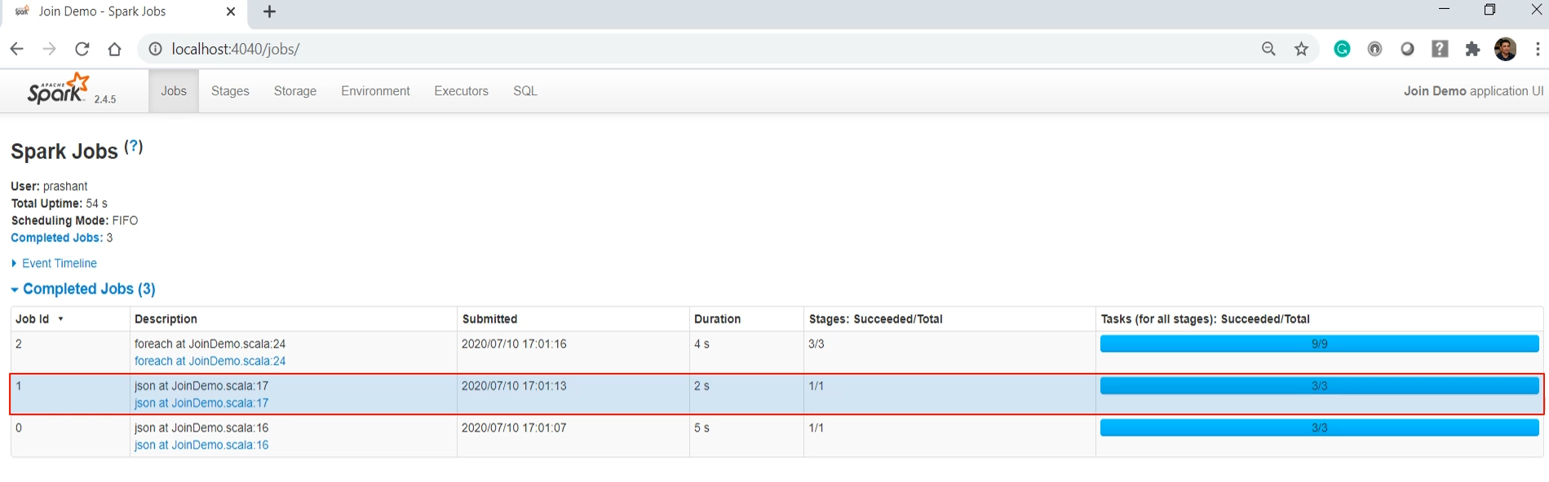

Let me drill down. So this is what I talked about. The join operation is accomplished in three stages. These two stages are to create a map exchange for the two data frames. And these lines are indicating the shuffle. So data moves from the map exchange to the reduce-exchange. Rest all is a simple sort-merge join. I will show you that as well. But let me turn your attention to these records.

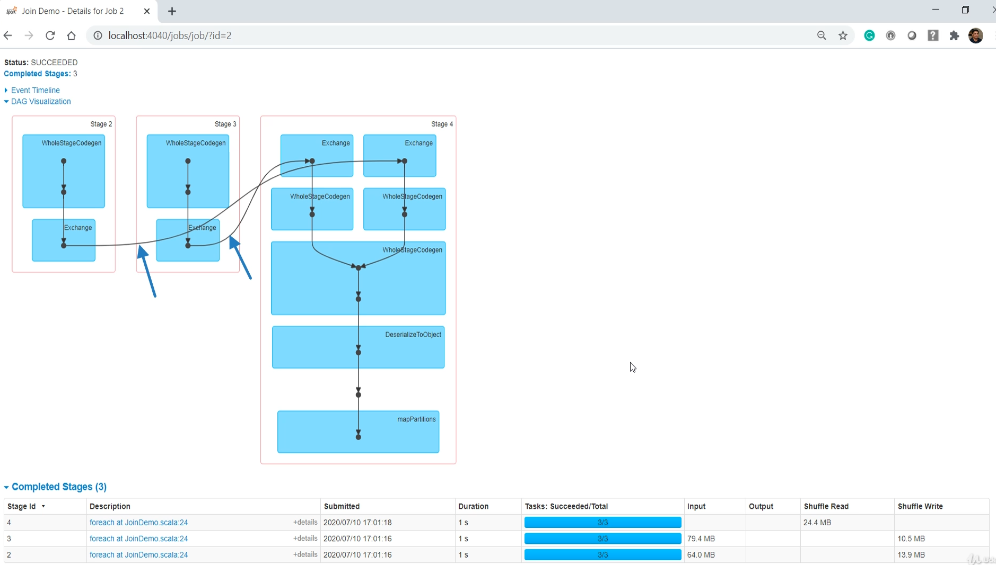

So the first two-stage were doing shuffle write, and all this happened in three parallel tasks because both the data frames had three partitions.

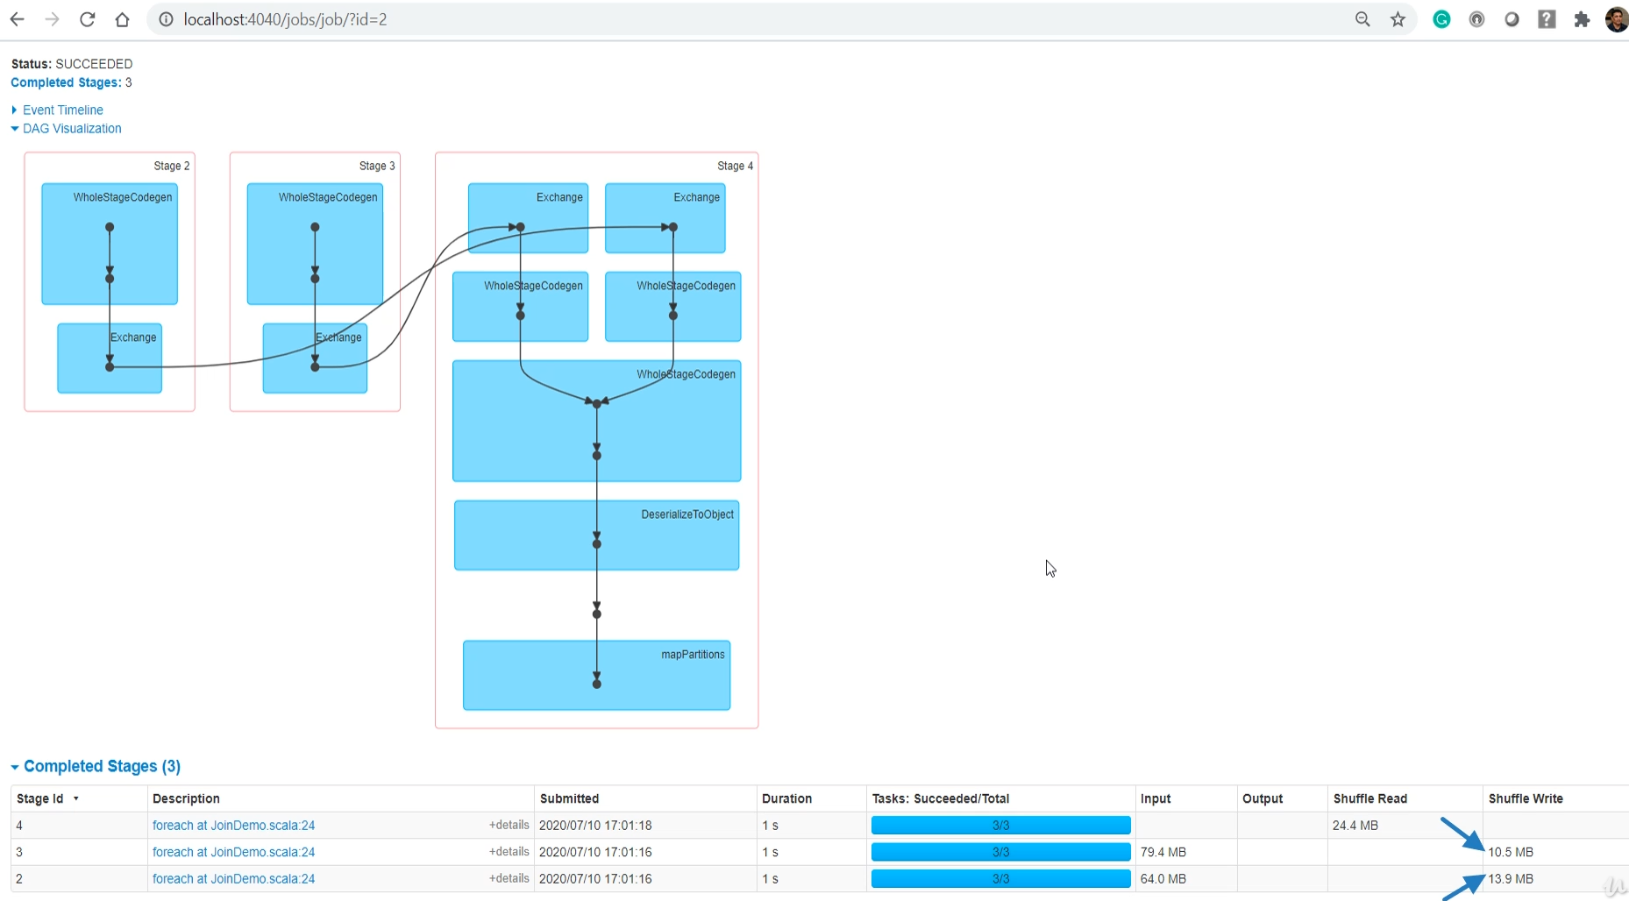

The final stage was doing a shuffle read. That thing also happened in three parallel tasks because we configured the shuffle partitions to 3.



Make sense. If you come to the SQL tab, you will see one job here. Why?

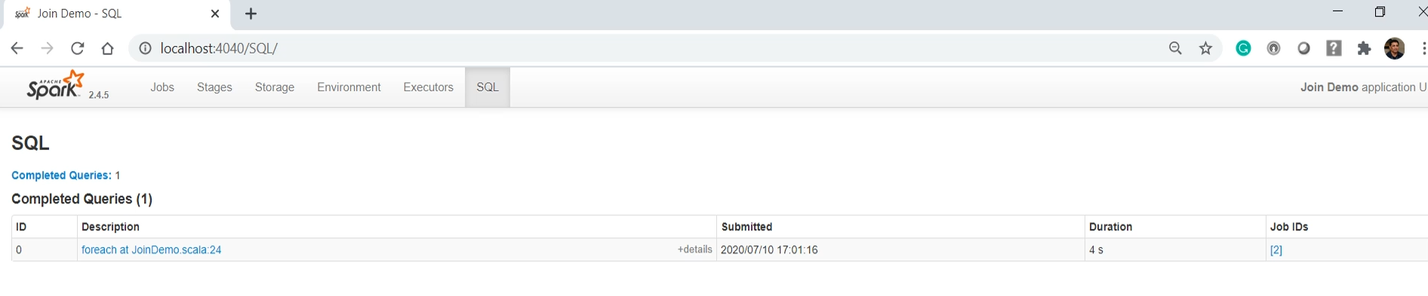

Because we performed a single SQL operation that is a join operation. Click here, and you will get the whole picture of what happened.

|  |  |
| --- | --- |
|  | So, here is the exchange. And this portion indicates the shuffle. We are reading and mapping two data frames before the shuffle. And then we are sorting the exchange and finally applying a sort-merge join. That's all.  So now you know how this Shuffle sort-merge join works under the hood. Knowing internals can take you too far in investigating join performance, tuning, and improving them.  In the next video, I will talk a little more about the shuffle sort-merge join and understand the key factors to achieve the best out of this type of join. I will also talk about the broadcast join and show you some internals of broadcast join.  Eliminating the shuffle is as good as removing the mother of all the join related problems. We will finally conclude this section with an example of how you can join two large data frames without even having to perform a shuffle. |

### Optimizing your Joins

We learned about the internals of a shuffle join in Apache Spark. In this lecture, we will take that learning further and understand some critical considerations for avoiding pitfalls of your shuffle join. We will also learn about the broadcast joins in Spark and learn when and how to use broadcast joins. So, let's start. Joining two Dataframes can bring the following two scenarios. You are joining a large data frame with another large data frame.

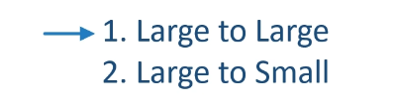

When we say large, we mean large enough to not to fit into the memory of a single executor. The second scenario is to join a large Dataframe with a small or tiny data frame. We consider it small when the Dataframe can fit into the memory of a single executor. However, if your Dataframe is more than a few GBs, t should be considered large and must be broken down into multiple partitions to achieve parallel processing. When both of your Dataframes are large, you should watch out for the following things in your join operation. Let's try to understand these considerations.

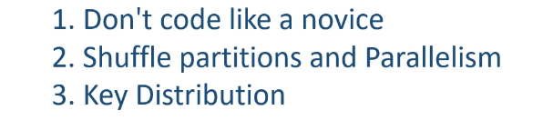

The first consideration is not specific to Apache Spark. It is a general common sense which applies to any other technology stack. Let me highlight a couple of common mistakes. We already learned that shuffle join will send all of your data from map exchange to the reduce-exchange. So, filtering out unnecessary data before you perform a join will obviously cut down the amount of data sent for shuffle operation. Sometimes such filtering is obvious, but more often, these things are not apparent unless you know enough about your datasets. Let's consider the following datasets. The first one is the global online sales, and the second one is only for us warehouse event dataset. You want to perform a left join by order_id, and it looks obvious to join them without any prior filtering. However, you know that orders from european cities are not going to match US cities' orders, and they will be filtered out in the Join operation.

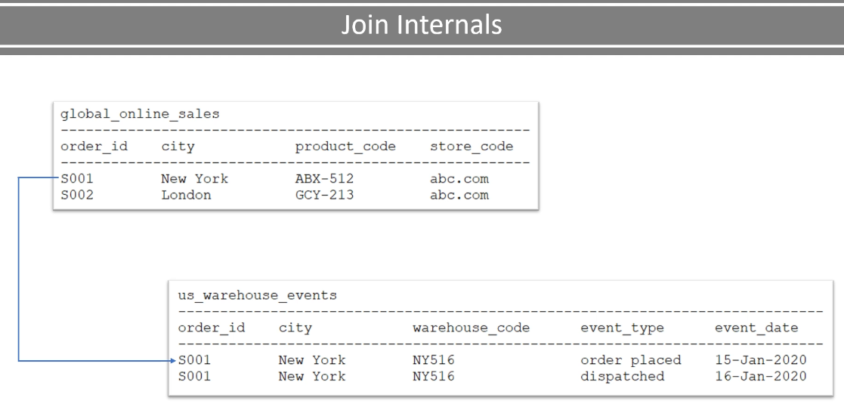

It makes a perfect sense to filter for the US orders from the global_sales even before we perform a join operation. How to do it? Do you have a country to city mapping? Something like this? Join it with the global sales and filter for the United States only. The point is straight. Look for all the possible opportunities to reduce the Dataframe size.

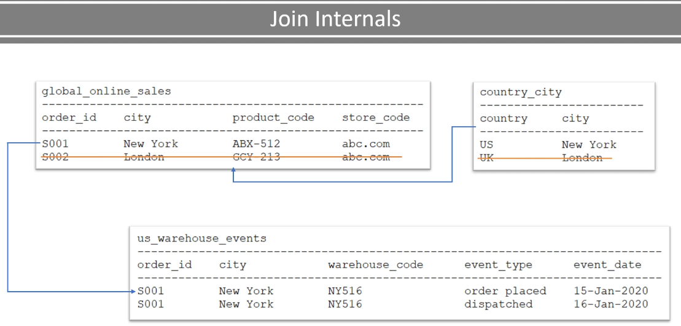

I have seen examples where people join the Dataframes first, and then they perform aggregations on the combined Dataframes. The recommendation is to look for opportunities where you can aggregate even before joining the Dataframes. The objective is almost always to cut down the size of your Dataframes as early as possible. Smaller the Dataframe will result in smaller the shuffle and faster join. The second thing is to look out for the number of shuffle partitions and the number of executors. These two are going to determine the degree of parallelism. You should start by asking this question. What is the maximum possible parallelism for my join operation?

|  |  |
| --- | --- |
|  | The first and most common limit is the number of executors. If you can run your job with 500 executors, then that's your maximum limit. The second limit comes from the number of shuffle partitions. If you have 500 executors, but you configured to have 400 shuffle partitions, then your maximum is limited to 400. Why? Because you have only 400 partitions to process in parallel. The third limit comes from the number of unique join keys. If you have only 200 unique keys, then you can have only 200 shuffle partitions. Even if you define 400 shuffle partitions, only 200 of those will have data, and others will remain blank. Consider the following Dataframes. You are joining these two Dataframes on product_id. And you have 200 unique products. You can have a maximum of 200 reduce exchanges where each unique key goes to its dedicated exchange |

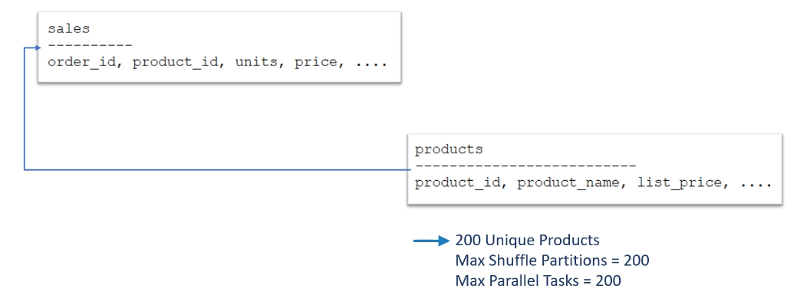

I mean, one reduce exchange should get records for only one unique key. And you already know that each exchange is equal to one shuffle partition. That means, your joined Dataframe can have up to 200 partitions. And you can take full advantage of 200 partitions by running your join operation on a 200 node Spark cluster. So, each node is going to process only one partition, and everything gets processed in parallel. If you have a 100 node cluster, then each node might have to process two partitions taking double the time in the ideal case. The point is straight. If you have 200 unique keys, then you can have a maximum of 200 parallel tasks. Even if you run your job on a 500 node cluster, you will be running only 200 parallel tasks. If you want to scale your Join operation and take advantage of a larger cluster, you should increase the number of shuffle partitions. If the number of the unique key is limiting your scalability, try increasing your join key's cardinality. Changing your join key to increase the cardinality or applying some trick to increase the cardinality of your current join key may not always be possible. However, you should be looking for opportunities to improve the parallelism if you have a large cluster.

The next important thing is to look for the distribution of your data across the keys. For example, you are joining the sales and product Dataframe. We consider that you have 200 products. So, all your sales transactions are joined with 200 products resulting in 200 shuffle partitions.

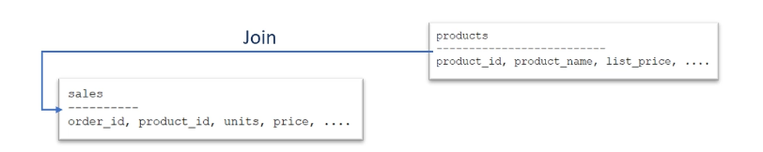

However, you may have some fast-moving products, some are slow-moving items, and others may be very slow-moving products. So, a fast-moving product should have a lot of transactions, and all of those will land into one partition because they all belong to the same product key.

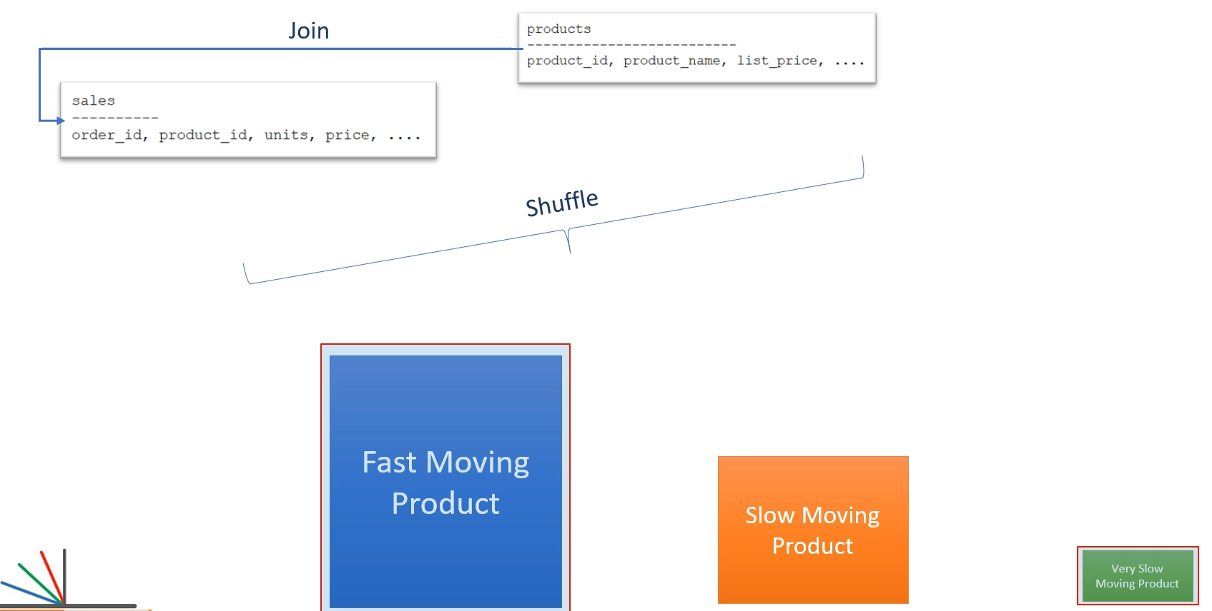

If you compare the size of your fastest-moving product partition vs. your slowest moving product partition, the difference could be significant. The Spark task, which is sorting and joining the larger partition, may take a lot of time, whereas the smaller partition will get joined very quickly. However, your join operation is not complete until all the partitions are joined. The point is straight. Watch out for the time taken by individual tasks and the amount of data processed by the join task. If some tasks are taking significantly longer than other tasks, you have an opportunity to fix your join key or apply some hack to break the larger partition into more than one partitions. In all this discussion, the most essential point is this.

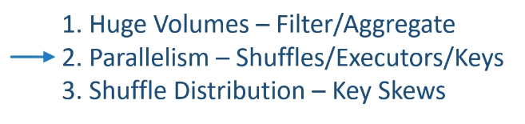

Shuffle joins could become severely problematic for the following principal reasons. You are joining huge volumes. You are not able to increase the parallelism and not to take advantage of a larger cluster Your shuffle partitions have got skew, and few tasks are delaying the overall execution time. We do not have a definite and fixed solution for any of these problems. However, knowing your data and thinking out-of-the-box may help you fix these problems and improve your shuffle joins. I talked about two scenarios in the beginning. Large dataframe to large dataframe joins and large dataframe to small dataframe joins

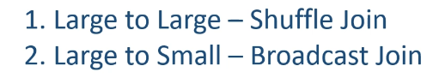

A large Dataframe to a large Dataframe join is always going to go for a shuffle join. We do not have any other option. However, a large Dataframe join with a small dataframe can take advantage of the broadcast join, which often works faster than the shuffle join. How? Let's try to understand. Let me again take the sales and the product Dataframes. Your sales dataframe is huge. You have millions of records in this dataframe. I am assuming that these records are partitioned, and you have 100 partitions. These partitions are distributed across a hundred executors assuming that you have enough executors. Your product dataframe is just 200 records, and it is worth 2 MBs. You have a single partition, and it is stored at one executor.

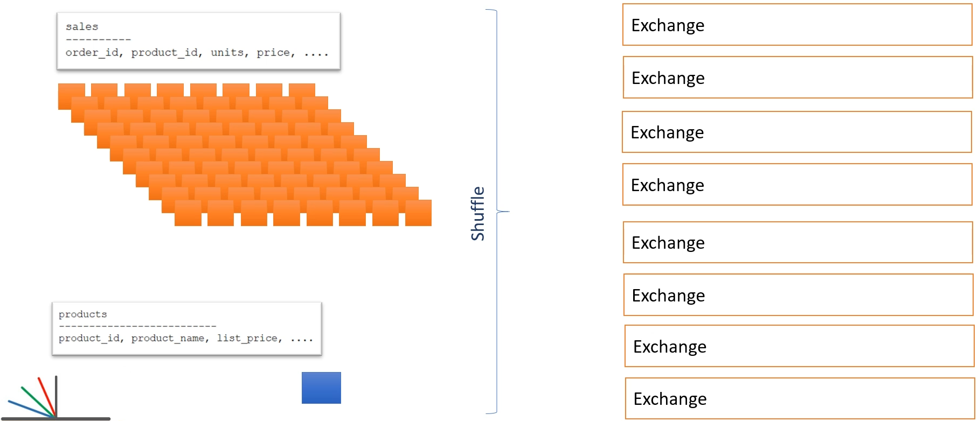

Now let's assume you are joining these two Dataframes using a shuffle join. So, you can expect 200 unique keys for this join. You have enough executors, so your shuffle is going to create 200 shuffle partitions. And all the data from these 100 executors will be shuffled to these 200 shuffle partitions. What does it mean? You are sending all those millions of records over the network for a shuffle operation. However, we have another much better alternative.

|  |  |
| --- | --- |
|  | Instead of sending this data from these 100 executors, we can dispatch this product table to all those executors. This dataframe is small, just 2 MB. So, even if we send it to all 100 executors, we send 2x100=200 MB of data over the network, which is a lot smaller than the sales table. And these executors can smoothly perform a partitioned join because they have a list of all the products. This approach is known as broadcast join. Why? Because we are broadcasting the smaller table to all the executors.  The broadcast join is an easy method to eliminate the need for a shuffle. You can perform a join without a shuffle. However, this approach works only when one of your dataframe is small. When I say small, it doesn't mean a few MBs. It could be 1GB or 2GB. The point is to make sure that your driver and executors have enough memory to accommodate your dataframe. |

And you can ask for the required memory using the spark-submit command-line options. You already learned about the --driver-memory and --executor-memory.

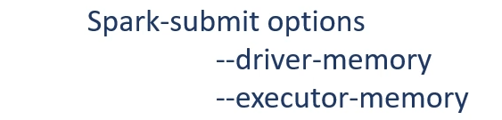

The next question is this? How to implement broadcast join. In most of the cases, Spark will automatically use the broadcast join when one of your dataframe is smaller, and it can be broadcasted. However, you know your Dataframes a lot better than Spark. So you should apply a hint for using the broadcast join. Let me show you. Here is the example that we created in the previous lecture.

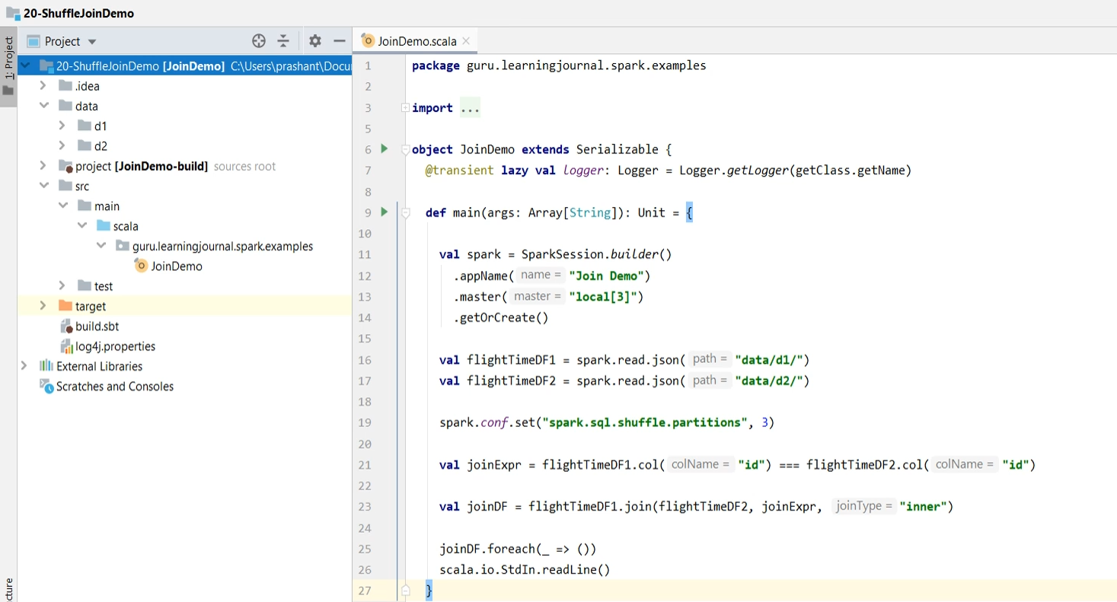

This example uses shuffle-join. Let me run it once and show.

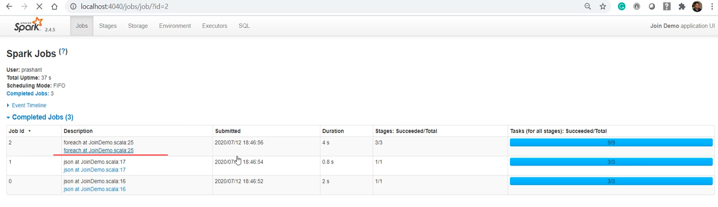

So, here we are. You can see this exchange.

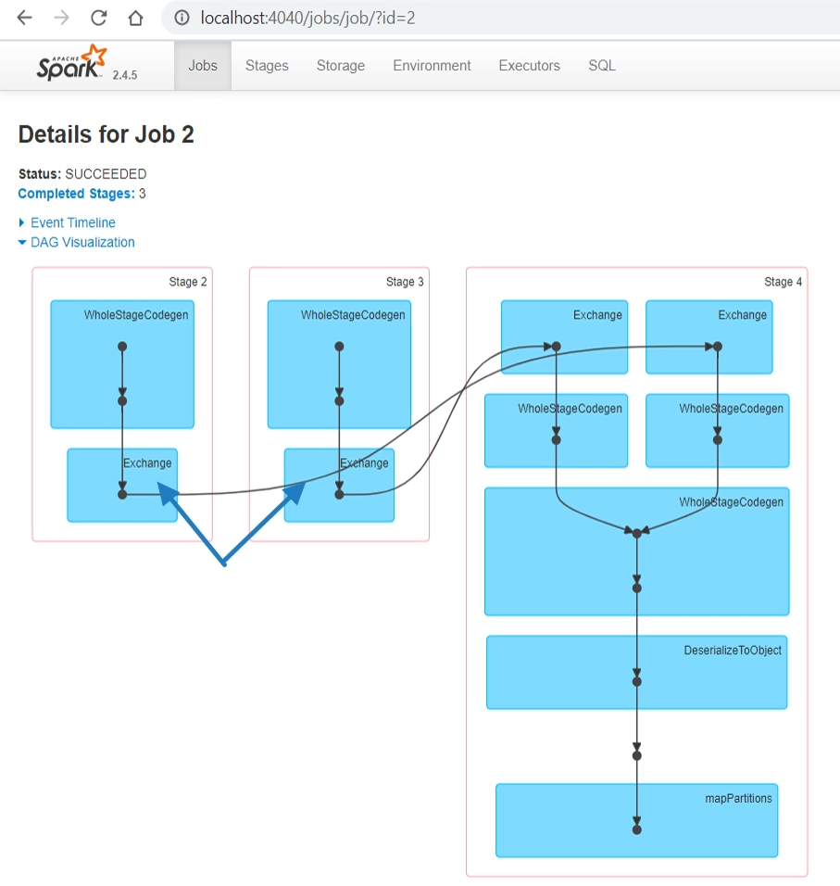

So, we are using a shuffle join. Let me come back to the code. Both of my Dataframes are small enough. I can easily apply the broadcast join for this example because these Dataframes would easily fit in my driver and executor memory. So, I am going to apply the broadcast function to the right side dataframe. What does it mean? I am giving a hint to spark that this dataframe is small enough, and you should consider broadcasting this table.

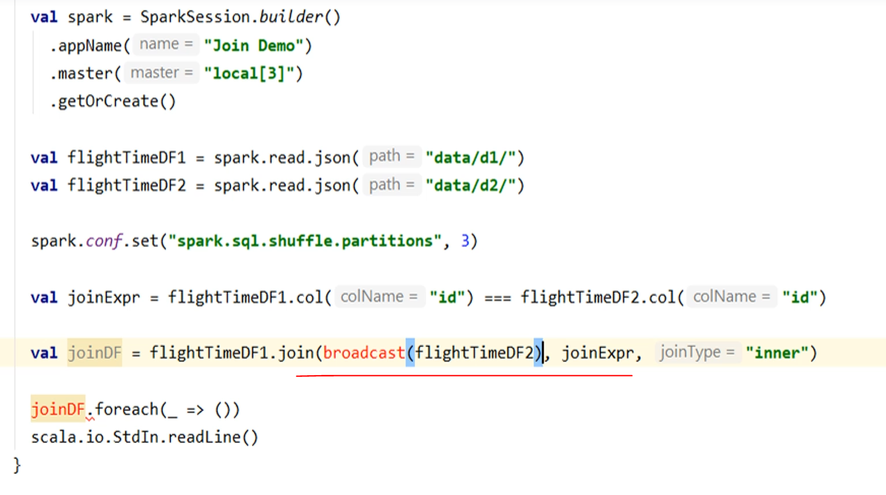

Let me run it and see what happens. Good. Let's go to the spark UI. Do you see this broadcast exchange, and here we have a broadcast hash join.

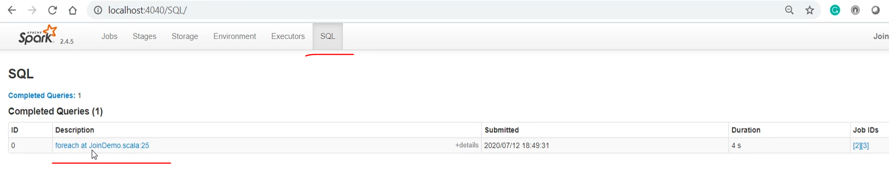

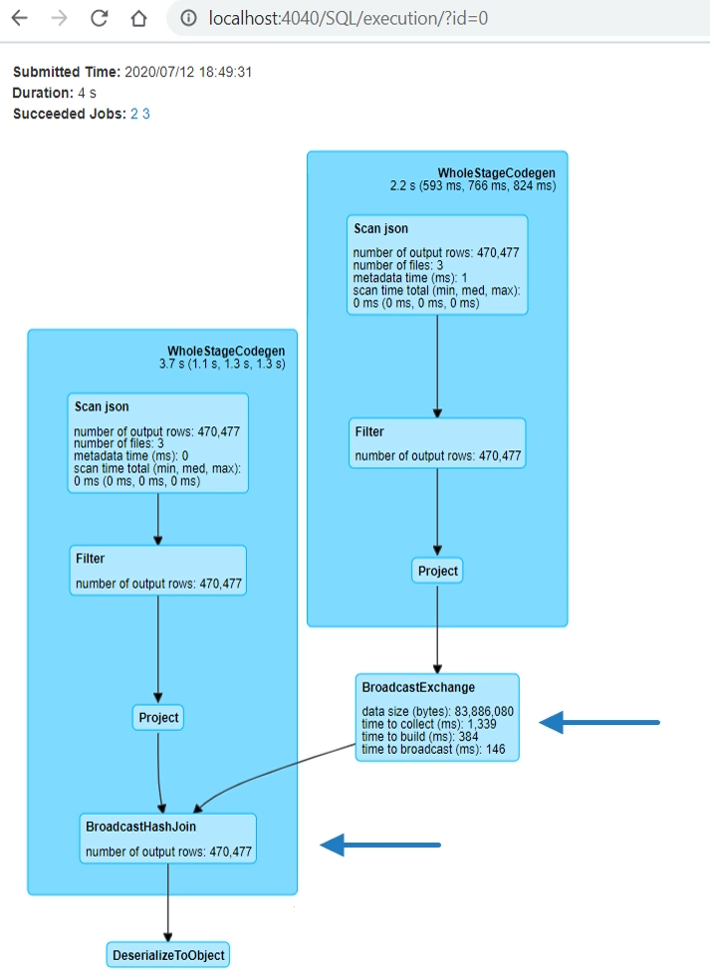

So We learned about the broadcast join and how to implement it. I also talked about three primary considerations while implementing a shuffle join. Shuffle is almost unavoidable in a large to large table joins. However, you may want to consider bucketing to avoid this shuffle in some known cases.

### Implementing Bucket Joins

In the earlier lecture, we discussed about the shuffle join. Shuffle join is almost unavoidable in case of a large to large dataset joins. However, in some scenarios, you can prepare yourself in advance and avoid the shuffle at the time of joining. In this lecture, we are going to learn about the bucketing your dataset and avoiding shuffle altogether at the join time. So, let's start. Let me start the discussion with the earlier example. So, here is the example which we created in the earlier lecture. In this example, we had two datasets - d1 and d2. We joined these two datasets, and we saw that the join happened using the shuffle sort-merge join approach.

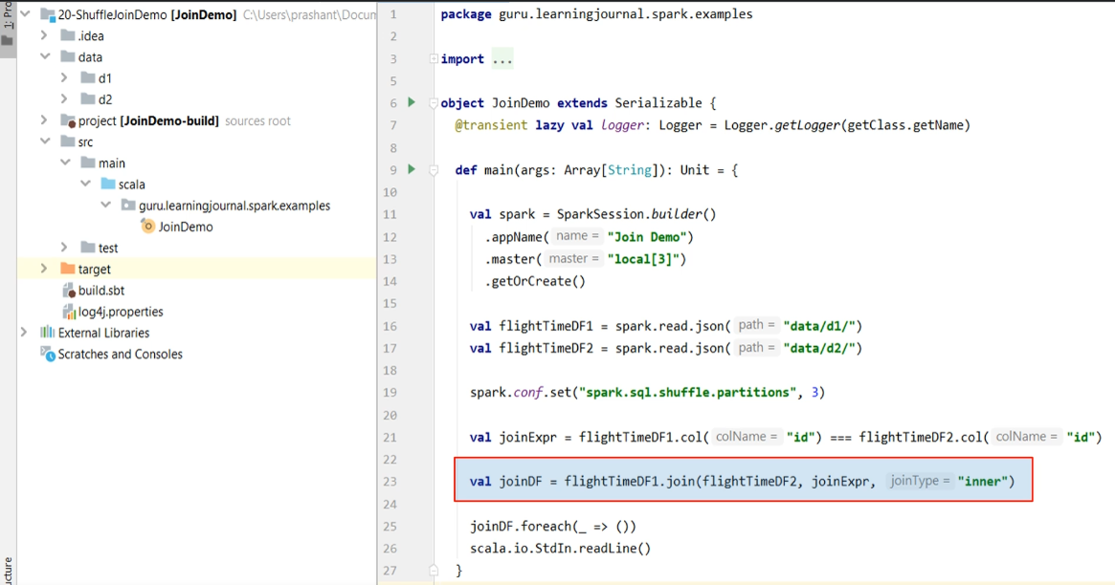

Right? How do I know that? We saw it in the query plan. Here it is.

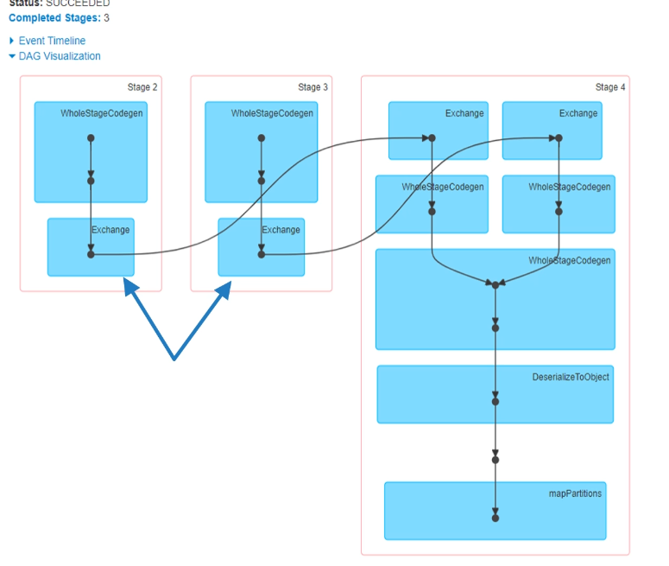

Now we want to do this same join without the shuffle. If I manage to do it, this shuffle stage in my query plan should go away. Let's plan it. I am assuming both of these datasets are large, and none could fit into the memory of a single executor. So, I cannot apply for the broadcast join. However, I know that I am going to join these two datasets. And possibly, I will be joining it several times for different types of queries. Can we plan the join in advance and layout my dataset so that the join can be done quickly? The goal is to avoid shuffle. That's where Spark bucketing could be handy. So, if you have two datasets that you already know you are going to join in the future, then it is advisable to bucket both of your datasets using your join key.

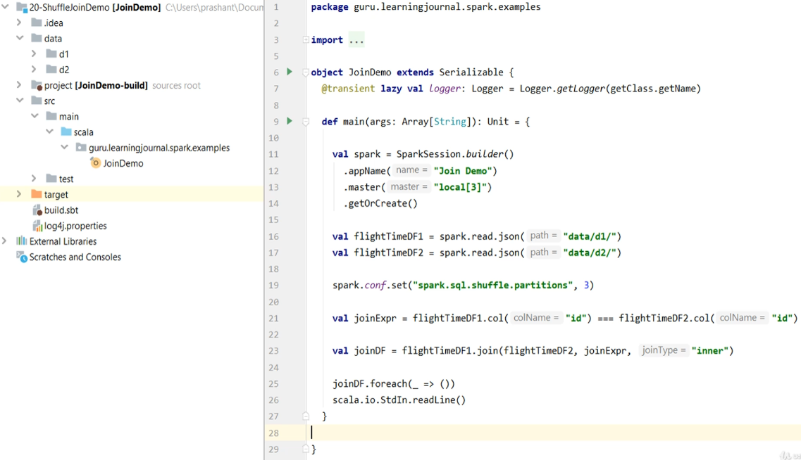

Bucketing your dataset may also require a shuffle. However, that shuffle is needed only once when you create your bucket. Once you have a bucket, you can join these datasets without a shuffle, and you can do it as many times as you need. So, bucketing is helpful to prepone the shuffling activity and do it only once. You can avoid the shuffle at the time of joining. Let's do it and learn the mechanics of implementing it. We will do it in two steps. The first step is to bucket your datasets. Let me create a new project. I need both of these datasets. So let me copy it to the new project. I also need the log4j.properties. We should also define the dependencies. So, let me create a main entry point for the example.

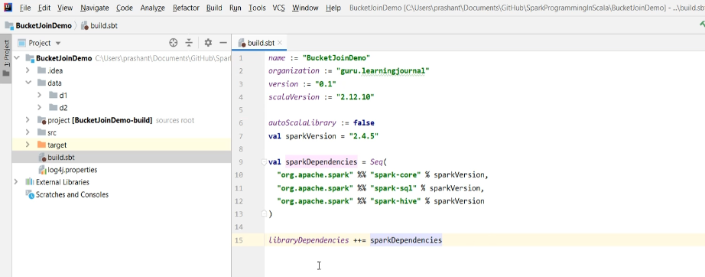

So we now have a spark session, and we are now ready to start coding. But what do we want to do? I want to bucket my dataset and prepare it for the future joins.

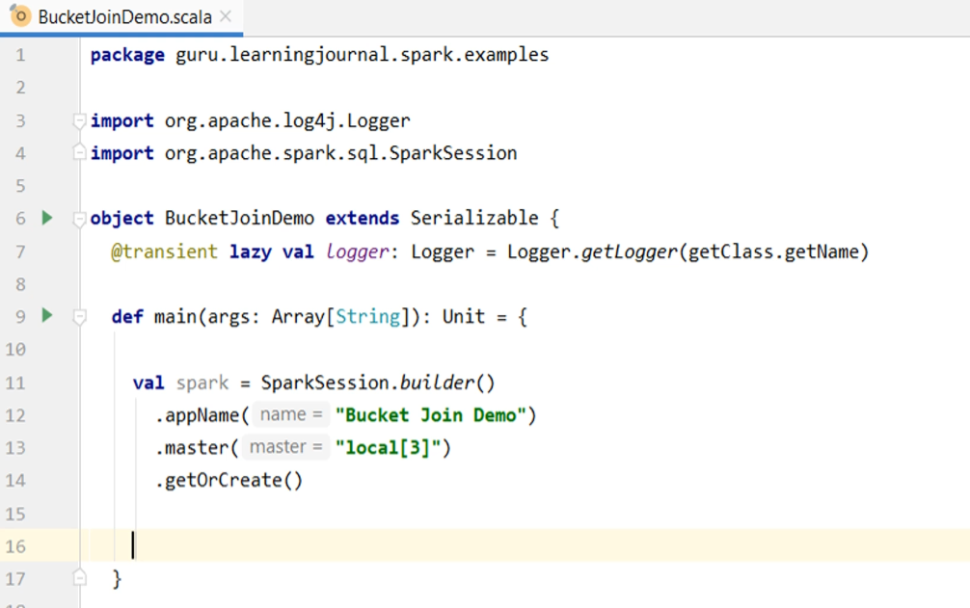

So, let me read both the datasets and show it once. Good. I can see it. So I loaded it correctly. However, I am seeing a lot of Log entries here. I think I forgot to define the VM parameters. Let me set it here.

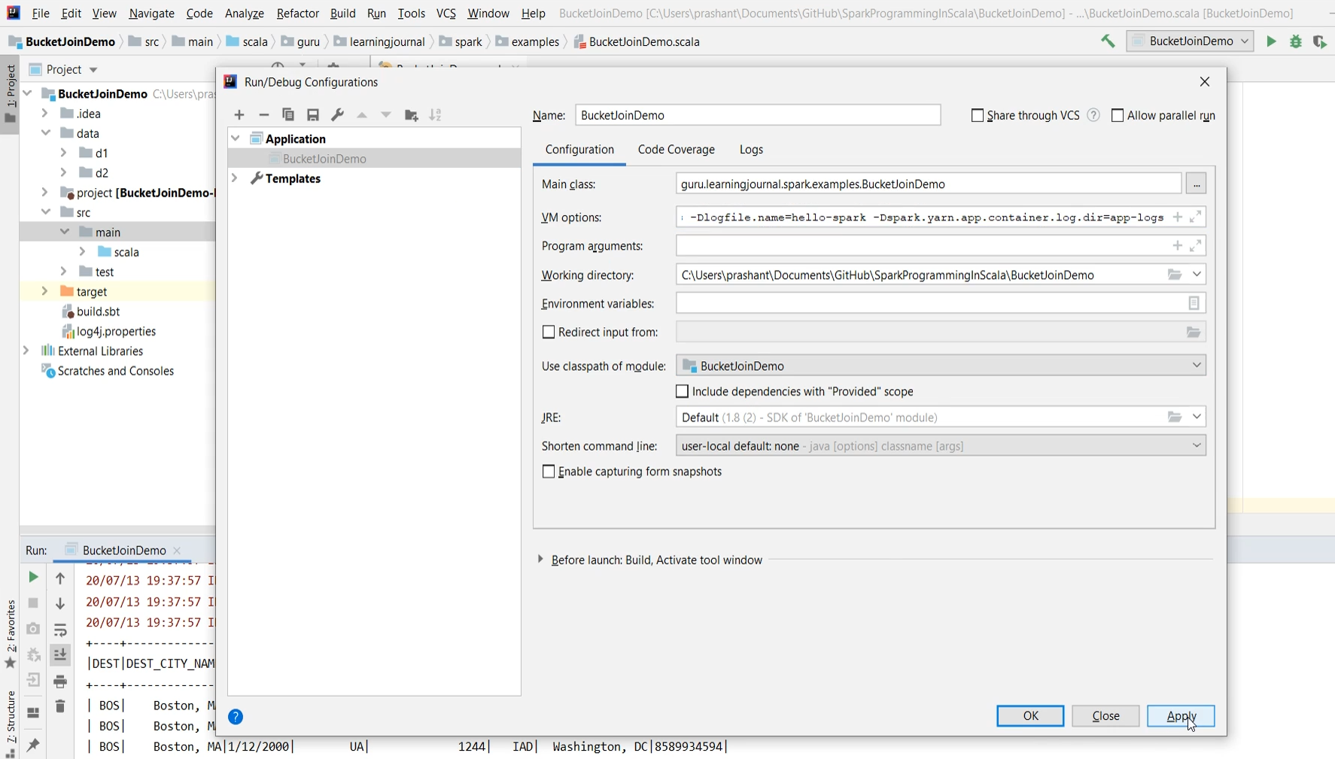

So these Dataframes are for my initial raw data. I may want to perform some validations and filter out the invalid data. Then I may have to fix the data types and schema. Take only those fields I need for my future analysis, and I may have to do some other necessary transformations as per my business requirement. All those things are your initial data preparation activities, depending on your business needs. Once your data is ready and in good shape, you will save it from being used by the future requirements or the other spark applications. And that's the time when you should be planning if you want to bucket your dataset. I am not doing any data preparation here. I am assuming that it is already good, and I simply want to save it as a bucket. So, let's do it. We start with the first dataframe. Colease it to a single partition and then write it to get the DataFrameWriter. Then we use the bucketBy(). The first argument is the number of buckets. How many buckets do you want to create? I am going to create three buckets. Why? Because I will run it using three threads, and I want three partitions or buckets to achieve the maximum possible parallelism on my three-node cluster. The number of buckets or the number of partitions is a critical decision. You can decide this number if you understand your dataset, and you also know something about the available cluster capacity. For example, Your dataset is 100 Gigs, and you are creating 10 partitions. That means you are planning to process it in 10 executors in parallel. And in an ideal case, you are expecting each partition to have 10GB of data. However, you may not get 10GB equal partitions. Why? Because your partition key might have a skew.

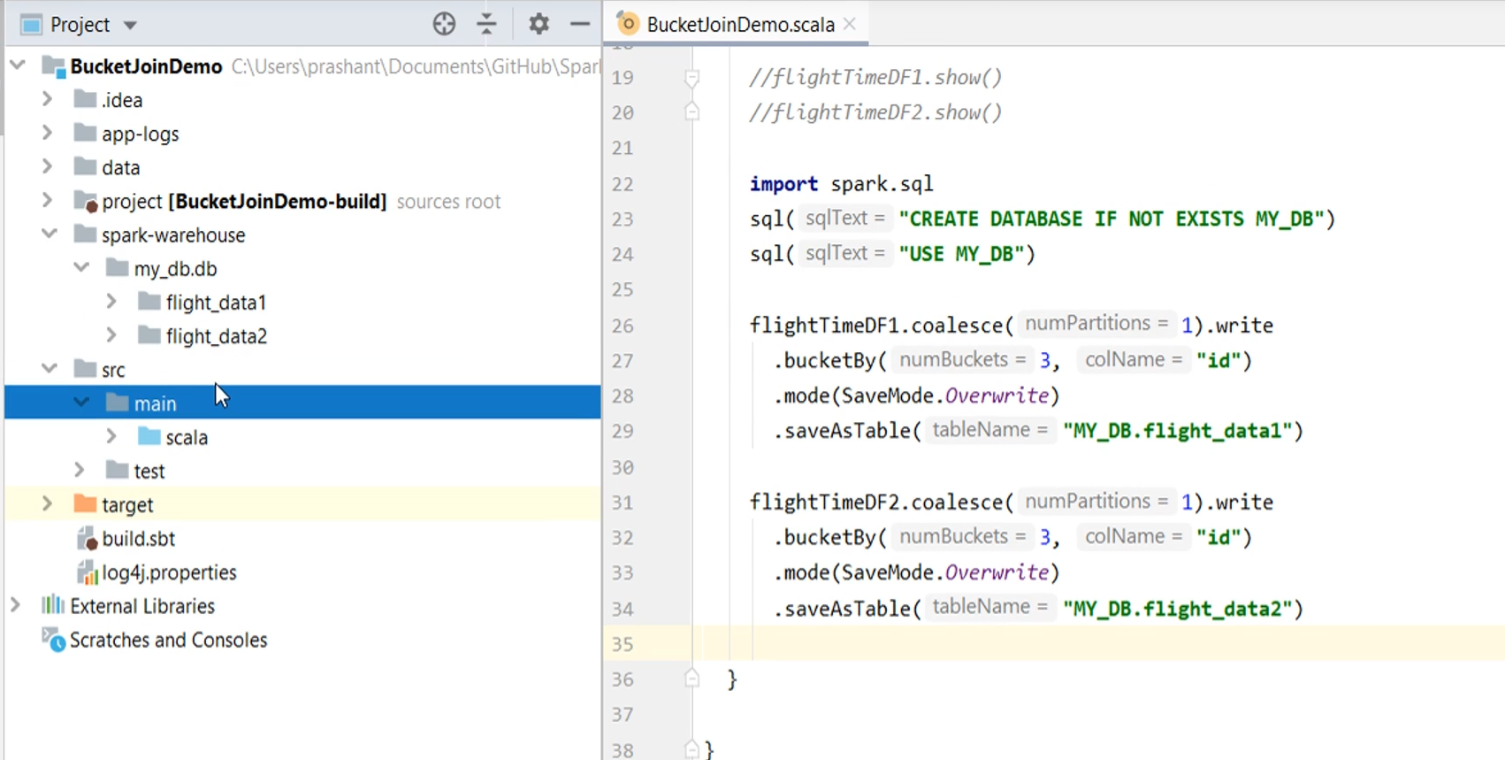

We discussed all this in the earlier lecture. I often get this question. What are the best practices for the best performance? The best performance doesn't exist. We want a predictable performance, which we can scale by adding more executors to do it faster. And scaling your spark application is more of maximizing the parallelism and minimizing the skew. Let's finish this. I am bucketing it on a single key. You already learned to bucket in an earlier lecture. Finally, we save it as a table. I also need to make sure that the database already exists. Let me add the save mode to overwrite. Good. Let's do the same for the other dataset. We are done. Let me run it.

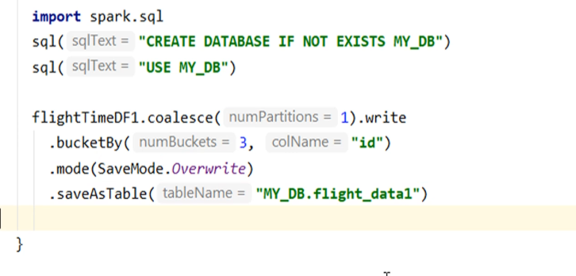

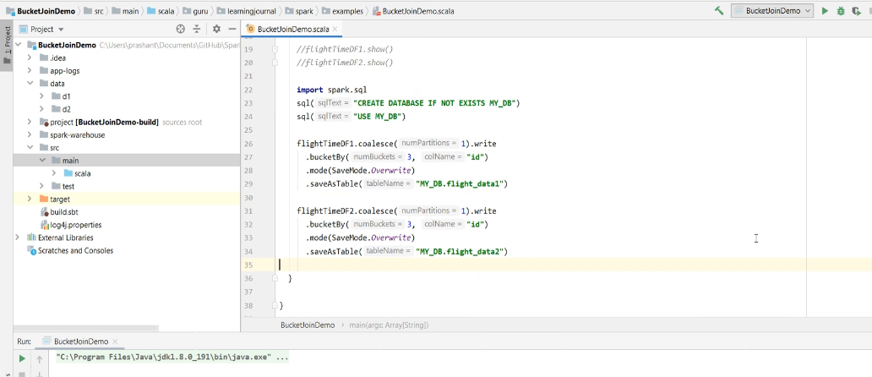

Simple. My database is created, and I have these two tables. Both of these are having three buckets. I showed you all this in an earlier video also. So, we are done with the first step.

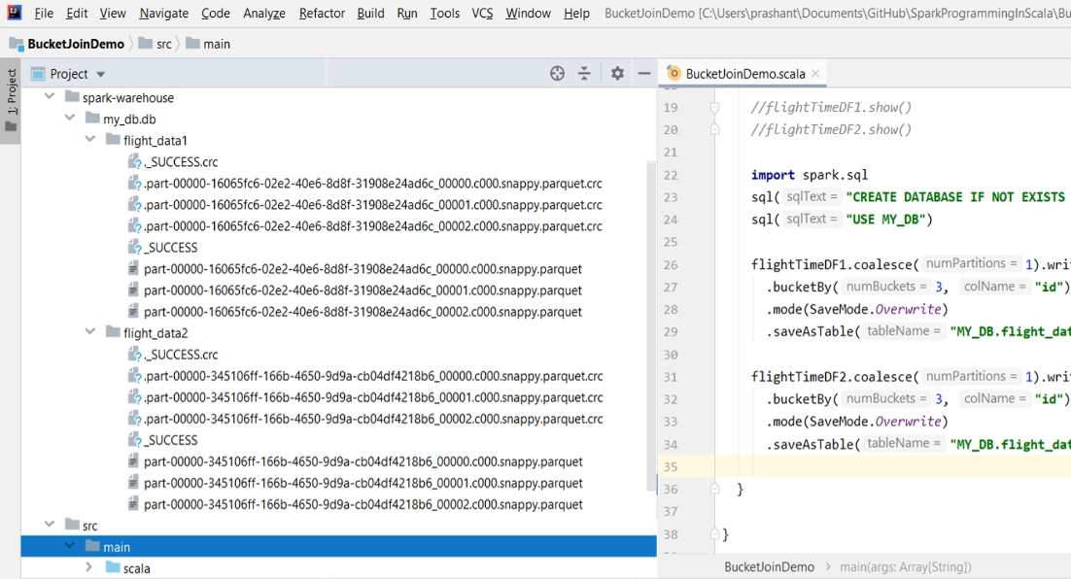

Now you have two tables that are created using buckets on your join key. These are now ready for joining and performing some analysis. So this was the first step. Now, let's assume we have a requirement for joining these two datasets. So, I should create a new application to join it and perform the necessary analysis. However, for simplicity, let me comment on these things and do it here. So, I am going to read both the datasets. However, these are database tables. So, I will be using the table() method. Then we define the join expression. And finally, we can join them. Let me add action and hold the application. We are done. However, we are reading a managed table.

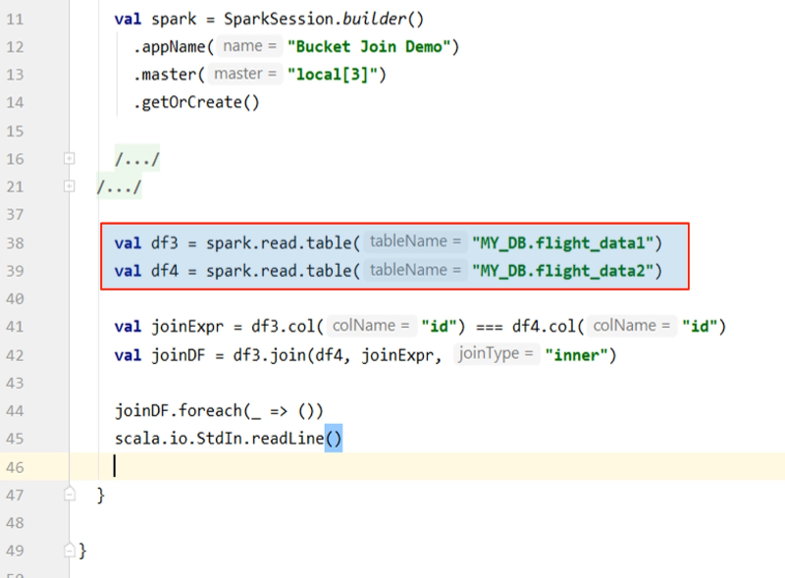

And these tables are small. So, Spark might automatically pick up a broadcast join. I don't want Spark to apply a broadcast join here. So, let me set the auto-broadcast-join-threshold. So, I am setting this value to -1. This setting will disable the broadcast join. We want to go for a sort-merge join without a shuffle. That what we are trying to implement and learn. Let's run and it and see if we are still using a shuffle. Here it is.

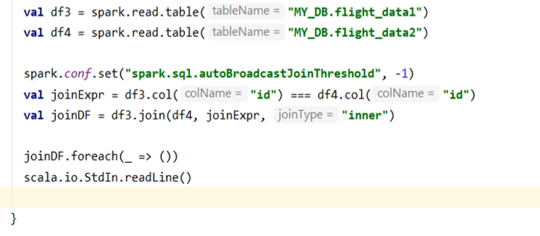

Let's run and it and see if we are still using a shuffle. Here it is. Do you see shuffle? No. We don't even see the broadcast. So what's happening here. A plain sort-merge join without a shuffle.

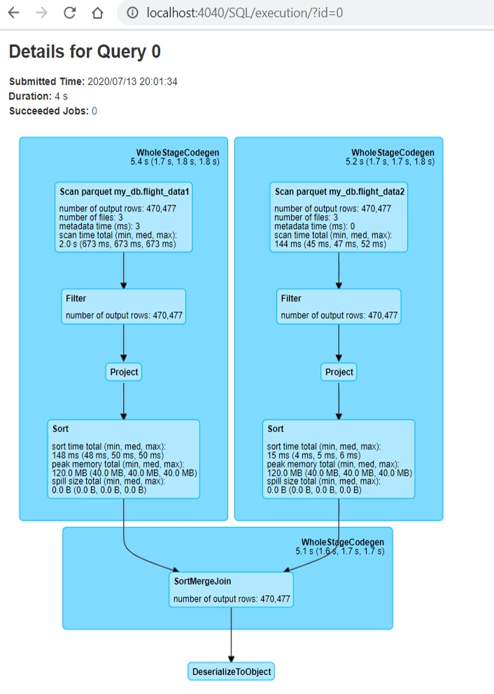

So we learned to avoid shuffle in our joins. However, you need to plan it ahead. Creating buckets is a design-time decision. The idea is straightforward. Understand your data. And also understand what and how you are going to use it. If you know these things, you can make smart design decisions and run your workload a lot faster.